

Functional User Guide V.1

# SUMMARY

1 / SUMMARY 2

1.1 / Scope of work 4

1.2 / References 4

1.3 / Wording and acronyms 4

1.4 / Cloud commerce summarized 6

1.5 / Solution environment 6

1.6 / Solution technology 7

1.7 / A complete solution 8

1.8 / A flexible solution 9

1.9 / An involving solution 10

2 / LET’S RUN A MARKETPLACE 11

2.1 / First steps with the CCF solution 11

2.1.1 / Solution mapping 11

2.1.2 / A front office experience 12

2.2 / A back office experience 16

2.3 / From the merchant to the marketplace 16

2.3.1 / Product vs offer 16

2.4 / Manual product creation 17

2.4.1 / Product change 19

2.5 / How to display products 20

2.5.1 / Browsing products 21

2.6 / Merchant shop experience 24

2.7 / Offers management 26

2.7.1 / Manual offer creation and activation 26

2.7.2 / Offer modifications 27

2.7.3 / Multi-offers 27

2.8 / Purchase funnel 28

2.8.1 / The classic cart 28

2.8.2 / Virtual product order workflow (mail) 32

2.8.3 / Hybrid cart 33

2.9 / Orders management 34

2.9.1 / A physical product order 34

2.9.2 / A virtual product order 36

2.9.3 / A hybrid product order 38

2.10 / Order status workflow 39

2.11 / How to set the cart 40

2.11.1 / Rules and settings 40

2.12 / PSP settings 41

2.12.1 / Rules 41

2.13 / A secure solution 42

2.13.1 / Authentication and authorization 42

2.13.2 / Password and databases 42

3 / A POWERFUL DASHBOARD 43

3.1 / Introduction 43

3.2 / Connection 43

3.3 / Sales 44

3.3.1 / Dashboard 44

3.3.2 / Customers 50

3.4 / Shops 53

3.4.1 / Catalog 53

3.4.2 / Settings 70

3.5 / Merchants 77

3.5.1 / Insights 78

3.5.2 / Complaints 80

3.5.3 / Rating 86

3.6 / PAYMENTS 87

3.6.1 / Commissions 87

3.6.2 / Cash transactions management 87

3.7 / ADMINISTRATION 87

3.7.1 / Users management 88

3.7.2 / Modules 88

3.7.3 / Shipping modes and zones 89

3.8 / SUPPORT 97

3.8.1 / Help 97

3.8.2 / Training tools 97

3.9 / MANAGING SELECTIONS 99

3.9.1 / Creating a selection 99

3.9.2 / Editing a selection 100

4 / AN EFFICIENT MERCHANT AREA 103

4.1 / MERCHANT ACCOUNT CREATION 103

4.2 / CUSTOMIZING THE SHOP 106

4.3 / MANAGING PRODUCTS 107

4.4 / MANAGING OFFERS 109

4.5 / MANAGING SALES 110

4.6 / MANAGING COMPLAINTS AND REFUNDS 112

5 / A USEFULL CUSTOMER AREA 115

5.1 / CUSTOMER ACCOUNT CREATION 115

5.2 / MANAGING A PROFILE 116

5.3 / MANAGE YOUR COMPLAINTS 117

5.4 / MANAGE YOUR WISHLIST 118

INTRODUCTION

## Scope of work

This document introduces all the features of the Cloud Commerce Factory solution from a functional point of view. As such it doesn’t deal with the technical side of the solution.

## References

|  |  |  |
| --- | --- | --- |
| Reference | Title | Version |
| [DOCSPEC1] | Technical documentation | V1.0 |
|  | | | |

## Wording and acronyms

|  |  |
| --- | --- |
| Word | Definition |
| Cloud Commerce Factory  (CCF) | The solution presented in this document. |
| Administrator back office (ABO) | The administrator back office (ABO) is the dashboard of the solution. It provides complete visibility in terms of performance as well as monitoring of all the sides : sales, merchants, customers, and refunds. |
| Merchant back office  (MBO) | The merchant back office (MBO) is the merchant’s dashboard. It allows managing orders and business. |
| Customer back office  (CBO) | The customer back office (MBO) is the customer account. It allows managing orders and the account. |
| Operator back office  (OBO) | The operator back office (OBO) is the customizable “front” back office. It helps manage all data in the platform (product sheets, product selections…) without using the ABO. |
| FRONT | The front office represents the front-end element such as the customer and merchant area and the platform front. |
| JS | A job scheduler is a computer application for controlling unattended and automated background program executions. |
| Offer | In our solution, an offer is what the merchant offers as a product or service. |
| SAAS | Acronym of “software as a service”. |
| Complaint | The system of customer complaints includes the following :   * The loss of a parcel for delivery * The return of a product in terms of logistics warehouses, whatever the reason for the return might be * Degradation of a product or a package making it impossible to deliver * Unclaimed or undistributed parcel * Client refusal * Defective Products   As long as the claim has not been the subject of a refund, a re- dispatch or re-integration in stock (fraud), we use the term open claim. Once the claim has been a final processing action i.e. a refund, return shipment, or a re-integration in stock, we no longer use the term open but closed complaint claims. |
| Tracking number | Shipping number provided by the logistics. |
| EAN | The EAN is a 13 digits barcode that identify products all around the world. |
| SKU | “Stock Keeping Unit” is a distinct item for sale, such as a product or a service, and all attributes associated with the item that distinguish it from other items. For a product, these attributes include but are not limited to : manufacturer, product description, material, size, color, packaging, and warranty terms. When a business takes an inventory, it counts the quantity of each SKU. |
| Customer | People that buy products or services on the platform. |
| Merchant | People or companies that sell products or services on the platform. |
| Administrator | Person responsible for maintaining the marketplace. |
| Merchant flow | Merchant data flow is a file in CSV or XML format, containing the merchant's products data. It’s available at a dedicated URL. |
| CSV File | A CSV file is commonly described as ‘Comma Delimited File’, ‘Character Separated File’, or ‘Comma Separated Values’. It’s a text file that can be opened by a text editor such as notepad for example. |
| Payment Solution Provider  (PSP) | A payment module allowing customers to pay for products bought on the platform (PayPal, be2bill, Ogone…) |

## Cloud commerce summarized

Our solution has been built from our experiences in multi-vendor platforms. The solution is more than five years old and is still growing with 15 dedicated developers. Moreover, we don’t forget our competitors. It’s the reason why we improve our solution to ensure the best e-business experience.

## 

## Solution environment

To understand how the solution works, we need to look at its architecture. It can be separated in two sections : a back-end and a front-end.

* The back-end has an administrator back-office (ABO). We offer a generic ABO for each platform. It provides complete visibility in terms of performance as well as monitoring and managing sales, merchants, customers and refunds.
* The front-end provides an access to several elements : an operator back-office (OBO), a merchant back-office (MBO), a customer back-office (CBO) and a platform front. These elements help manage orders and sales. We will talk about them later on.

## Solution technology

Currently, we offer the version 3.1.1 of the Cloud Commerce Factory (CCF) solution to our customers. This solution uses the C# language using MVC. MVC is a framework for building web applications using the MVC (Model View Controller) design (fig. 1) :

* The **Model** represents the application core (for instance a list of database records). Model objects often retrieve and store data from a database.
* The **View** displays the data (the database records).
* The **Controller** handles the user input (to the database records).

Model

View

Controller

Figure 1: MVC model introduction

It also provides full control over HTML, CSS, and JavaScript. Moreover, the MVC separation helps you manage complex applications because you can focus on one side at a time. For example, you can focus on the view without depending on the business logic. It also makes it easier to test an application.

The MVC separation also simplifies group development. Different developers can work on the view, the controller logic, and the business logic in parallel.

## A complete solution

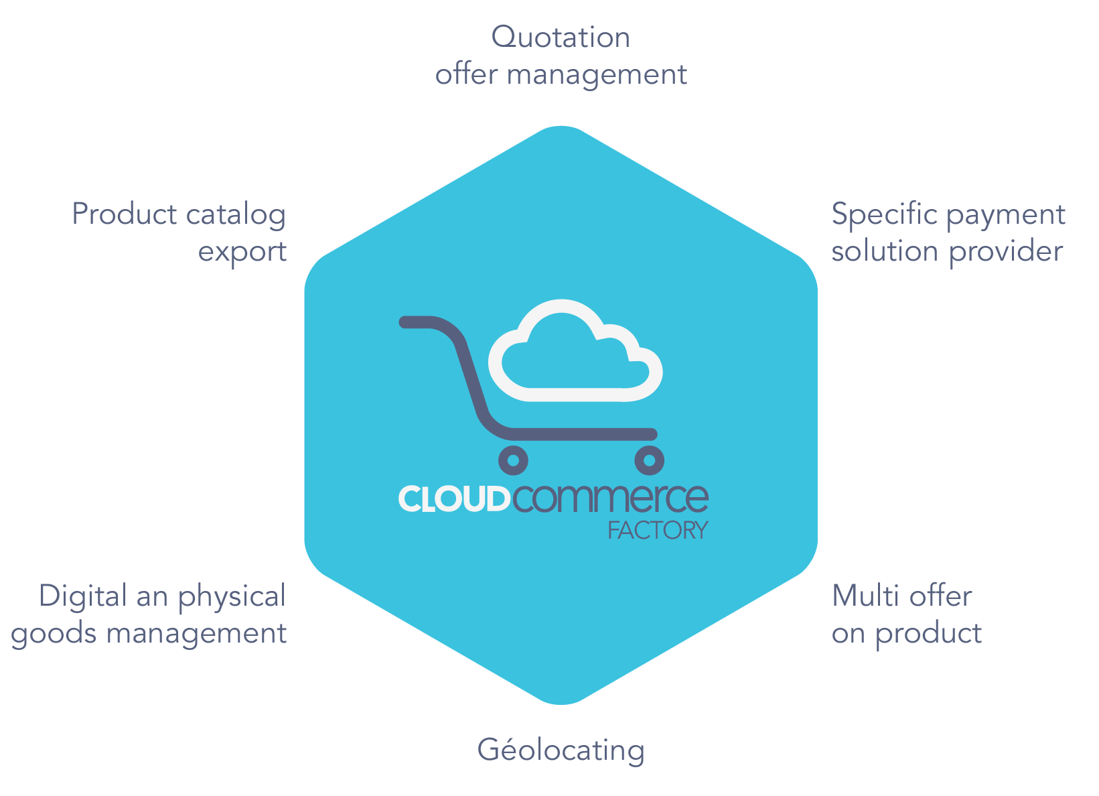

Figure 2: Software features scope

Our solution allows managing each kind of e-business data (fig. 2). Other solutions are unneeded apart from a payment provider to start the business. Furthermore, dedicated sections are available to run the business as needed.

## A flexible solution

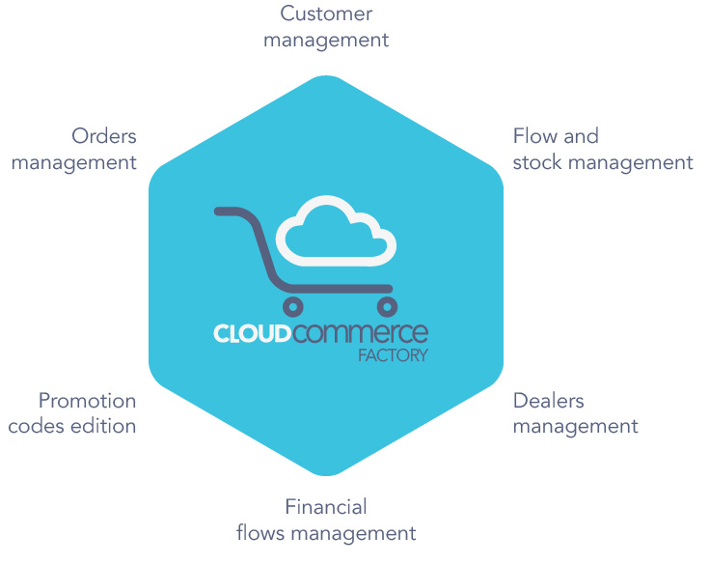

Figure 3: Software additional features

Our solution has features helping it adapt itself to a model’s needs (fig. 3). We offer a unique experience to build the best multi-vendor platform on the web. It is possible to use the existing features or create specific modules for specific needs. User experience can be customised for any need. Everything is customizable.

## An involving solution

|  |  |  |  |
| --- | --- | --- | --- |
| Where | V3.1.1 | Features | Status |
| ABO | V3.1.1 | Cross-selling | OK |
| ABO | V3.1.1 | Reviews reminder | OK |
| ABO | V3.1.1 | Reviews on products | OK |
| ABO | V3.1.1 | Edit brand pages | OK |
| ABO | V3.1.1 | Complaints and refunds management | OK |
| ABO | V3.1.1 | Cart reminder | OK |
| ABO | V3.1.1 | Passwords management | OK |
| ABO | V3.1.1 | Merchant review module | OK |
| ABO | V3.1.1 | Promotion code bug fixing | OK |
| FRONT | V3.1.1 | Research improvement | OK |
| ALL | V3.1.1 | Unit tests | TODO |
| ABO | V3.1.1 | Commissions and cash flows management | TODO |
| SYSTEM | V3.1.1 | Packaging script NANT | In progress |
| ABO | V3.1.1 | ABO Flat design and bug fixing | In progress |

Figure 4: Roadmap 2015 draft

Based on our clients or prospects, we complete our roadmap (fig. 4) and create new versions of the solution. Understanding their needs, our software is built without ignoring the market issues. Every six months, we deliver a new version. Our goal is to offer features that fit with each kind of activity. E-business is evolving so we need to adapt to it.

# LET’S RUN A MARKETPLACE

## First steps with the CCF solution

### Solution mapping

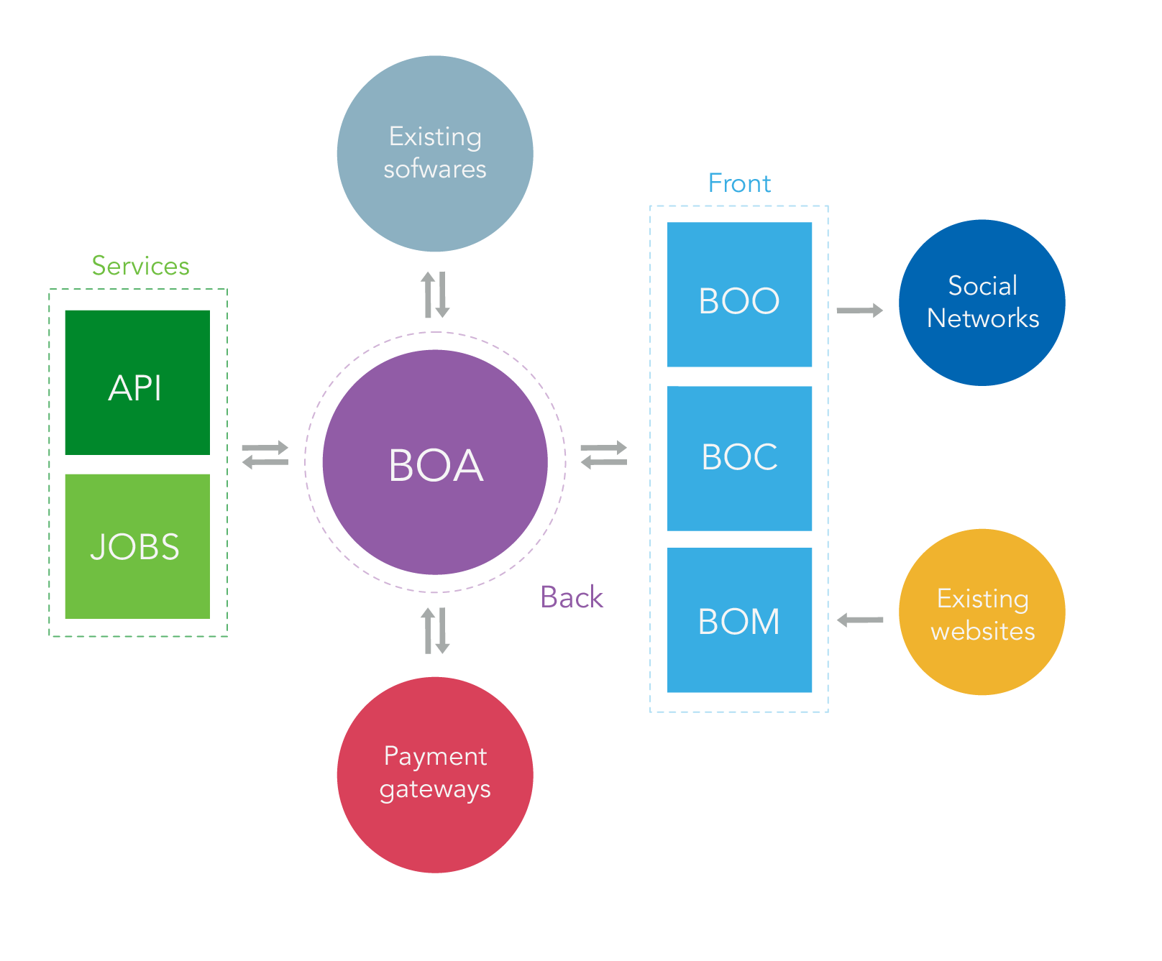

Figure 5: Software environment

Based on the activity, there may be a need to connect the platform with existing tools. It ‘s the reason why our solution can exchange data flows with other solutions (fig. 5). As a modular solution, CCF can have custom modules in order to interact with the existing software. This way, a customer list can be powered by a CRM solution or any other third-party. The solution is complete, which makes it possible to connect with any existing software. As shown in the figure 5, our solution has a triple application structure (Front-end, Back-end, Services).

### A front office experience

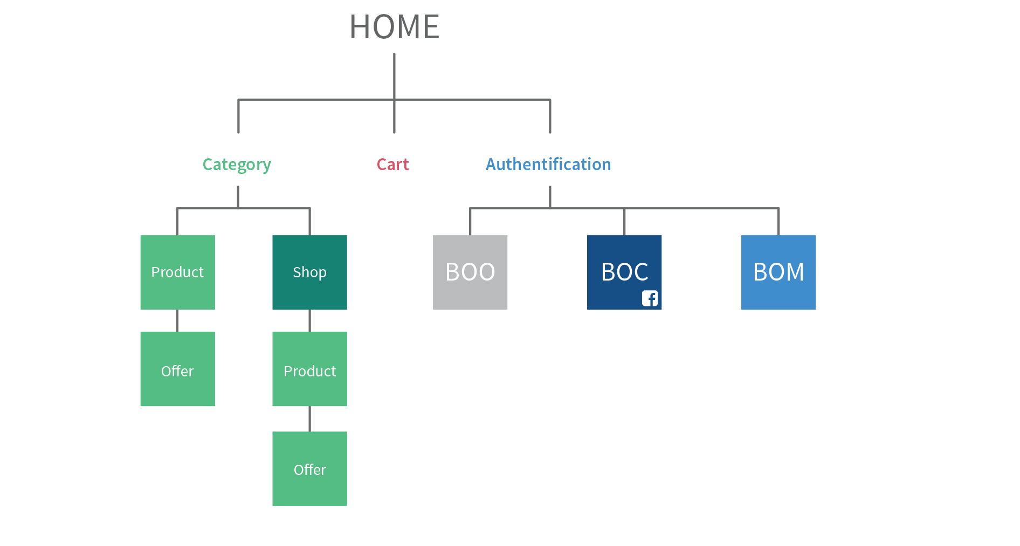

Figure 6: Front-office structure

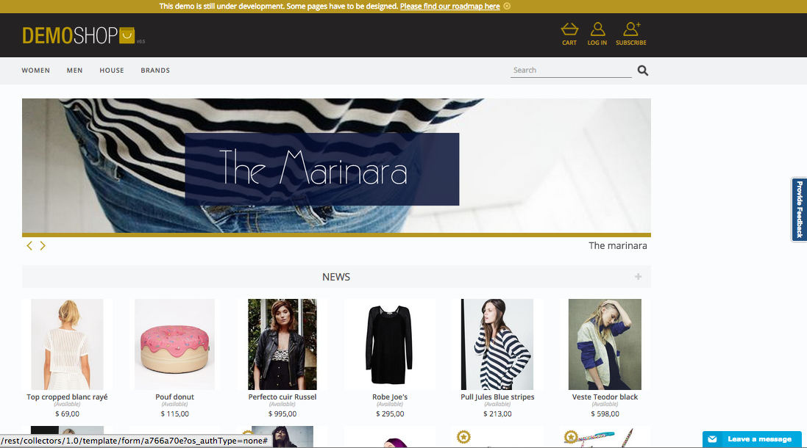

Figure 7: Front-office Header

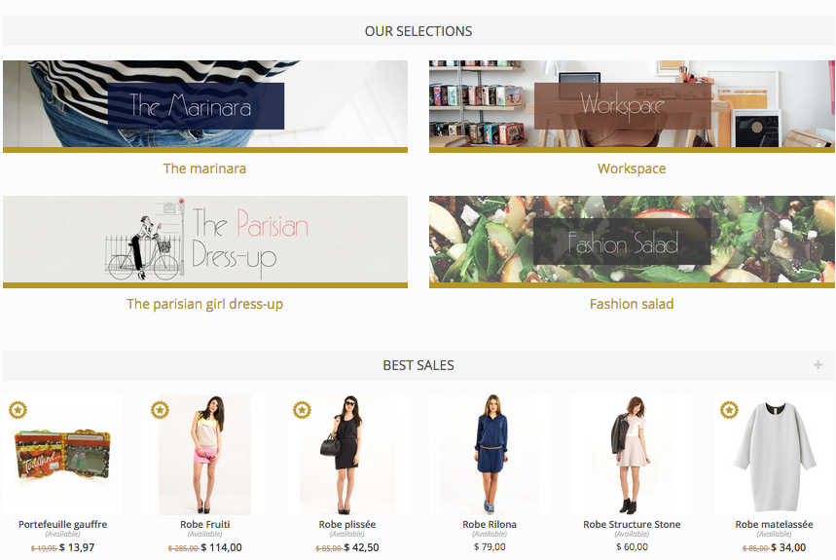

Figure 8: Front-office body

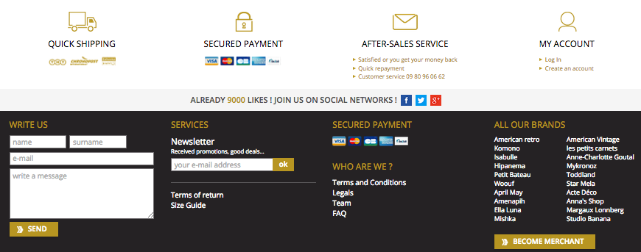

Figure 9: Front-office footer

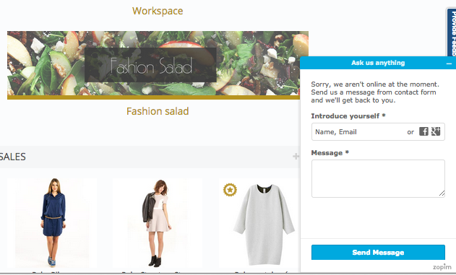

Figure 10: Front-office live chat area

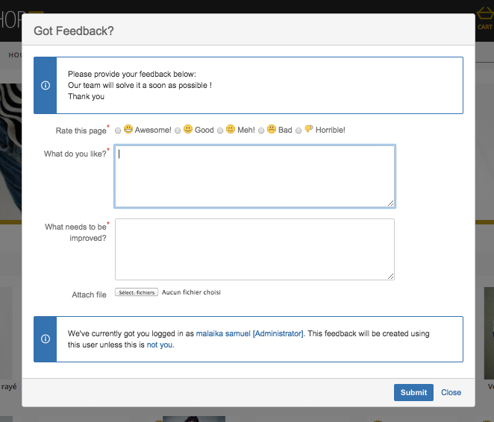

Figure 11: Front-office feedback section

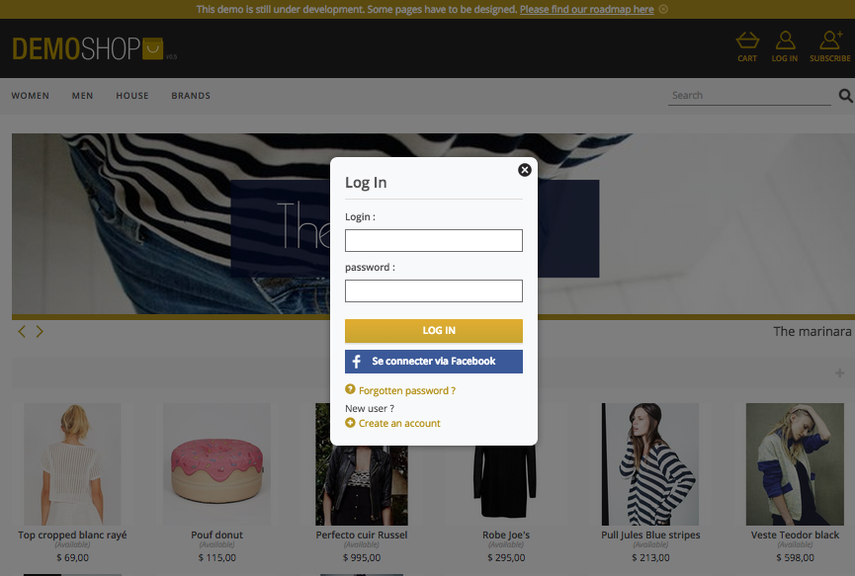

Figure 12: Log in box example

To begin with, let’s have a look at the front office experience (fig. 6). For this example, we introduce our template Demoshop connected with Jira (a bug reporting solution), Zopim (a live chat solution), and Be2bill (a payment solution provider) (fig. 7-12).

Our template provides a complete marketplace example. There are only a few categories but there can be as much categories and sub-categories as needed. The front-end can be customized by adding more sections (cross-selling, best sales…).

Based on e-business best practices, tools like Facebook connect or reinsurance panel should be used too.

A live chat solution and a bug reporting solution allow for improving the customer relationship.

This demo doesn’t highlight facetted navigation or breadcrumb trails but they are also features that can be found in the solution.

## A back office experience

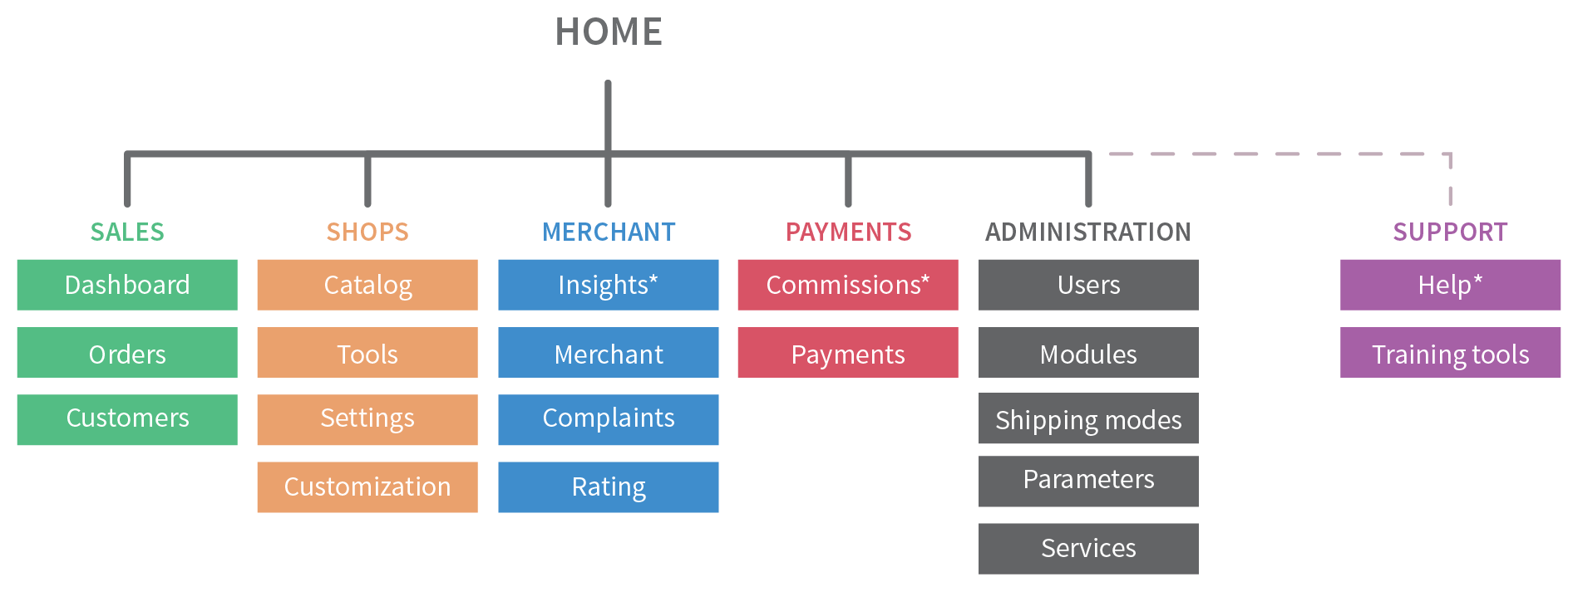

Figure 13: Administrator back-office mapping

As mentioned previously, CCF has a generic back-office deployed for each marketplace (fig. 13). This ABO is a separated web application with a specific URL. Its features have been classified in five sections (sales, shops, merchants, payments, administration). Moreover, in order to help using the ABO, we developed a support section. In this area, there is a help center and documentation about ABO management (training tools and specifications).

## From the merchant to the marketplace

### Product vs offer

To get a better understanding of our solution, we must define two concepts: product and offer :

* A product is an article or a service that someone can buy in a marketplace. It can be sold by one or several merchants based on the marketplace configuration. A product sheet can be created by importing files or manual creation based on the quantity of products needing to be created.
* An offer is what a merchant offers on a product. It contains the price and the quantity of the product available in a merchant shop. A product can have several offers. But a product can’t be sold without an offer.

## Manual product creation

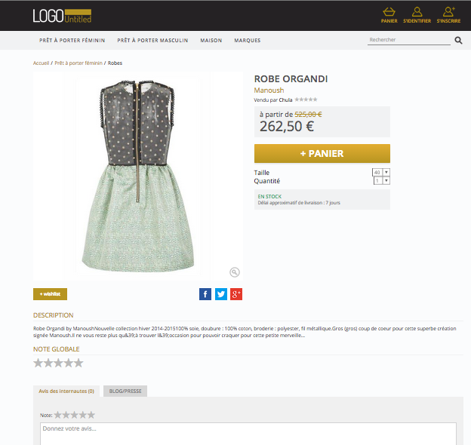

Figure 14: Product sheet example

After a successful setup, the platform is operational. The first thing to do is decide what will be sold: physical goods or services?

Whichever it is, our solution helps easy creation of new physical goods using the ABO or the MBO.

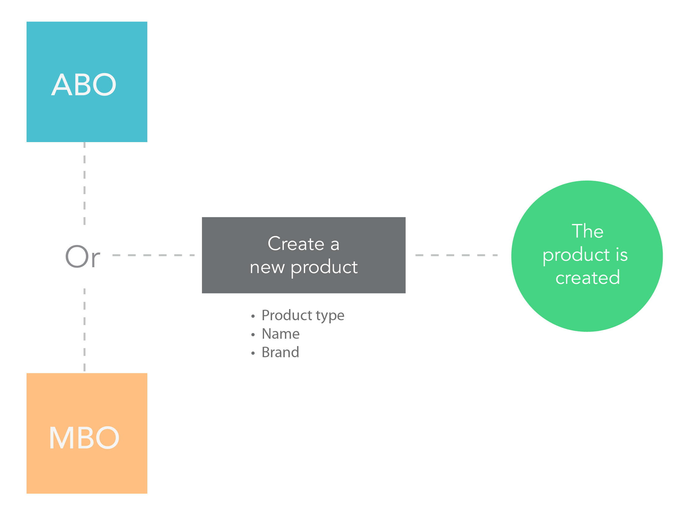

Figure 15: Product creation workflow

As stated earlier, our solution offers two ways to add products on the platform:

* Catalogue import
* Manual creation

Let’s first focus on manual creation as catalogue import will be introduced later on. In order to ease product management, we separate products in two types: “physical” and “virtual”. Creation of new products has some required data:

* Product type
* Name
* Brand

In order to improve platform management, we recommend filling the “EAN”, “Reference” and “SKU”.

Moreover, we advise against using special characters in the product names and checking that the product EAN is unique and has 13 digits.

A merchant should take the time to create an attractive product sheet (fig. 14). Creation workflow is the same for physical and virtual product (fig. 15). The following data should be added to products:

* A product category (products won’t be activated if there is no category matched)
* A short description (2 lines max)
* A description
* Some pictures (the number of pictures allowed can be changed in the ABO)

Attention, products can’t be deleted in the solution. If there is a need to stop selling a product, it can be achieved by simply deactivating the product on the product sheet. It should be noted that our solution allows creation of duplicates. It could become difficult to find the right product sheet to create an offer for if there are too many duplicates. Most of the merchants would want to sell variations of products but it is a weaknesses of our solution. To solve this problem, we offer a cross–selling feature.

### Product change

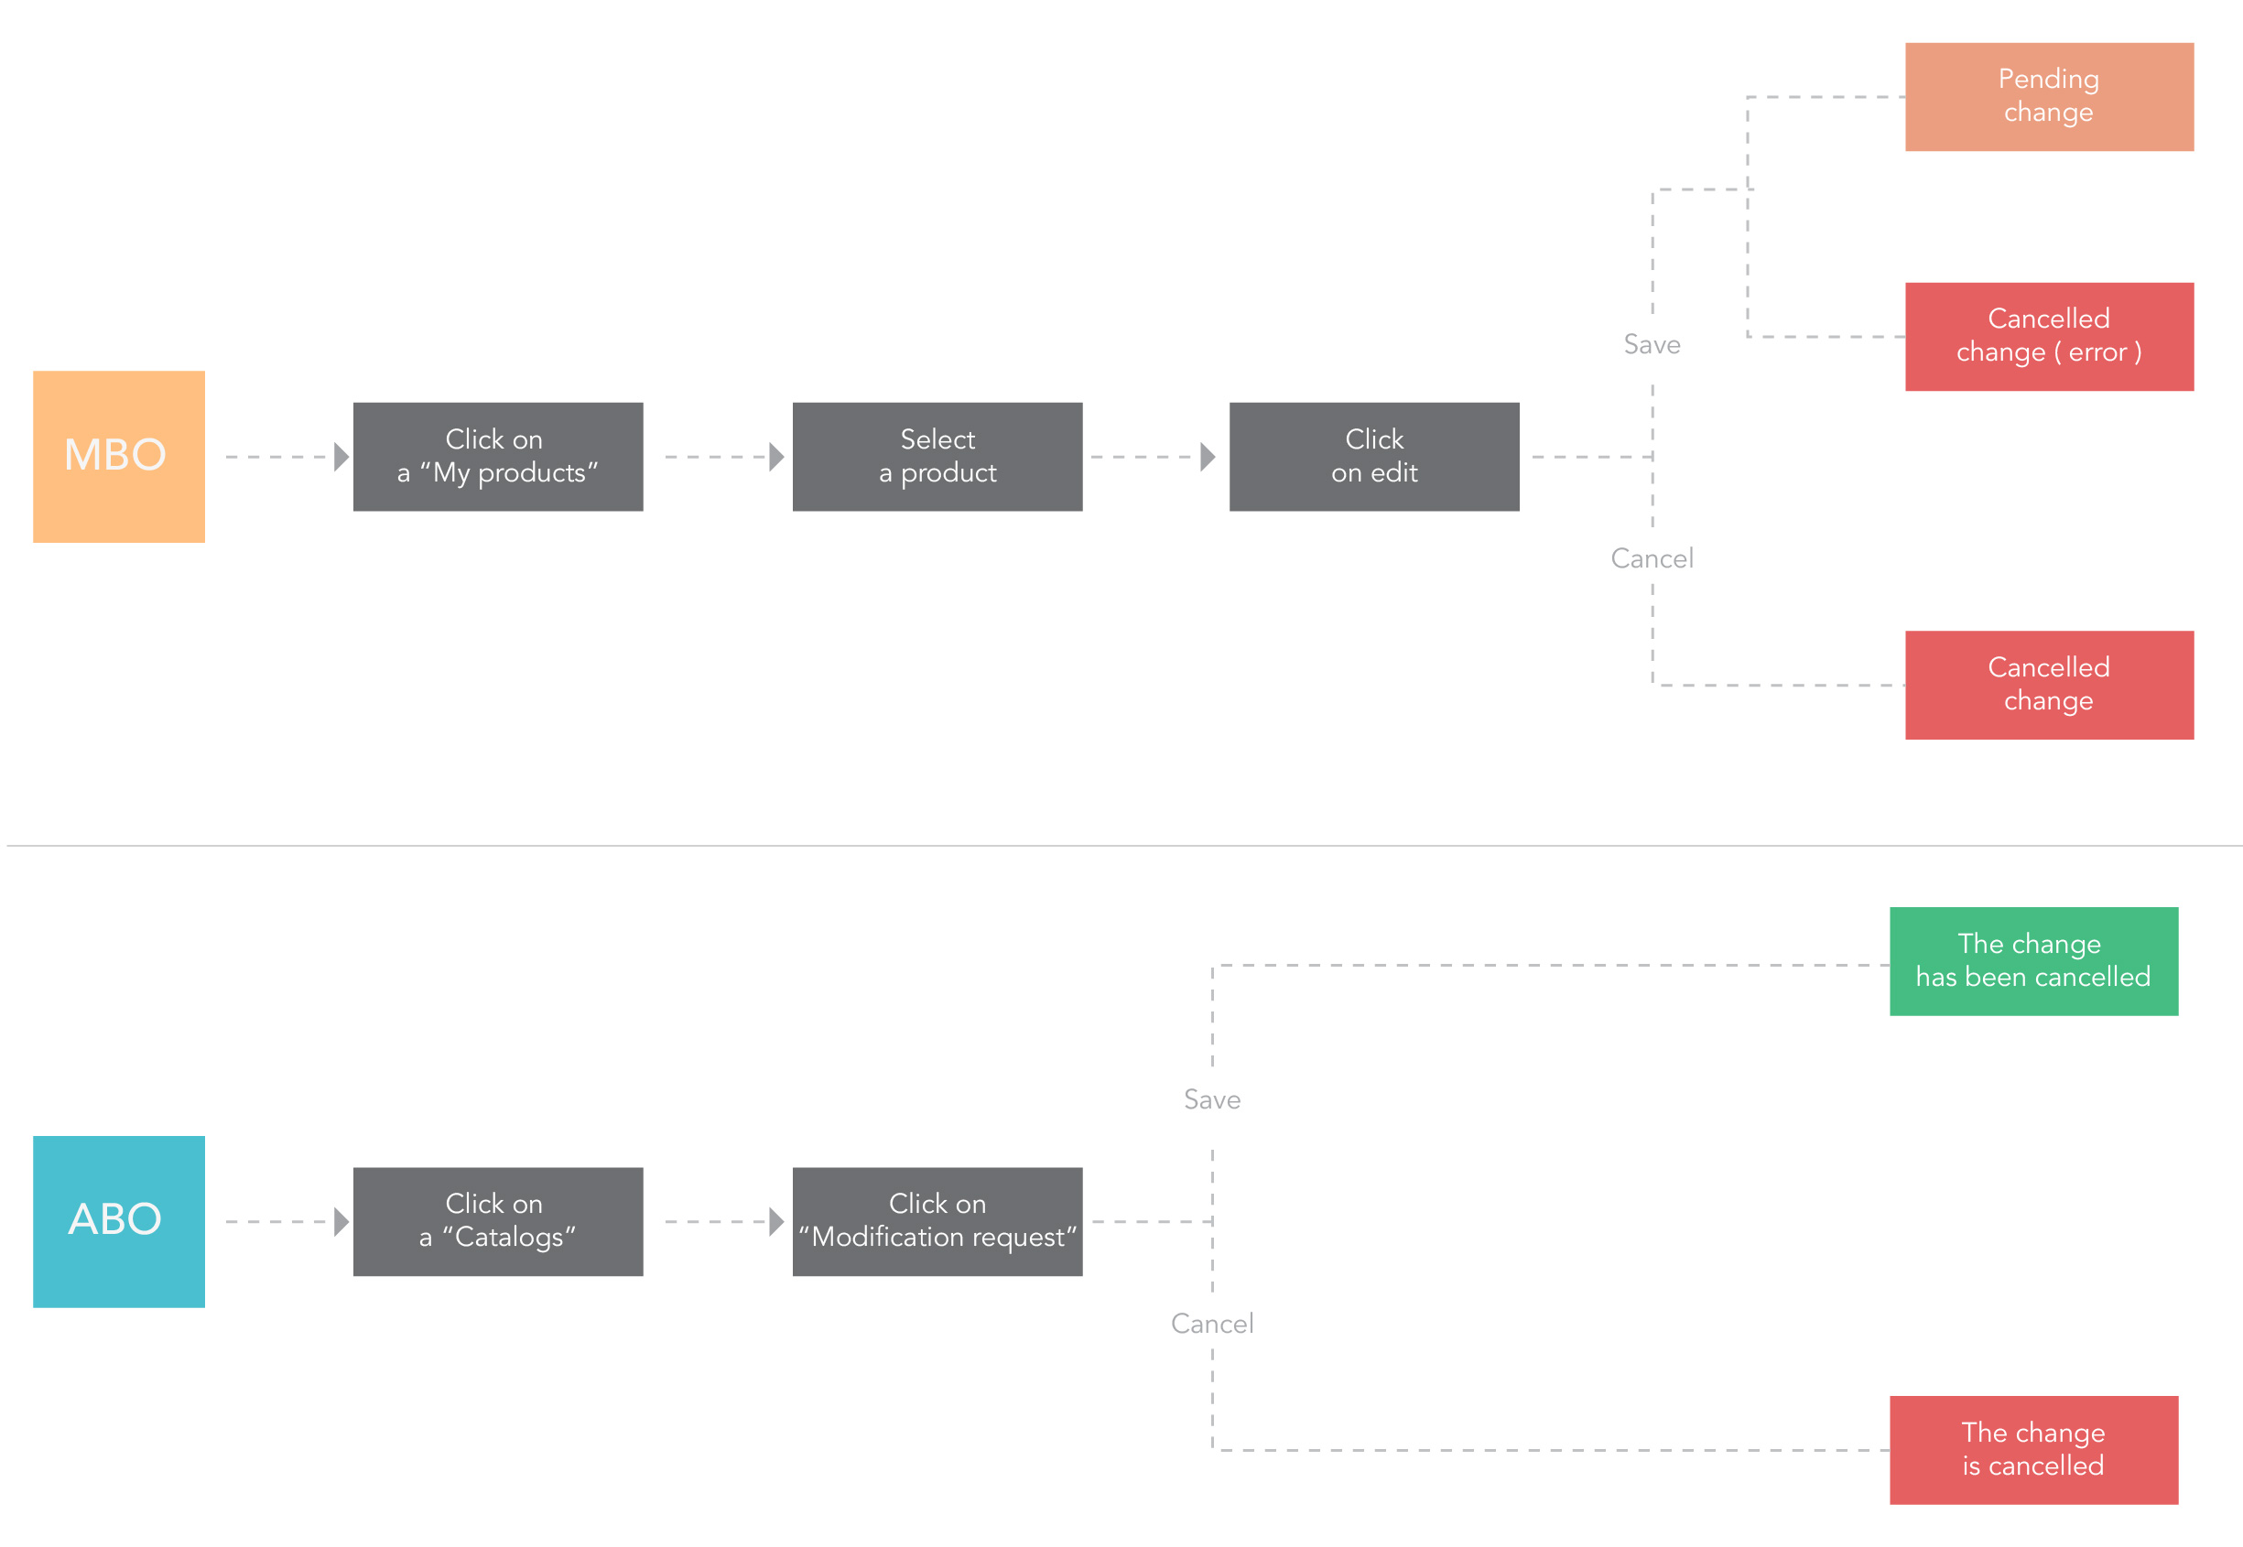

Figure 16: Product modification workflow

If there is a need to add or update data on a product, it can be done through the MBO and ABO (fig. 16). To ensure coherence in all data, the administrator must approve or invalidate this change in the ABO. In case of multi-offer activation, it should be noted that the product sheets are the same for each merchant. So, we recommend keeping some generic data.

## How to display products

* Physical products

To display a physical product in the platform, a few rules need to be respected.

Firstly, after the product creation a product ID is generated. Below is the list of attributes a product must have the values of in order to be available to the front-end :

* Product ID
* Category
* Category ID
* Brand
* Brand ID
* Product name
* Activated offer(s) associated
* Description (optional but we advise adding one)
* Picture (optional but we advise adding one)

An activated offer will always contain the following attribute values :

* Price
* Shipping mode and zone
* Activated merchant
* Product ID
* Positive stock (units in stock superior to zero)
* Offer ID
* Virtual products

Displaying a virtual product in the platform is not too different from displaying a physical product. In the same was as a physical product, a virtual product must have the values for the following attributes:

* Product ID
* Category
* Category ID
* Brand
* Brand ID
* Product name
* Activated offer(s) associated
* Description (optional but we advise adding one)
* Picture (optional but we advise adding one)

In order to activate an offer on a virtual product, the offer must have the values of the following attributes :

* Price
* Activated merchant
* Positive stock
* Offer ID
* Product ID

### Browsing products

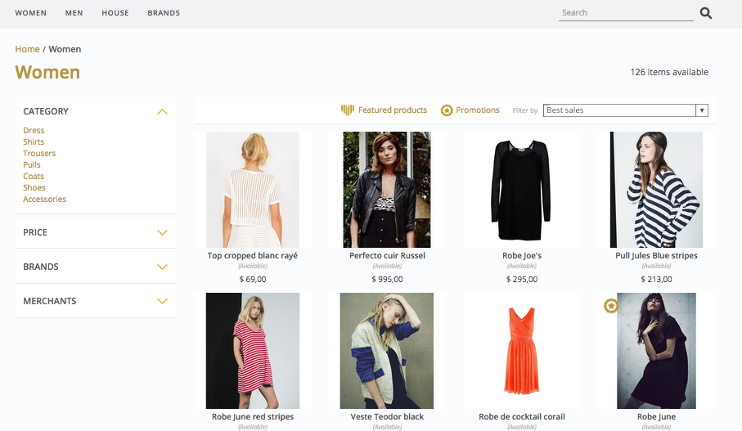

Figure 17: Product category and sub-categories example

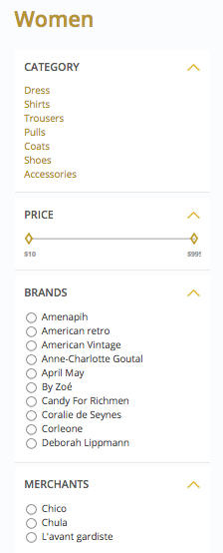

Figure 18: Front filters details

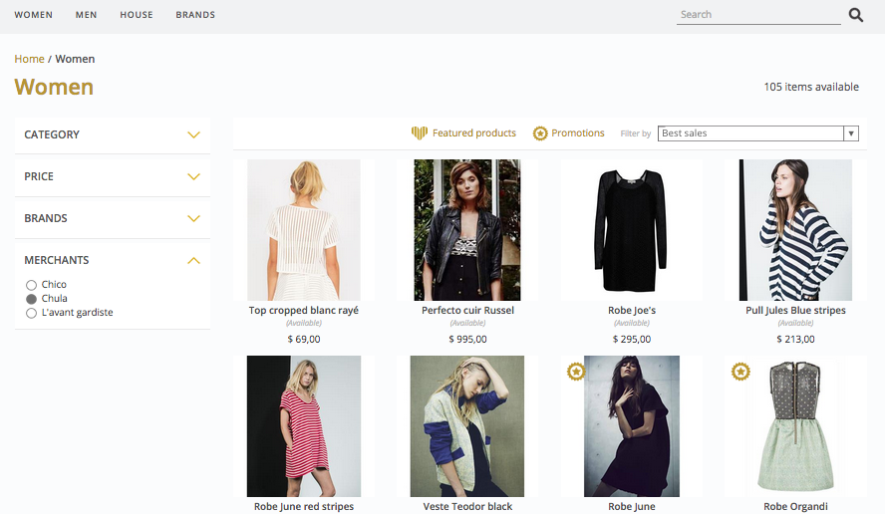

Figure 19: Merchant page

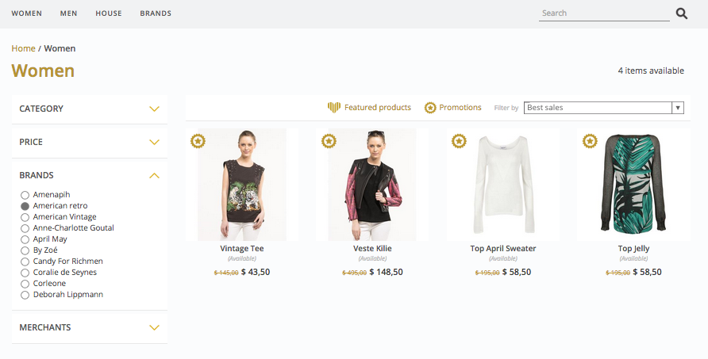

Figure 20: Brand page

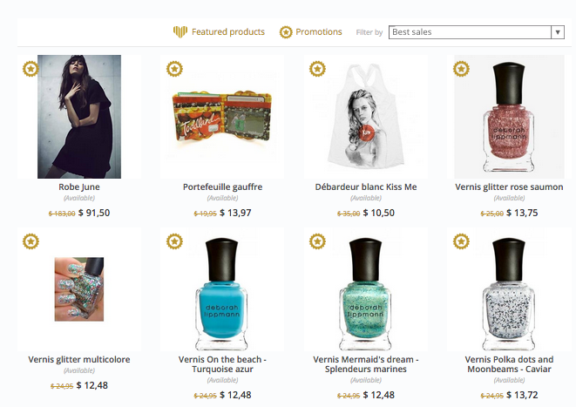

Figure 21: Promotion page

Our solution ensures an easy classification of the products. There are filters and various types of pages to help users easily find a product in the front-office (fig. 17-21). Patches or selections can help promoting specific products, a brand or a merchant catalog.

## Merchant shop experience

Based on the need, our solution can provide a merchant shop experience and organisation.

Each shop will have its own page and data. There, the merchant will introduce his activity and his environment. The section being customisable (banner, logo and description) reinforce a closer customer-merchant experience (fig. 22).

Merchants should try to adapt their shop to their look and feel. Taking time to choose a short and explicit description of the activity and creating complete product data sheets is important.

To increase sales in the marketplace, offering to specify where the product or service can be delivered is a good beginning. Highlighting all data about the merchant (for example notations and reviews) can reassure clients.

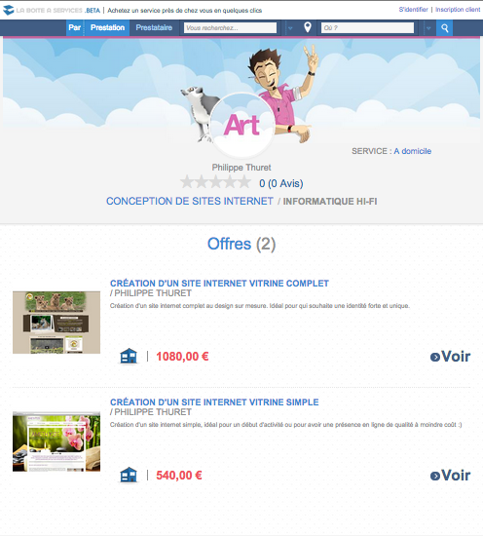

Figure 22 : Merchant shop example

## Offers management

### Manual offer creation and activation

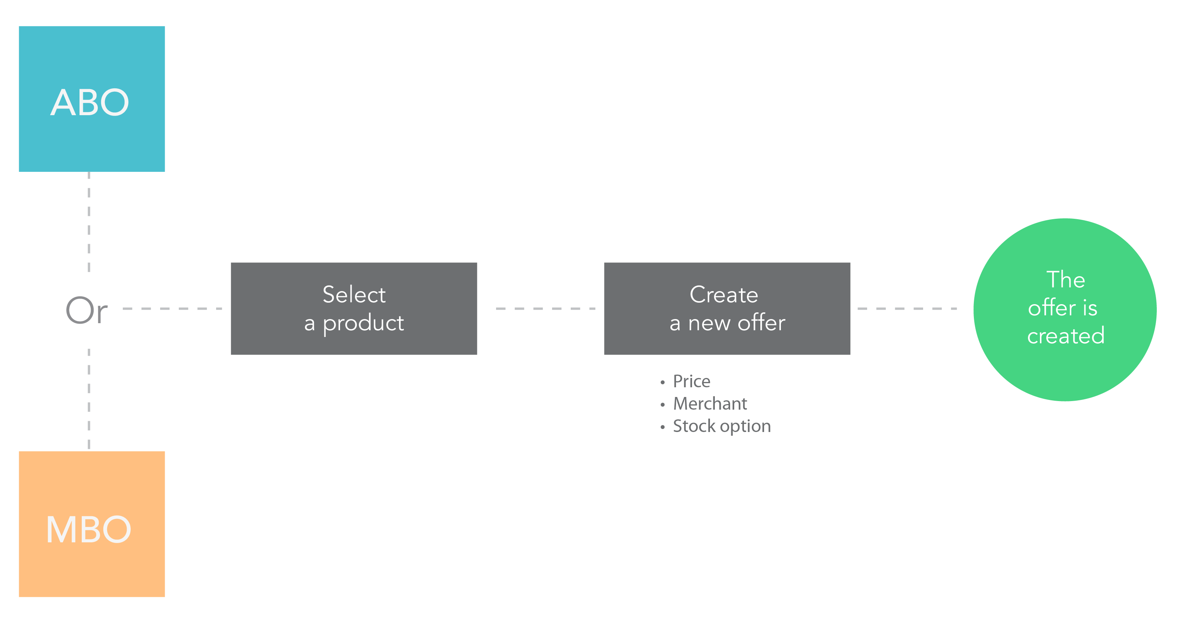

Figure 23: Offer creation workflow

After creating a product sheet, an offer must be added on the product if it is to be sold (fig. 23). The offer needs the following attribute values in order to be activated :

* Price (product price)
* Merchant name (for example: company name of a professional)
* Some stock options (quantity per product version).

A customer can buy a product only through an activated offer. Offers are created by merchants or administrators. In order to allow customers to buy a product, it is needed to have at least one associated offer active. If the product is not available, the offer will be deactivated automatically. But offers can’t be deleted.



Figure 24: Offer activation workflow

During the offer activation, shipping methods and fees must be selected (fig. 24). It is necessary in order to complete the activation process. There is no price in the shipping fee, the shipping fee will be free of charge. After that, the shipping fees display can be set (ie : displaying the shipping fees from the cheapest to the most expensive). It should be noted that the shipping methods and fees are only available for physical products.

### Offer modifications

Changing offers is possible in the MBO and ABO. All data can be removed in the offer details page. However the required attributes still need to have values. It is also possible to manually program some promotions.

### Multi-offers

Our solution also offers a way to get multi-offers on products. In order to allow using the multi-offer, it must first be activated in the ABO. This way several merchants can easily create and sell similar offers. By doing this, product sheets will have links leading to the other offers. Thus, the customer can compare different offers a product.

## Purchase funnel

### The classic cart

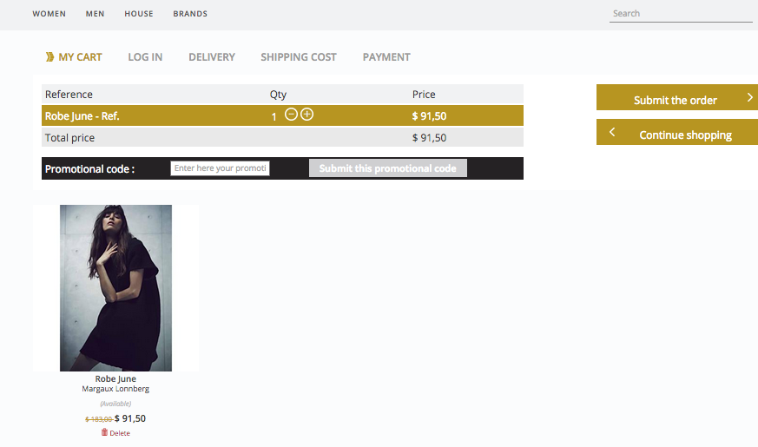

Figure 25: Cart example

After selecting and adding a product in the cart, the customer has to click on the cart and follow each step. Our cart supports modifications and promotion codes. The cart can be updated in the purchase funnel. If a promotion code is applicable, the customer can fill its name in the dedicated area and it will become effective after clicking on the “submit” button (fig. 25).

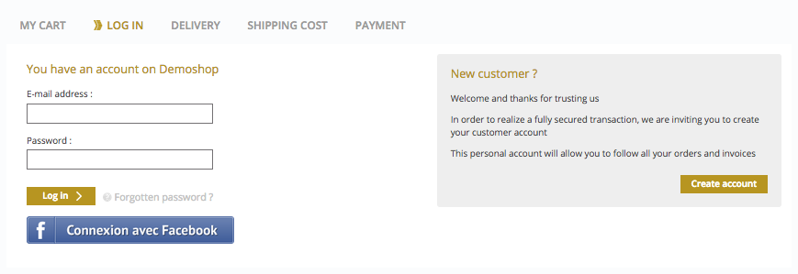

Figure 26: Cart authentication page

After submitting the cart, it is required to log in (fig. 26). In order to do that, there are 3 ways :

* Creating a new account (if the user doesn’t already have an account)
* Connect using a Facebook account
* Connect with an existing account

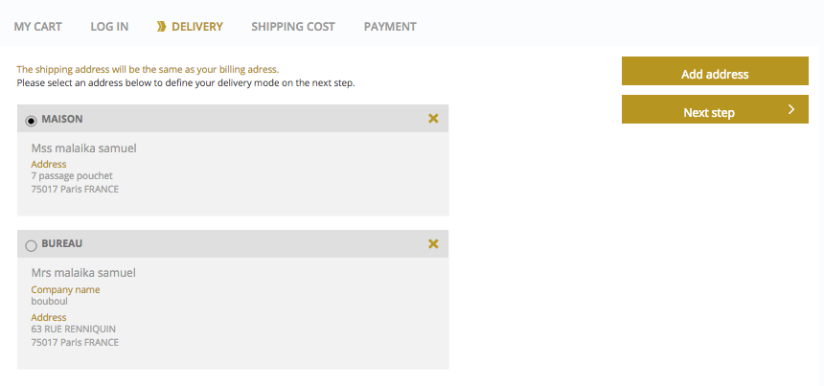

Figure 27: Delivery data page

Then, a delivery address must be selected or created and then submitted in order to access the next step (fig. 27).

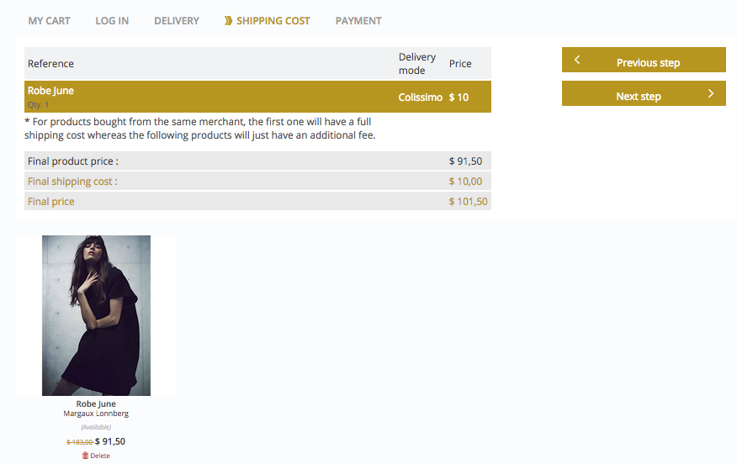

Figure 28: Shipping cost page

Depending on the product and the merchant, the customer can have shipping costs on the cart. In this case we display a summary of shipping costs on the cart (fig. 28). Some merchants offer shipping fees rules and can offer combining parcels. In a multi-vendor’s cart, there can be several shipping fees (fig. 29).

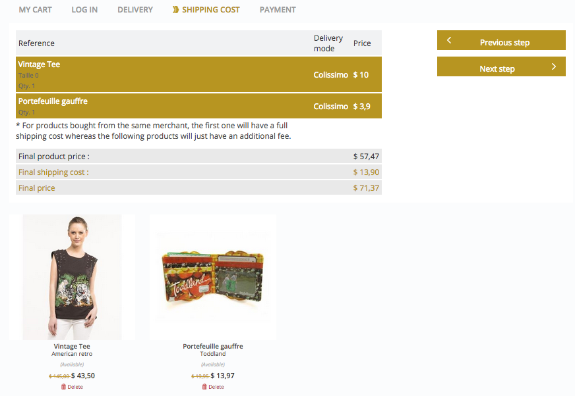

Figure 29: A multi-vendor cart example

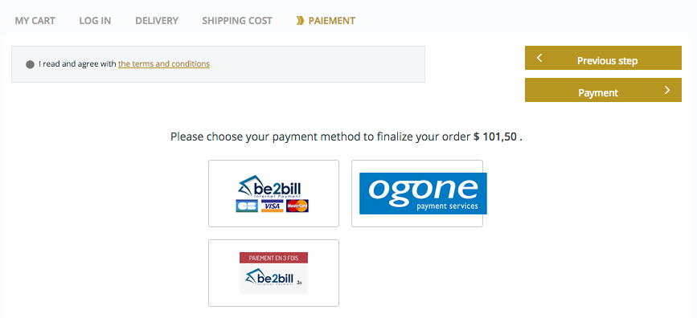

Figure 30: Payment selection page

In order to finalize the order, the customer needs to accept the marketplace terms and conditions and choose a payment method (fig. 30). It is very important to provide several payment methods.

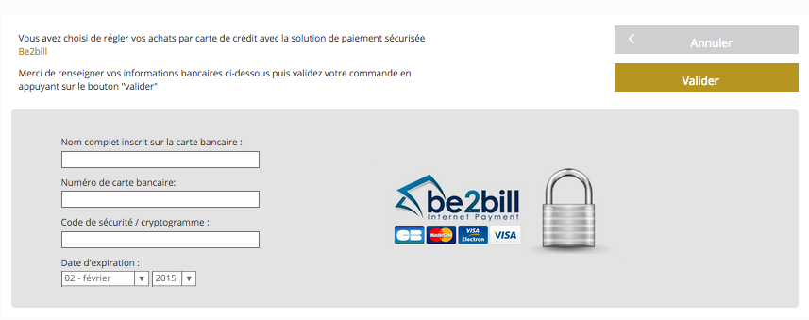

Figure 31: A payment page example

The last step is to fill in the credit card information in a secure page. Once the payment has been accepted the customer will receive a confirmation email.

### Virtual product order workflow (mail)

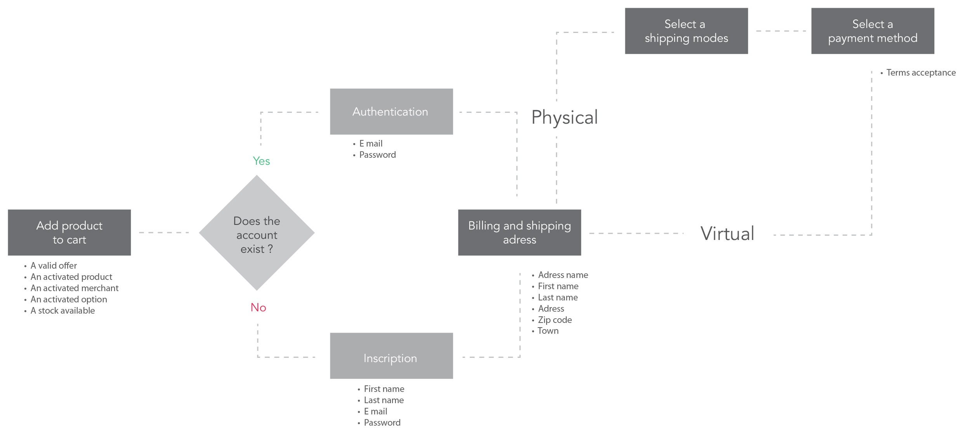

Figure 32: Classic cart workflow

Figure 32 summarizes the steps described in this section (2.4.1 The classic cart) in the form of a schema.

### Hybrid cart

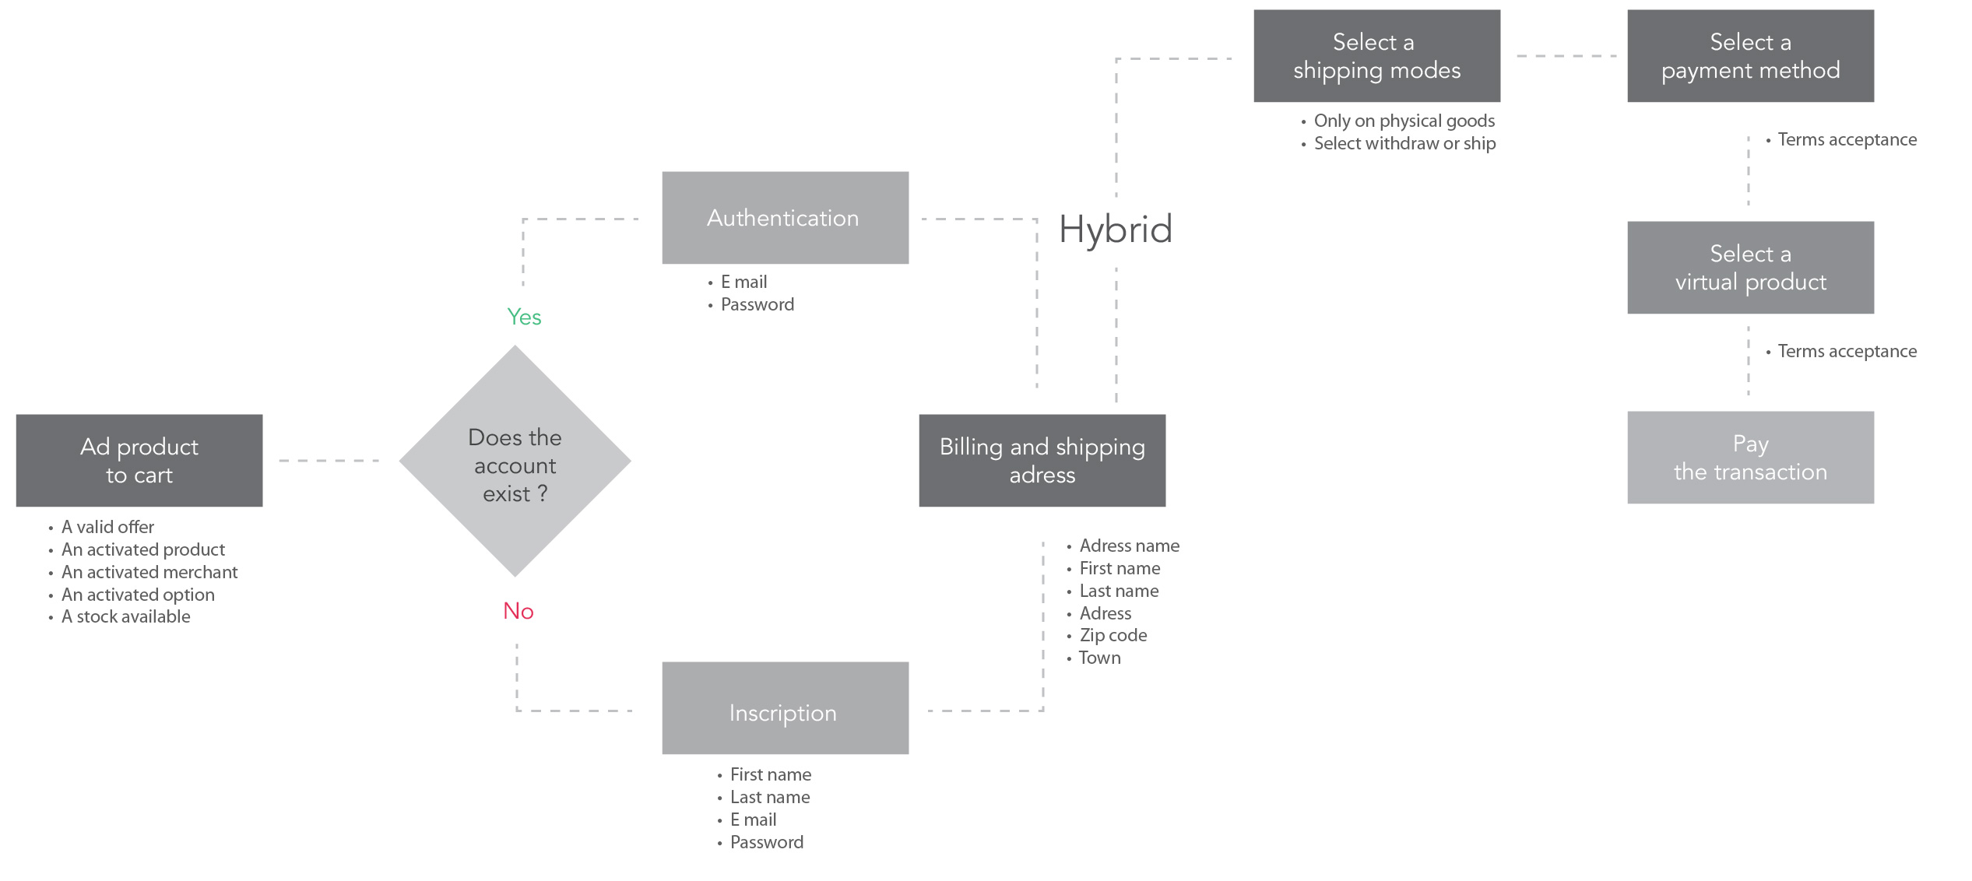

Figure 33: Hybrid cart workflow

As mentioned previously, CCF supports physical and virtual products. Based on the business need, additional virtual products can be put in the cart. But it must be set it at the beginning and decided where virtual products can be added. Figure 33 shows the 2 possible places where a customer can add virtual products.

## Orders management

### A physical product order

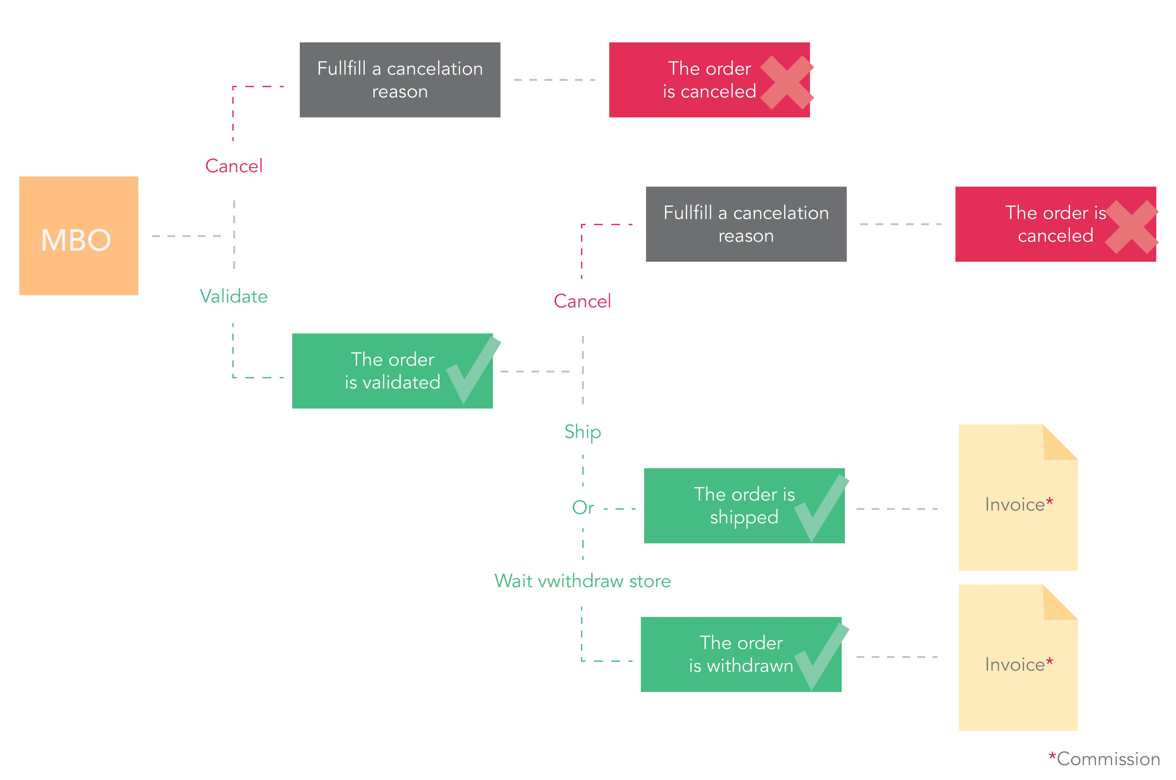

Figure 34a: Physical product order workflow

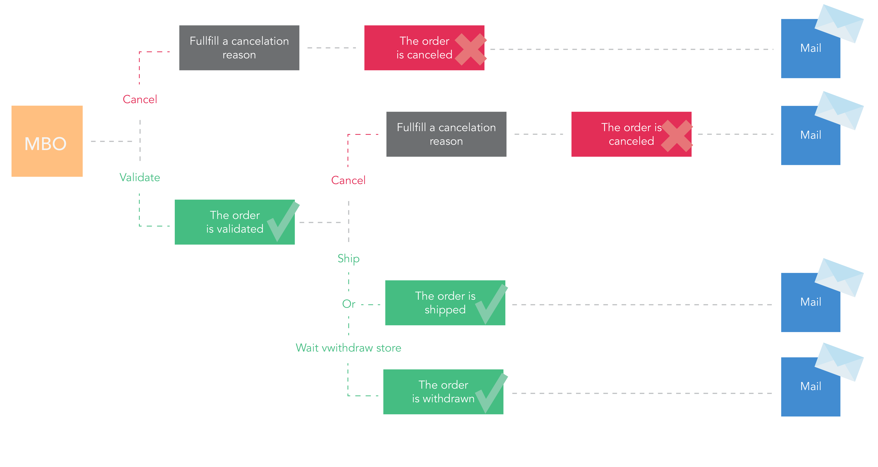 Figure 34b: Physical product order workflow

After a successful payment, a merchant has to manage the orders (fig. 34a & 34b). Administrators that also are merchants need to be very careful while managing orders.

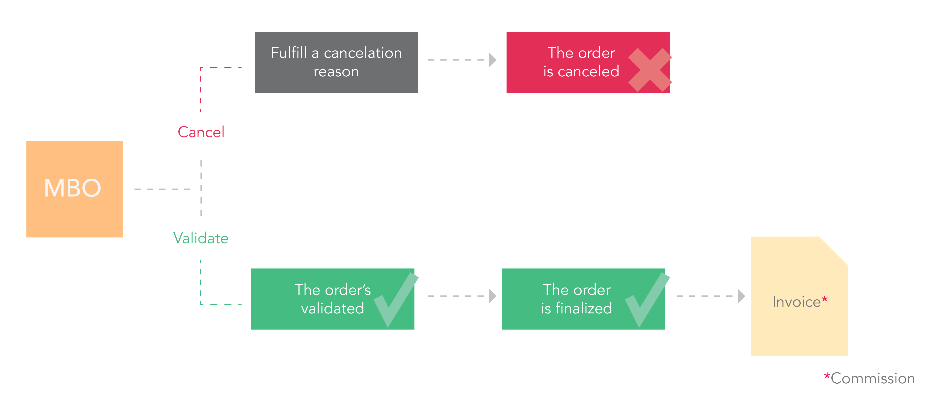

Figure 35: Physical product order notification workflow

A better communication between the merchant and the customer is a key factor for success. For this reason, each step of an order has notifications. After receiving the confirmation email, a merchant can accept or cancel managing an order, based on product stocks and customer needs (fig. 35). Each action will generate an informative email. A merchant or an administrator of the platform can set delivery modes (ie : choosing between shipping the product and proposing to withdraw it in store).

For a cancellation process, our solution requires a cancellation reason to be confirmed. Thanks to this, we can secure cancellation and avoid mistakes. Furthermore, it can provide some marketing data for analysis on merchants.

### A virtual product order

A customer can click on a service or a virtual product and add it to the cart. For this type of product, there are no shipping fees. Based on the solution configuration, the customer can take an appointment or just pay for the product.



Figure 36: Virtual product order workflow

For a flexible use of the platform, change status can be set (ie : the order will automatically finalize or ask for any merchant validation). Moreover, our solution has a commission invoice generator that could also be set. But for a better use, we recommend to set it so it activates after the last status “finalized”, “shipped” or ”withdrawn” (fig. 36). Manually uploading an invoice for the customer is also possible.

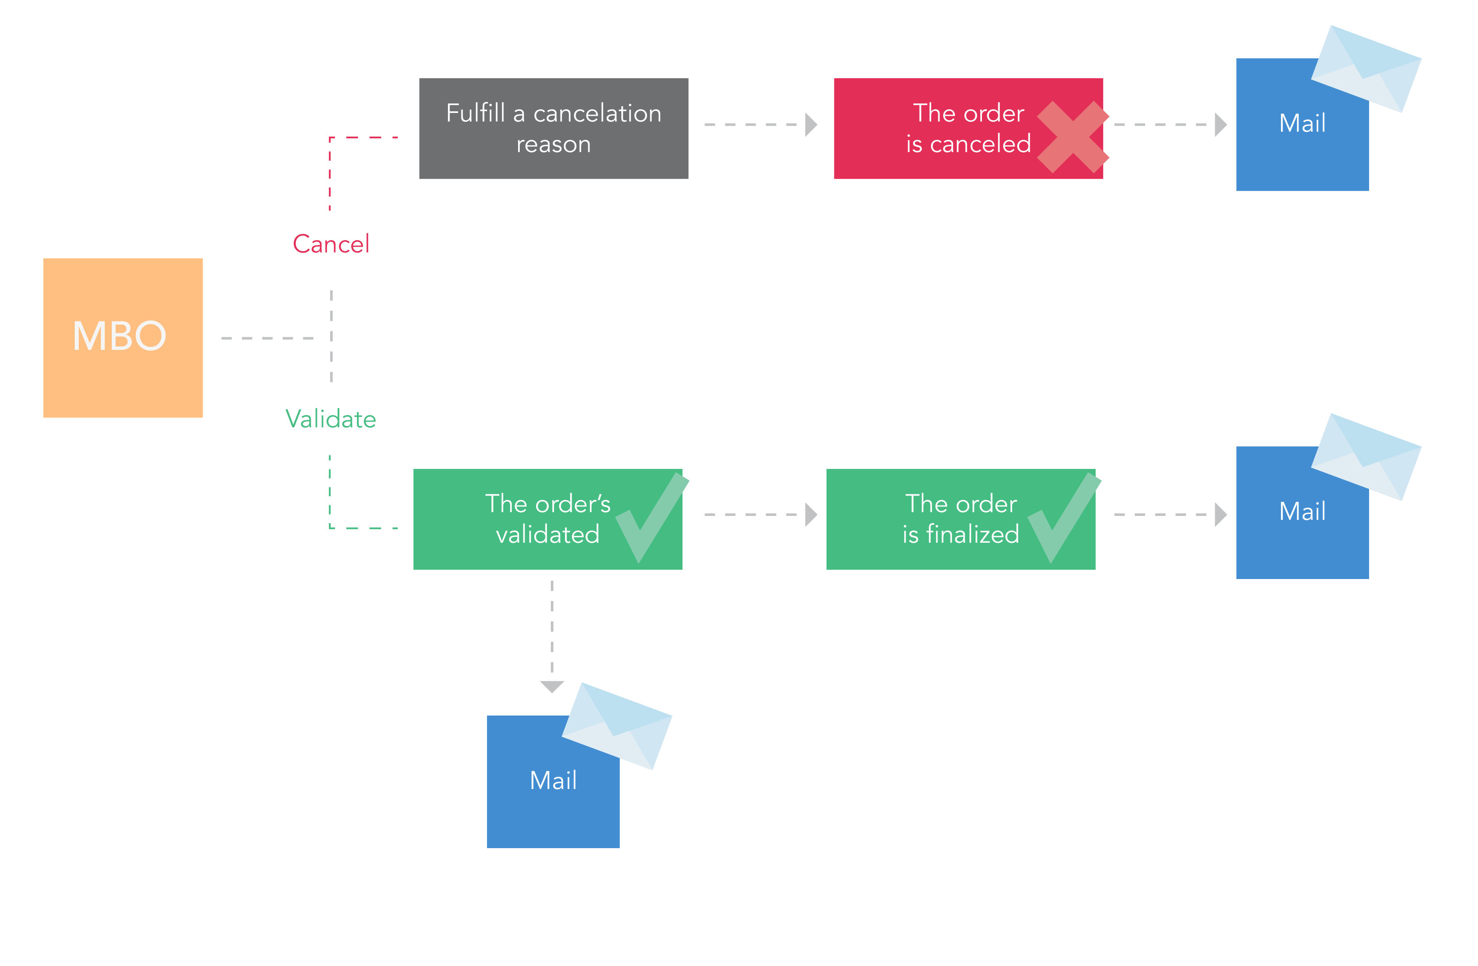

Figure 37: Virtual product order notification workflow

Similar to the physical product workflow, each step of a virtual order provides a notification (fig. 37).

### A hybrid product order

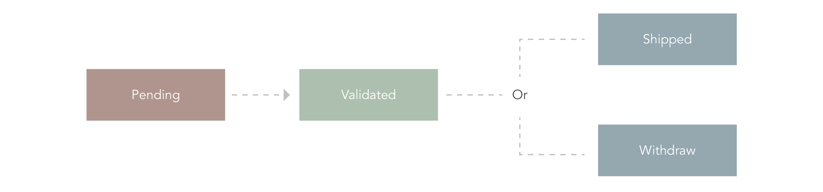



Figure 38: Hybrid product order workflow

There is no major distinctions in managing hybrid orders from managing virtual orders. If all the products are available, validation is possible. Partial validation is not included in our solution for a merchant. If it is needed, we recommend merchants validate the whole order and only then refunding the customer in the MBO.

## Order status workflow

A merchant order gives us data about the processing of the order by the merchant and the customer.



Figure 39: Status workflow for a merchant order on physical good

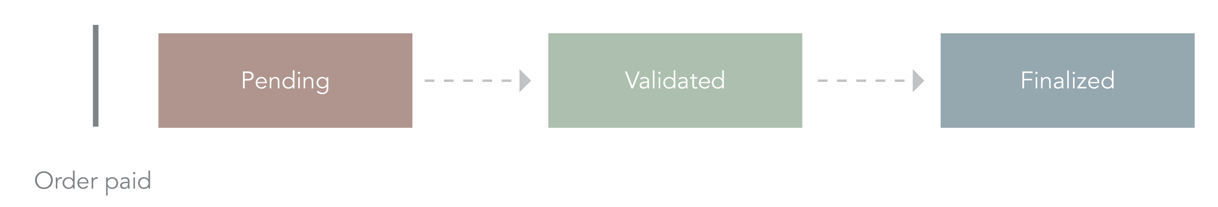

Figure 40: Status workflow for a merchant order on virtual product

For a merchant order, there are 3 steps in status changing :

* Whether the order has been paid or not, it stays on the « Pending » status.
* After the merchant checks product availability and accepts to process the order, the status will be changed to « Validated ».
* Then, depending of the product type, it can be shipped, withdrawn, or finalized (for a virtual product) (fig. 39-40).

For an order file, only two statuses exist “Paid” or “Not paid”. So, it’s easy to see if the transaction has been successful or not.

## How to set the cart

### Rules and settings

A flexible solution is a highly customizable solution. It’s the reason why we created parameters on the cart. If needed, it is possible to add in a cart a product out of stock or restrict to buying products from only one merchant per cart.

Sometimes, there is a need to allow only one product per customer. It is also possible. Another situation is restrict to adding only one physical product per cart. In this case, the product will change to the most recent product added in the cart.

## PSP settings

### Rules

Running an e-business always needs for some reliable PSP. But there are a lot PSP and several behaviours are allowed. Based on the settings, our solution will answer with dedicated statuses and answers for all pre-established scenarios.

Firstly, there is a choice between automatic flow (fig. 41) and payment with a capture (fig. 42-43).

Then, the action can be set, which authorizes the capture in the order workflow.

Lastly, payment in instalments or with 3D secure can also change the workflow.

It is important to define all the PSP before launching a platform.

What would be the results of an unsuccessful payment? It‘s one of the most important questions to think about.



Figure 41: Payment without capture

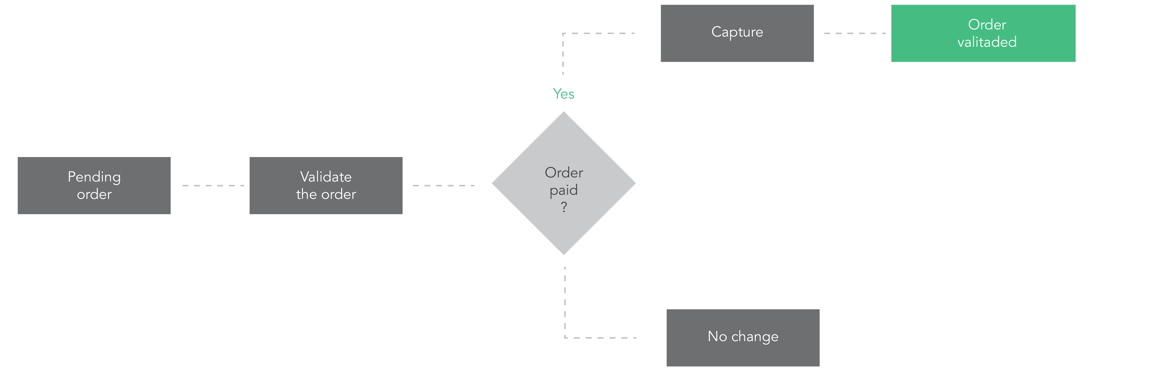

Figure 42: Payment with capture at validation step

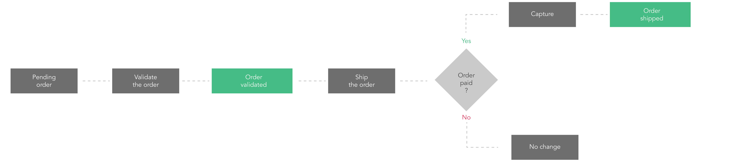

Figure 43: Payment with capture at shipping step

## A secure solution

### Authentication and authorization

Our solution uses the Microsoft .NET Framework and Microsoft Internet Data Services (IIS) as well as ASP.NET to provide Web application security. In order to help protect our ASP.NET solution, we have the two fundamental systems : authentication and authorization.

Our solution works with a login, password, and SSL protocol authentication. For each connection request in the databases, the profile is analysed in order to find if the account is allowed to access them. We place a token in a cookie in order to define and authenticate the customers. This way, all back-office accesses are secured. Furthermore, the solution records transaction IP addresses in the ABO.

### Password and databases

In order to protect personal data, we provide a solution with a minimal password length of 6 characters. In the platform databases, we use an advanced encryption standard to encode the password. Then, we store the secret keys in the app configuration file. After ten failed authentications, the account is blocked.

As most websites, we have a forgotten password process. For a customer, a temporary link is sent by mail to reset the password. This link is available for 6 hours. That time can be changed with a parameter in the ABO.

The merchant password is sent by mail and he can’t reset it without contacting the marketplace operator or admin. In the ABO, each market place administrator can send merchants their passwords or create a new password for a merchant or a customer in the account section.

# A POWERFUL DASHBOARD

## Introduction

As introduced earlier, our solution offers a complete dashboard for each market place operator to supervise and build the platform. The dashboard has all the features needed to administer a multi-vendor platform.

Our solution is a generic SAAS, so all of the available features may not be needed in order to launch the marketplace. There are modules for different kinds of activities.

In this part, we will focus on the main actions done by the market place operator.

## Connection



Figure 44: ABO authentication page

In order to log in as an administrator, it is necessary to begin by entering the ABO URL in a browser. Filling and submitting the administrator ID and password is the next required step in order to gain access to the ABO (fig. 44). Our ABO is secured by the SSL protocol. Be aware that it is not recommended for anyone to communicate their credentials to other people as this makes a huge hole in the security.

## Sales

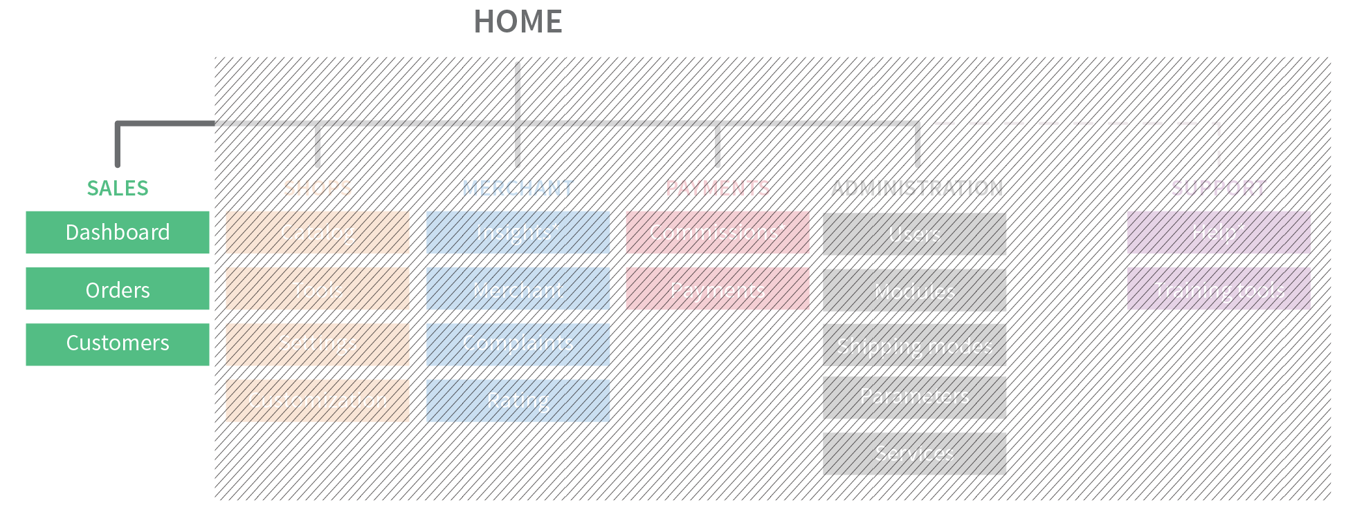

Figure 45: Sales section in ABO

### Dashboard

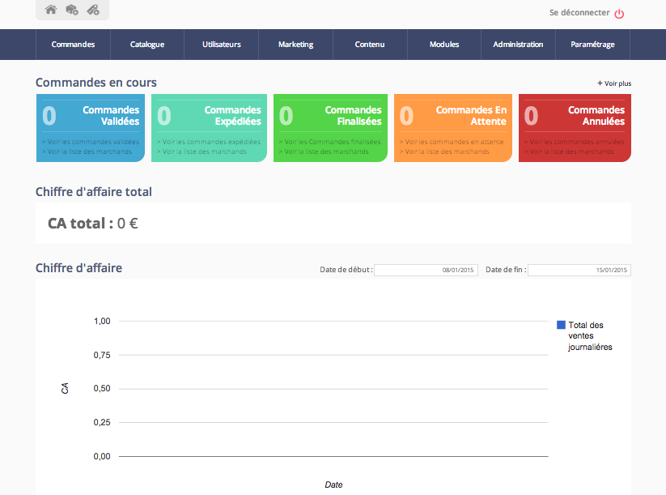

Figure 46: ABO Homepage insights

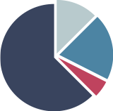The ABO allows several actions that give some insight on sales and activities.

In the Homepage (fig. 46) it is possible to view :

* A number of pending/validated/shipped/cancelled orders
* A chronological view of the turnover achieved on a ten day period histogram
* The last 10 orders
* The 30 most purchased products

Currently, it is not possible to export the summarizing views. But it is possible to export each section separately. We will introduce each section further in.

Orders

* General rules

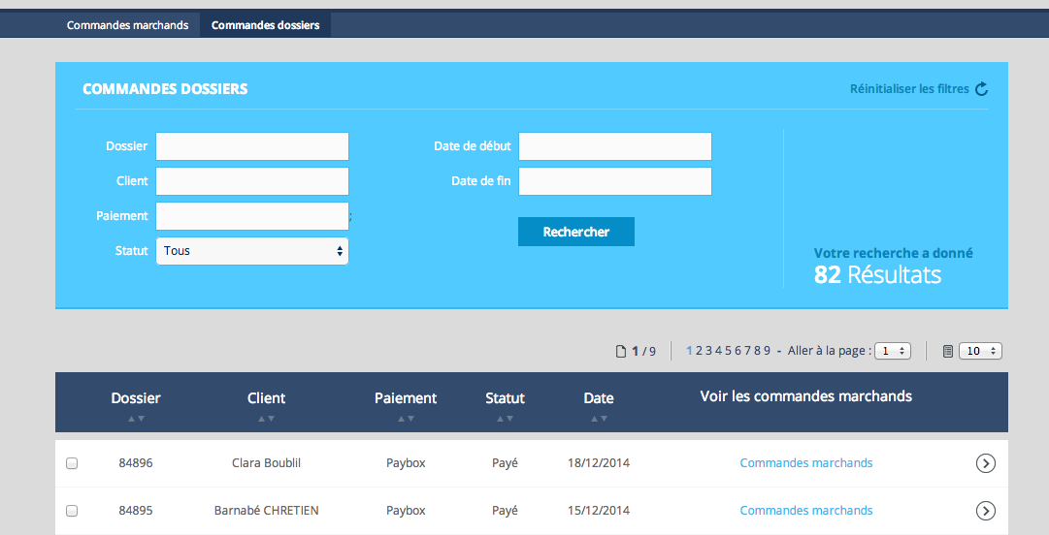

Figure 47: ABO order section

Our dashboard uses two types of orders : merchant orders and order files. Each type of order is sorted and filtered by id, customer, payment method, merchant, and payment status… (fig. 47)

The order file supports the customer cart data. It can contain multiple merchant orders if the customer bought products from multiple merchants. Each type of order has its processes and statuses.

Furthermore, some payment solution providers refuse changing the merchant order status if the order file has not been paid fully. Thus, the order file brings data about the payment and the PSP selected. As an administrator, it is also possible to change manually the order status by clicking on the dedicated button (fig. 48).

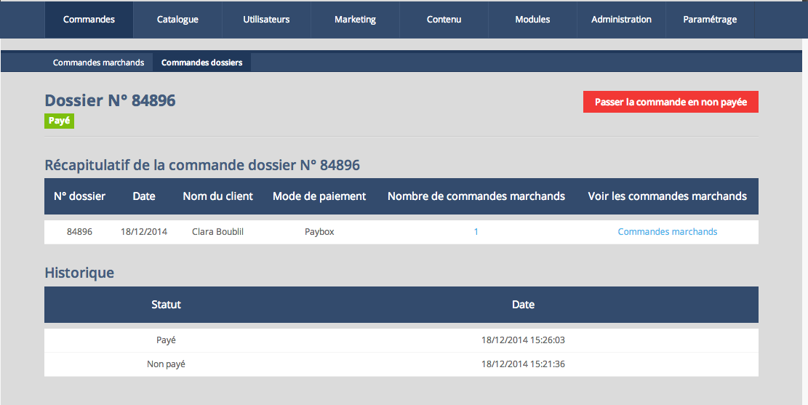

Figure 48: ABO order file detail page

* Exports

**Merchant orders export**

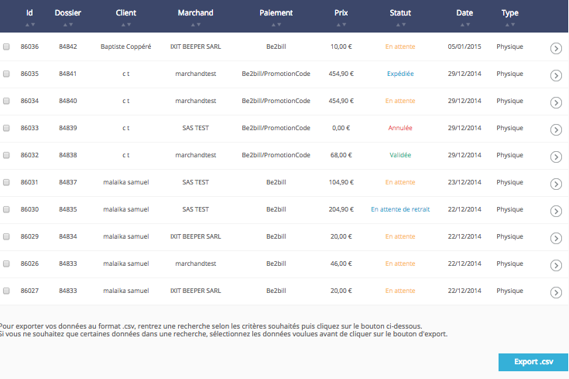

Figure 49: Merchant orders table

In the merchant order area, all data about the latest orders in the platform is summed up in a table (fig. 49). For marketing and accounting reasons, it is possible to export all data, and more, about the orders.

The merchant order CSV export gives :

* The order id
* The purchase date
* The item
* The quantity
* The merchant name
* The price
* The delivery fees
* The customer name
* The customer address
* The customer city
* The customer zip code
* The customer country
* The customer email

**Order file export**

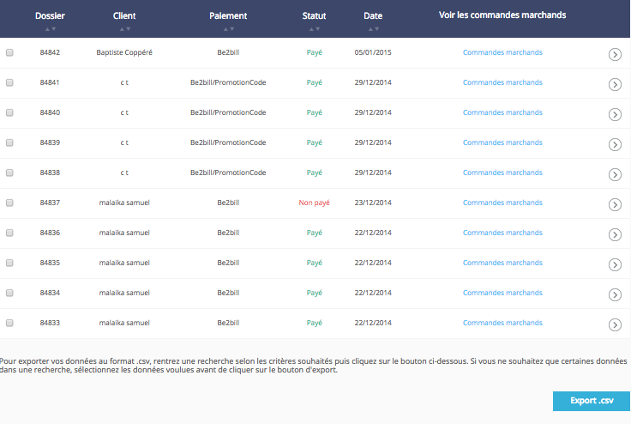

Figure 50: Order files table

Similar to the merchant order area, it is possible to display a summary of all data on order files in a table (fig. 50). All exportable, same as for the merchant order table. The order file CSV export gives many informations. Here is the most important data from it :

* The order file id
* IP address
* Customer name
* Customer address (company name, street, city, postcode, Telephone)
* Customer email
* Billing data
* Payment method
* Last modification date
* Price
* Promotion price
* Promotion code name
* Voucher price
* Price without VAT

* Detail pages

**Merchant order detailed page**

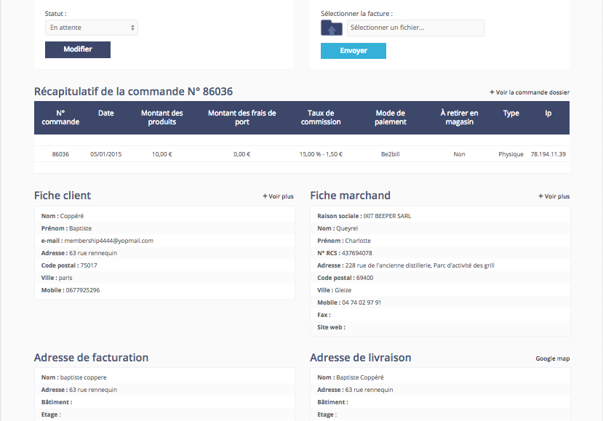

Figure 51: Merchant order detailed page

In our solution, a merchant order page (fig. 51) sums up detailed data about the customer, the order and the merchant of an order :

* Order ID
* Order status
* Commission invoice
* Order invoice
* Purchased date
* Product price
* Shipping fees
* Commission rates
* Payment method
* Product type
* Customer IP address
* Customer data (name, first name, email, address)
* Merchant data (company name, contact name, address, mobile phone, website)
* Billing address
* Shipping address
* Product data (brand, model, declination, description, reference, category, price per unit, quantity, price)
* Status history

**Order file detail page**

The order file detail page (fig. 52) is simple and supports billing contents:

* Order file id
* Order file status (paid or not paid)
* Purchased date
* Customer name
* Payment mode
* Number of merchant order
* Statuses history per date

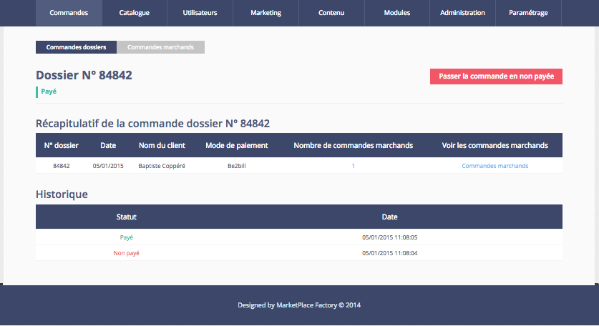

Figure 52: Order file detail page

### Customers

* Managing customers

Managing customers is one of the most important jobs of a marketplace administrator. Our secure solution highlights customer data to also help manage orders. Furthermore, it is possible to make a mistake during account creation. So it’s important to have another way of changing customer data such as billing address, shipping method and more…

Customer section (fig. 53) allows to :

* Sort and filter customers according to different data and purchase statistics
* Change customer data
* Export customer data

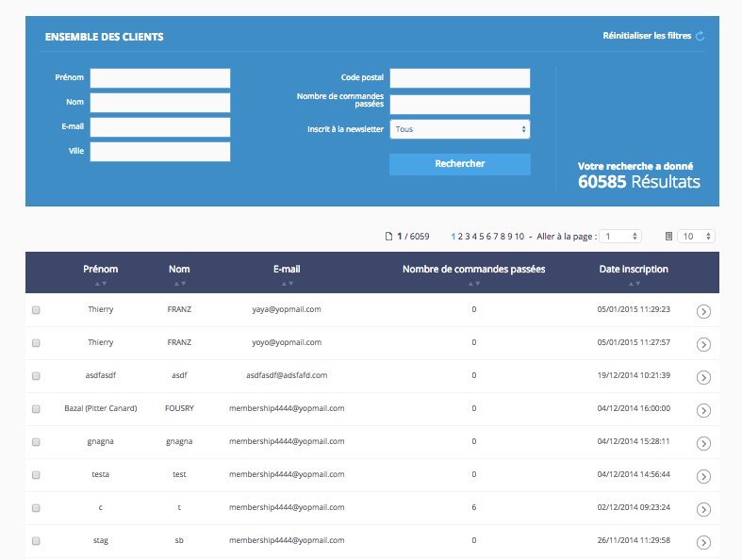

Figure 53: Customer section page

Customer detailed page

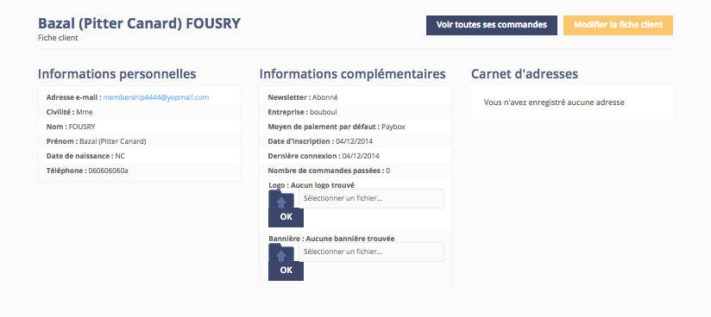

Figure 54: Customer detail page

Our ambition is to promote a complete customer experience. Our customer detail page has 3 sections that lists all the data about a customer : personal data, complementary data and address (fig. 54).

In the personal data, we list the essential data about the customer account in the platform :

* Email (can’t be removed)
* Title (M or Mrs)
* Last name (required)
* First name (required)
* Date of birth
* Phone number

Complementary data lists:

* Newsletter subscription status
* Company name
* Preferred payment method
* Sign in date
* Last connection date
* Number of order purchased
* Logo
* Banner

As a customer, it is possible to add a logo and a banner if, for example, there is a social dimension in the marketplace to promote community and people who make whishlists.

Finally, the address section contains all the addresses added by the customer. It is possible that there is a need to complete a customer detail page. An administrator can add additional data such as:

* Phone number
* Mobile phone number
* Description
* Address

But the email address can’t be removed because it’s the customer login. Text area have maximum lengths that needs to be respected.

* Customers export

To improve customer relationship management, an administrator can export data about customers registered on the platform. Most of the data is relevant to establishing an analysis on the marketplace uses. The data contains :

* First name
* Last name
* Date of birth
* Telephone
* Newsletter subscription
* Company name
* Street
* Address
* Postcode
* City
* Gender
* Description
* Number of orders
* Registration date
* Customer invoice

Our software doesn’t create invoices between merchants and customers. It’s not our goal. But we understand that some merchants want to forward online invoices to their customer. In order to answer that demand, in the ABO it is possible to upload a bill for a merchant order. If there is a need to change an invoice, it can be done simply by uploading another file.

## Shops

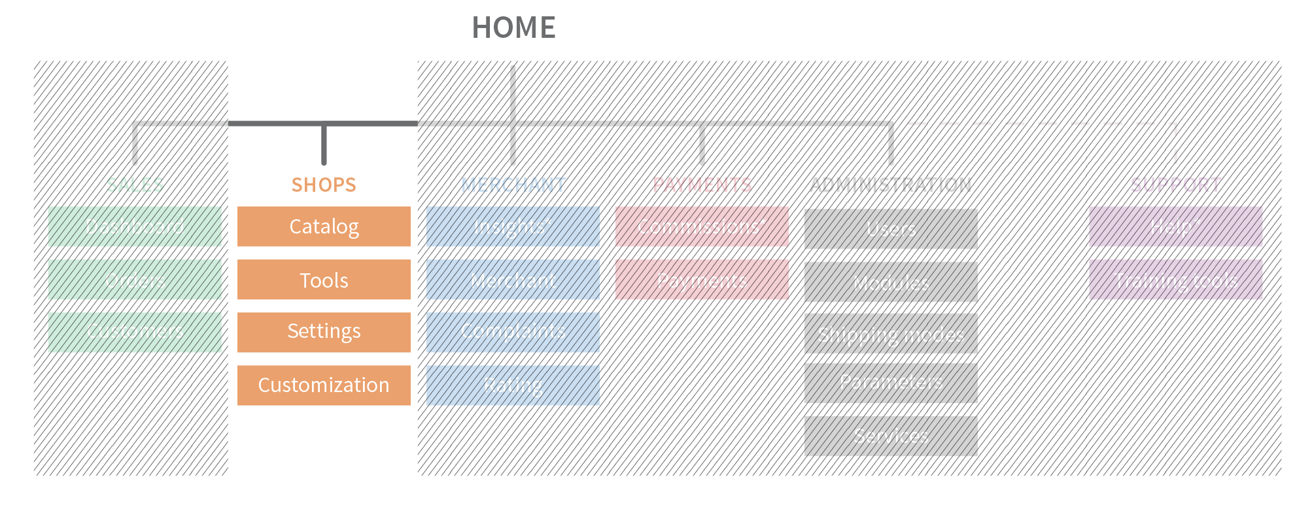

Figure 55: Shop section in ABO

### Catalog

* Products

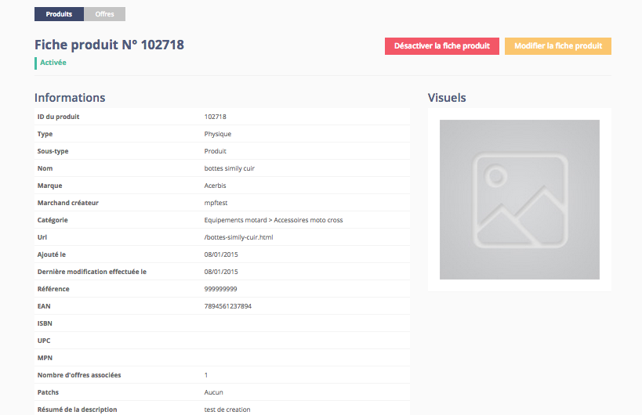

Figure 56: Manage product page

The product ABO section (fig. 56) allows managing product sheets :

* Sorting and filtering products according to related data
* Creating products
* Modifying products
* Activating/deactivating products

As we explained before, products can be physical or virtual with specific rules if needed. It is also possible to export a products catalogue which will contain :

* Id product
* Product Model
* Manufacturer name
* Category
* Merchant ID
* Merchant name
* Article URL
* Manufacture Id
* Product price
* EAN

Some marketplace may need a marketing strategy focused on sharing product sheets on social networks. So, we developed a specific export on product catalogue to help build a strategy. Facebook, Google or any price comparison solution can develop or improve sales. This way, we ensure easy exporting of product catalogue data.

A flexible product management is our ambition. In this regard, we offer a product page with several features. How to improve advertising of a product? Firstly, ensure that the basic data about the product has been given :

* Name
* Brand
* Category
* URL
* Reference
* EAN

It is possible to change the data of the product as needed, but common practice is : shorter is better. Furthermore using the same URL for product variations should be avoided. After all, people want to reach faster the product they are looking for. To improve the product’s SEO, meta-descriptions can be added. For a public description, our solution uses the description by default.

After, it is possible to use several types of description to promote a product sheet. Our solution provides a complete product sheet :

* Product ID (automatically attributed and unique)
* Product type (virtual or physical)
* Product picture (jpeg, png, gif, bmp).
* Product sub-type (product, gift card, lesson)
* Name (max length 256 characters)
* Brand (dropdown list)
* Merchant (dropdown list)
* Category (dropdown list)
* Reference (max length 64)
* EAN (barcode: max length 13 digits)
* ISBN or ISBN-13: international Standard Book Number (max length 13 digits)
* UPC or Universal Product Code (max length 12 digits)
* MPN or Manufacturer Part Number (max length 13 digits)
* Meta-Keywords (between 6 and 20 meta keywords, so 255 characters allowed)
* Meta – description (140 max length characters)
* Short description (256 max length characters)
* Description
* Description 2 – extra description information, not mandatory
* Available patch
* Special description tittle (max length 64 characters)
* Special description (max length 2048 characters)
* Specific model

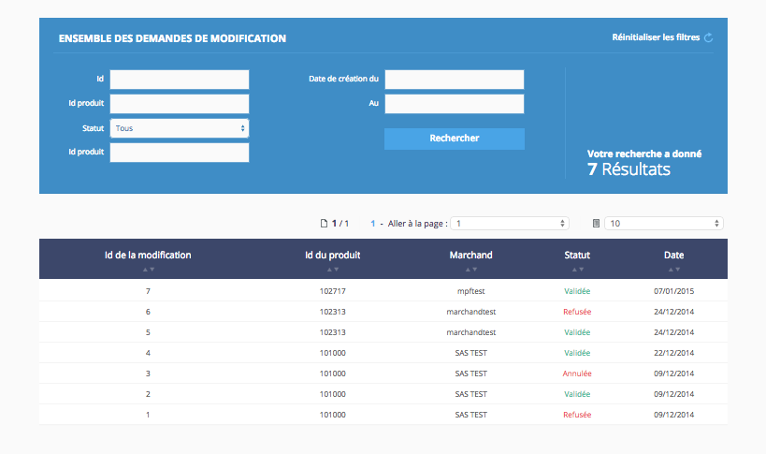

Figure 57: Product modification section in ABO

Most of the time, product modification needs an administrator approval. To solve this problem, we offer a modification management system where administrators can validate or invalidate modification requests on a product sheet (fig. 57). For each modification, there is a modification sheet opened, and closed after the decision. Before an administrator decision, the modification can’t be applied on the product sheet.

* Offers management

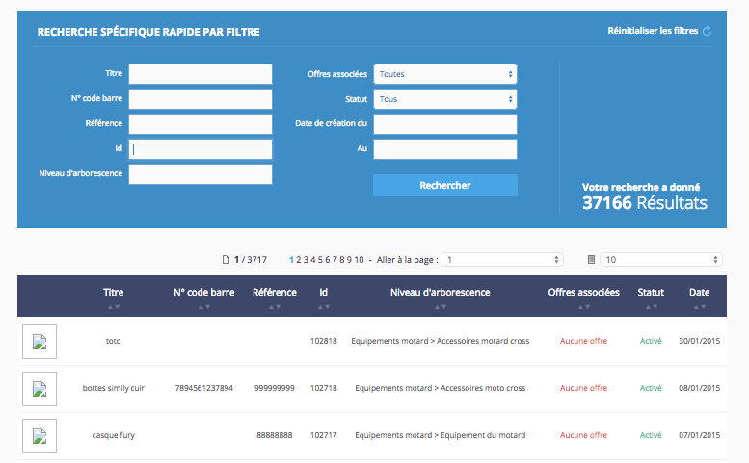As we explained earlier, each product needs an offer in our platform. And this offer can be created in the ABO. Let’s focus a little bit on all the characteristics available in our solution to ensure the best offer on a product.

Figure 58: Offer management section in ABO

To create an offer, there is a shortcut available in ABO header or the “create an offer” button. This action brings up the product choice page (fig. 58). This page contains some filters and a table to help find and select the product concerned.

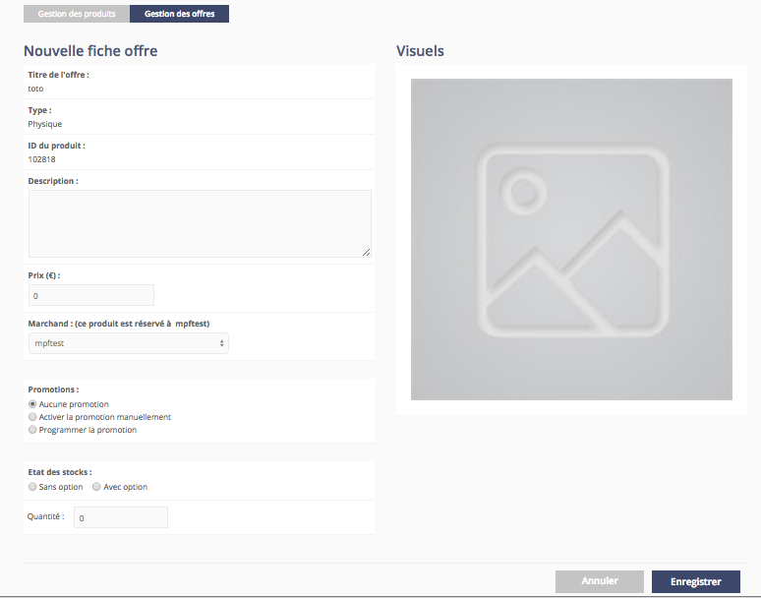

Figure 59: Offer creation page

Then, to select a product for the offer, a simple click on the line containing the product open the add offer page (fig. 59).

Some data as offer title, product type, product id, and product picture can’t be removed in this area. To complete the offer, the following attributes can be added :

* Description (text area with max character length)
* Price (in a wanted currency). The solution can’t manage multi-currencies. Furthermore, the platform will refuse price where decimal separator is a dot.
* Merchant (in a dropdown list). By default, the product is booked for the merchant who is creating it. But an administrator can change ownership of a product to another merchant.
* Promotions
* Stock available

Promotions can be activated on offers. It is possible to plan a promotion with a date picker or launch it manually. Promotions can be a percentage or a fixed value. To manage quantity and stock per variation, a stock with “option” must be chosen (fig. 60).

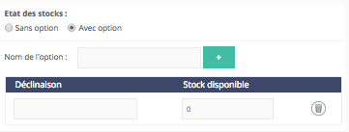

Figure 60: Stock management section in offer creation

The option can be:

* A size
* A shoe size
* A range in cm
* …

Short option names are preferred to long ones. Then, the quantity per variation is needed. The “+” button allows to add more quantities per variation. It should be noted than an offer can’t have more than one option. The trash icon allows deleting of variations and deleting all variations in an option deletes the option itself. When everything is done, clicking on the submit button will give access to the next step.

The next step is adding delivery data and fees on the offer (fig. 61).

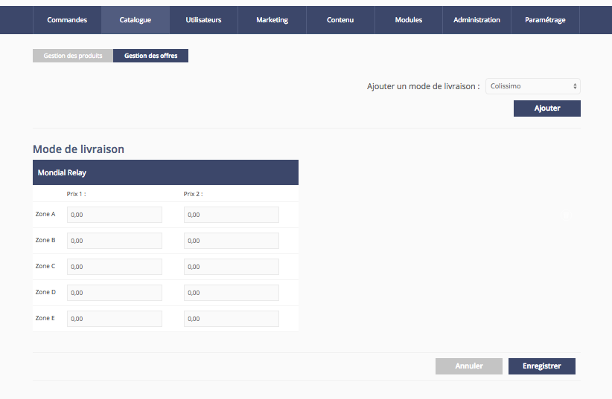

Figure 61: How to choose a delivery mode

To complete the offer setup, shipping information must be added. An offer can support several shipping modes and prices per zone. Sometimes, some merchants want to offer an express shipping method more expensive than the others. An offer can have many prices and shipping logistics.

For a merchant, the solution always offers two prices. One called “Price one” which represents the price for one parcel and product. And “Price two” is the price per additional product in the parcel. For each additional product, you have to pay the “Price two”.

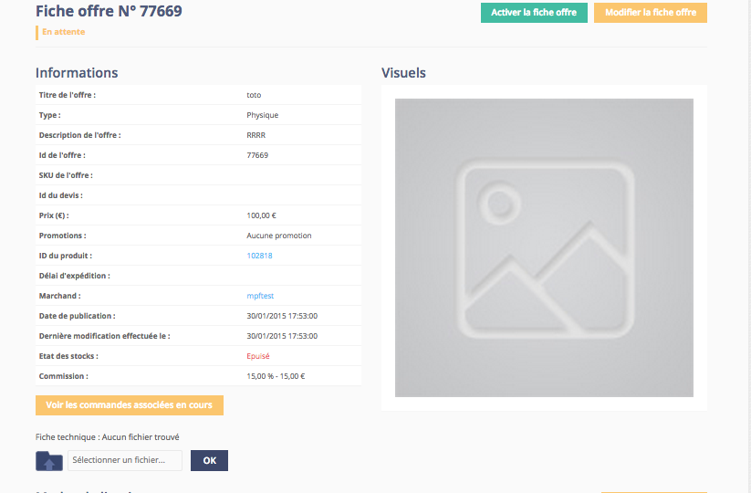

Figure 62: Offer detailed page

Our solution also allows editing offers. In a need to stay generic for greater coverage, many attributes are available to describe an offer:

* Offer title (unchangeable)
* Offer description
* Offer ID (automatically attributed)
* Price
* Promotions
* Shipping date
* Product ID (unchangeable)
* Merchant name (unchangeable)
* Publication date (automatically attributed)
* Last modification date (automatically attributed)
* Stock available
* Commission (unchangeable and defined by the merchant settings)

Technical data sheet is where specific elements for the offer, such as pictures or operating instructions, can be uploaded.

It is possible to sort, filter, and export offers by:

* Id
* Status
* Product name
* Product id
* Merchant name
* Merchant ID
* Price
* Price less promo
* Promo price
* Promo date begin
* Promo date end
* Quantity stocks

Also, displayed in the footer is a button, which can apply a specific promotion per percentage to all selected offers (fig. 63). If it was mistakenly activated on an offer, a 0 per cent promotion will give access to the last basic prices. The range of possible promotions with this button goes from 0 to 99%. A 100% will not have any incidences on an offer’s price. To be sure about any change, a popup will ask for confirmation on the current selection. Finally, offers can’t be deleted in the solution. They can only be deactivated or activated.

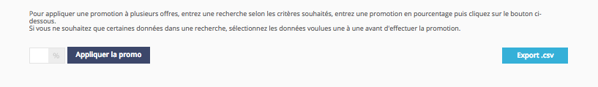

Figure 63: Automatic promotion button in ABO

* Product categories management

In order to improve navigation on the platform, creating categories to classify product catalogs is necessary.

On the one hand, a category name must be explicit to everyone. Category names should have a simple definition to people who use the platform. Before launching the platform, it is important to take time to think about product categories.

On the other hand, categories can be managed in the category page in the ABO (fig. 64). An administrator can use the website and create/edit/remove categories as needed. Much in the same way for everything else, our solution doesn’t allow deleting product categories or subcategories. In case of an error, it is possible to deactivate or rename a category.

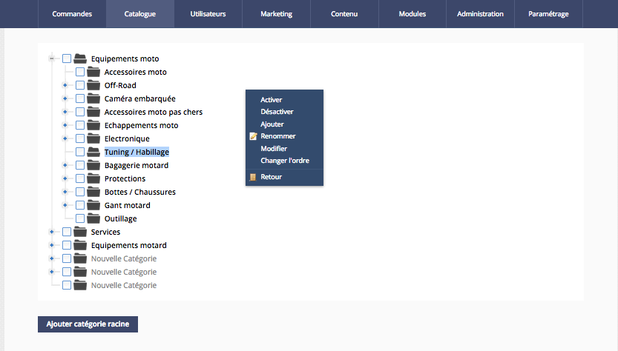

Figure 64: Manage categories

* Unknown categories management

When importing an existing product catalog, it is possible to import specific product categories. For this case we added a feature in the solution that helps matching the unknown categories and existing categories (fig. 65).

It is simple :

* An unknown category from the dropdown list needs to be selected. In this section, all products which are not matched to a category are listed.
* Then a category from the platform needs to be selected.

This feature exists to ease product management after an import. It may not be needed or used.

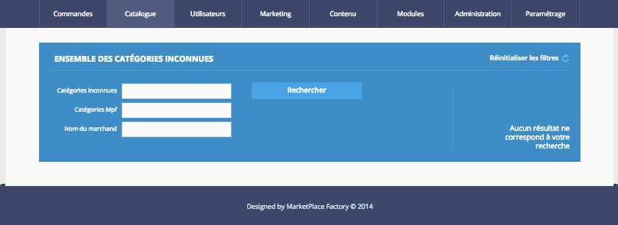

Figure 65: Manage unknown categories

* Brands management

**Creating a brand page**

Most of e-business solution’s aim is to create brand-dedicated pages. In order to promote products on the platform, our solution ensures a powerful brand page (fig. 66).

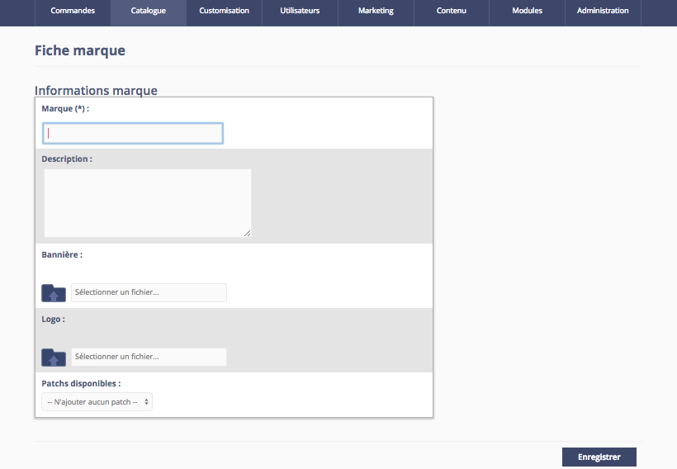

Figure 66: Brand creation page in ABO

Our brand pages contain the following attributes :

* Brand name (max length 40 characters)
* Description (max length 255 characters)
* Banner (A picture, only png)
* Logo
* Available patches

**Editing a brand page**

It is possible to display brand pages on the platform. Exporting products or navigating between products per brand is a feature in the solution. Each export gives :

* Product ID
* Product model
* Manufacturer name
* Category
* Merchant ID
* Merchant name
* Article URL
* Manufacturer ID
* Product price
* Ean
* Quotation offer management

**Creating a quotation offer**

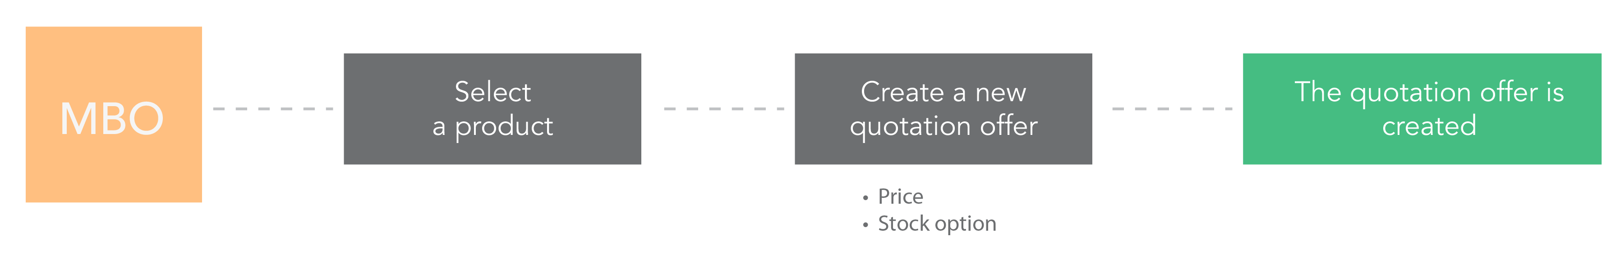

Figure 67: Quotation offer creation workflow

The process of creating a quotation offer is exactly the same as for the « normal » offer, but the product has to be virtual. A quotation offer can’t be created in the ABO, only in the MBO. Contrary to a normal offer, quantity and price are not needed on the quotation offer. Localization, appointment date, and delivery time are optional.

**Quotation offer process**

When a customer selects, in the front office, the product with a quotation offer, instead of a button “buy” there will be a button “ask for a quotation”.

If the customer is logged, a page in the back office will be loaded. On this page, the customer will be able to write the needs and submit them.

Once the quotation process has been created, both sides (merchant and customer) will be able to exchange messages. Each message will be notified by mail.

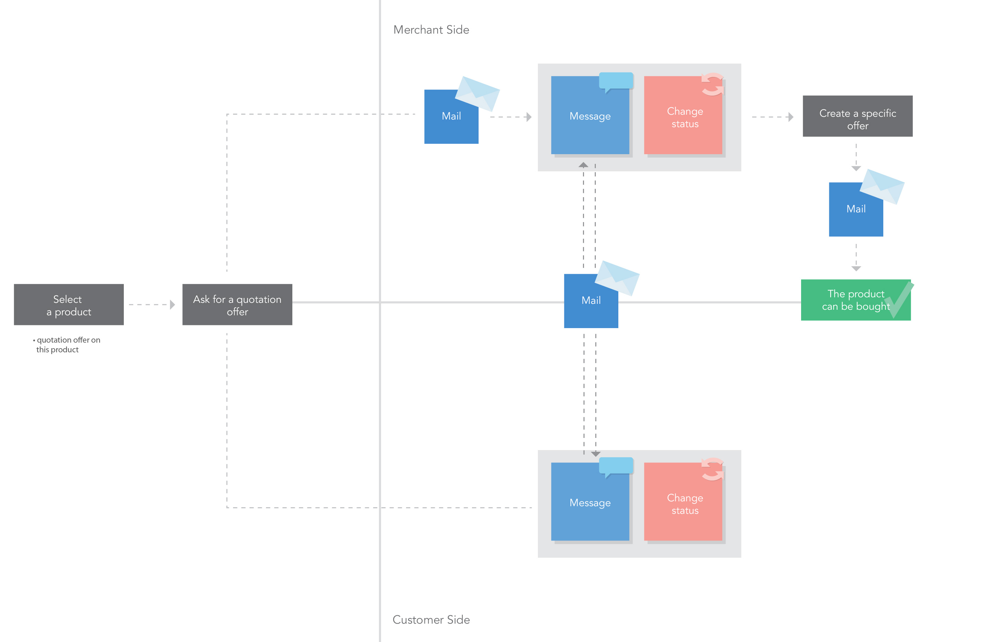

Figure 68: Quotation offer workflow

For a better understanding, let’s introduce the quotation process step by step (fig. 68) :

1. The customer creates a quotation transaction. The status of the quotation is “opened”.
2. The merchant can submit a quotation document (xls, xlsx, doc, docx, pdf,). If there is no file to share with the customer, the merchant can write a quotation in the field provided for this purpose, in the detail of the quotation transaction page, in the MBO. A mail is then sent to the customer and the status becomes “Quotation submitted”.
3. The customer can accept or refuse the quotation. If rejected, the merchant can send a new quotation. If accepted, the status becomes “accepted”.
4. When the quotation is “accepted” the merchant can create an offer that will be visible only to the customer. The status becomes “Offer created”.
5. Once the quotation is paid for by the customer (classical buying process) the status becomes “solved”;

- The process can be canceled at any moment from both sides.

- To avoid the quotation process to last too long there is a time limit, customizable by administrators in the ABO.

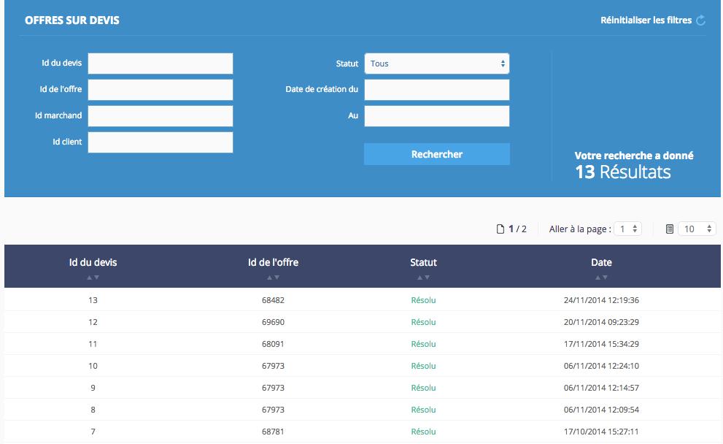

Figure 69: Quotation offers listing

ABO also provides a list of all quotations on an offer (fig. 69) created between a merchant and a customer in order to get a history of each transaction (fig. 70).

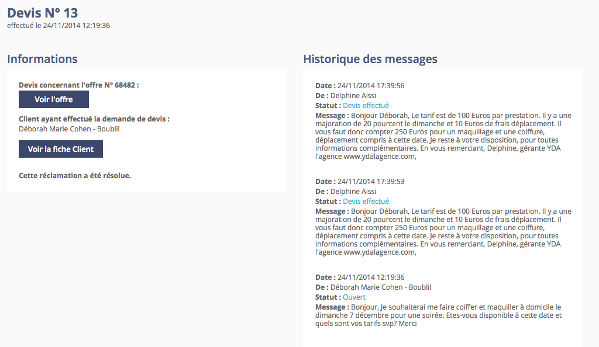

Figure 70: Quotation offer history example

Tools

* Promotion codes

Coming soon …

* Private sales

Coming soon…

* Newsletter

Customers can subscribe to the marketplace newsletter to stay connected with merchants or marketplace operators.

For group mailing we offer exporting all customers, registered or not in the newsletters subscribers list. In the export, the following attributes can be found :

* Email
* Email registration status
* Telephone
* Telephone registration status
* Token ID
* Cross-selling

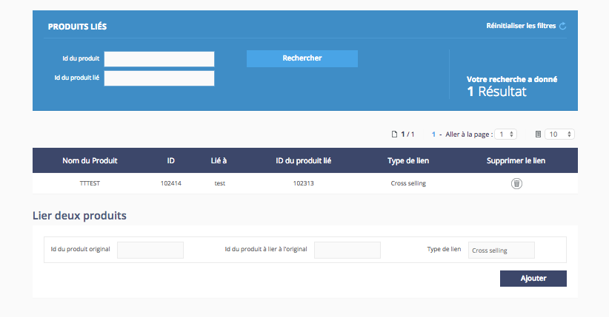

Figure 71: Cross-selling interface

In the ABO, it is possible to quickly create cross selling for a product. For this, only the products ID is needed. Then, for each cross-selling product, a link is created (fig. 71).

* Product rating

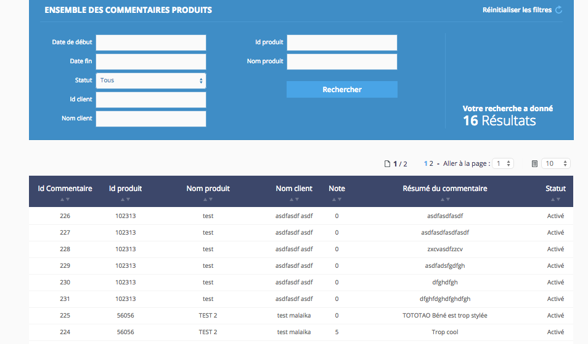

Figure 72: Product rating section in ABO

### Settings

* URL rewrite

URL rewriting is available in the solution. Each time a new URL is created, it can be found in the dedicated section in the ABO. We’ll introduce later how to massively create URLs with a parameter. The most important thing to know in this section is that there is an access to all customized URLs created in the marketplace. If there is a need to reduce or edit an existing URL, it can be done in the product sheet easily by changing the corresponding field and saving the changes, if it concerns a product.

It is possible to filter and sort all existing rewritten URLs in the marketplace (fig. 73).

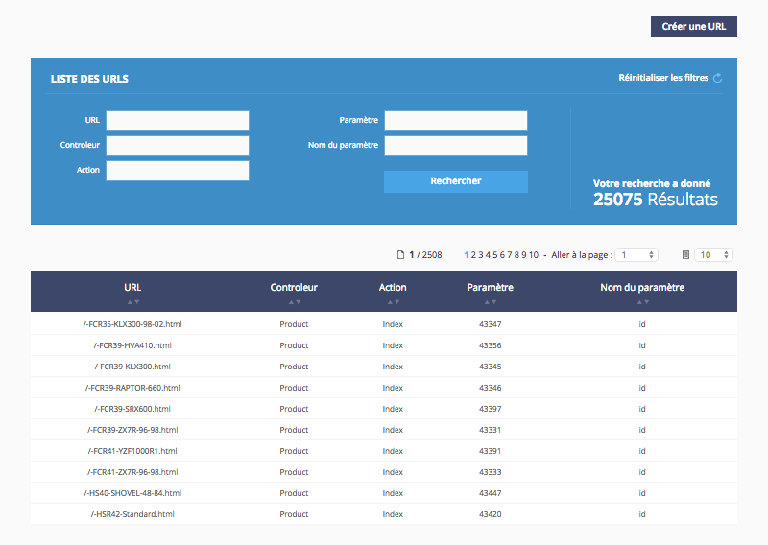

Figure 73: URL rewritten listing

But if there is a need to create a customized URL based on the marketplace structure, the instructions below explain how it’s done.

First, on the page needing customization, the existing URL should follow this model from the figure 74.

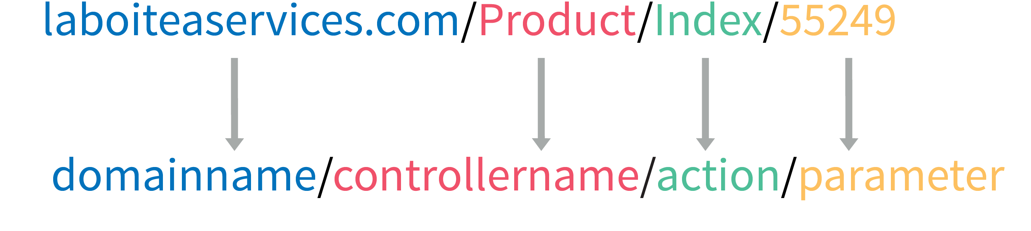

Figure 74: URL structure example

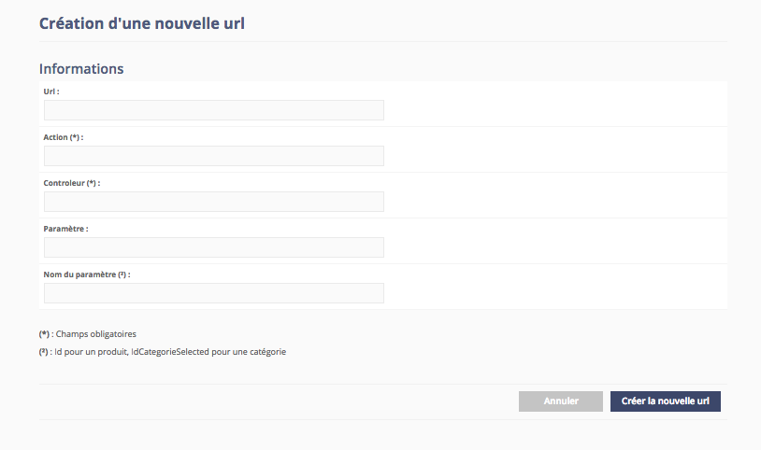

Figure 75: Create a new URL page

Creating new customized URLs is easy when the URL structure and the way it work have been understood.

To begin, filling the new URL the following attributes are needed :

* Action (required)
* Controller (required)
* Parameter (required)
* Parameter name (optional)
* Static pages

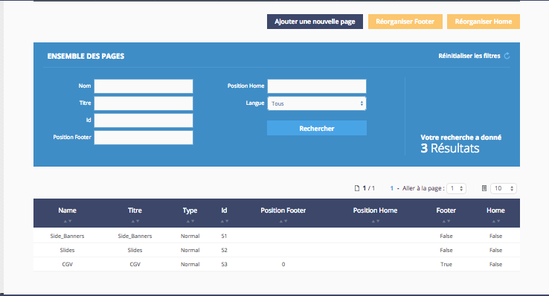

Figure 76 : Static pages management

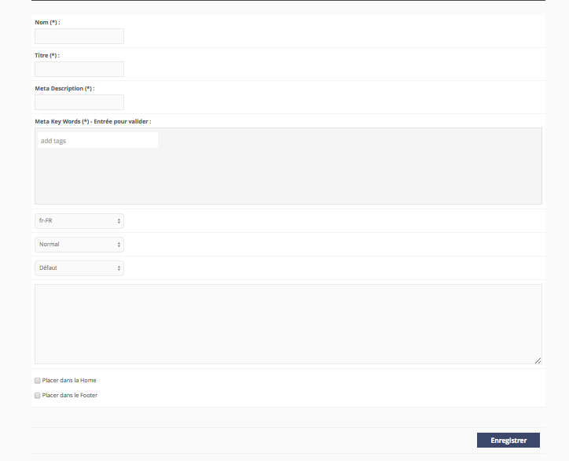

Figure 77 : Static page creation

This page allows for management of static pages in the platform. Headers and footers can be added to pages. Meta-datas andkeywords can also be added in order to improve EOS (page ranking).

* Manageable pages

Coming soon

* Product selection

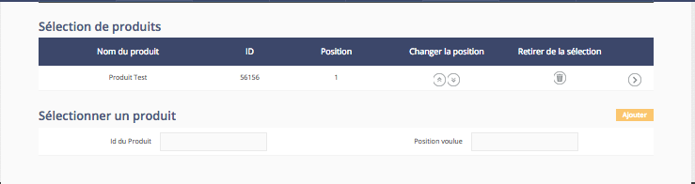

Figure 78 : Product selection creation page in ABO

Coming soon

* Merchant selection

Coming soon

Customization

* EAV management

**EAV attributes**

Coming soon

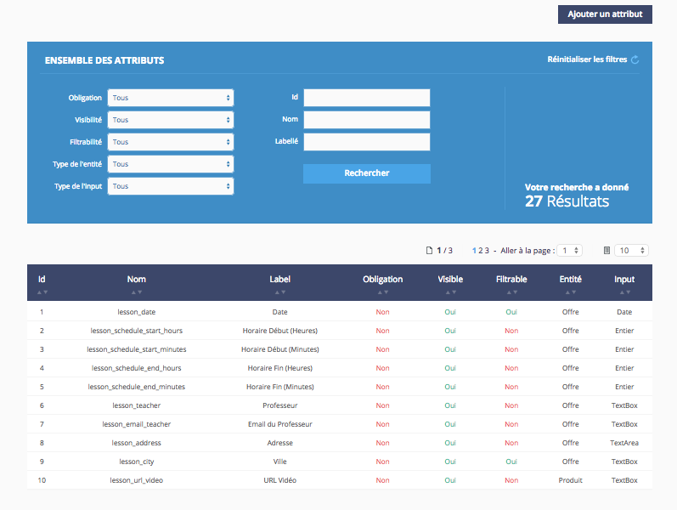

Figure 79 : EAV list in ABO

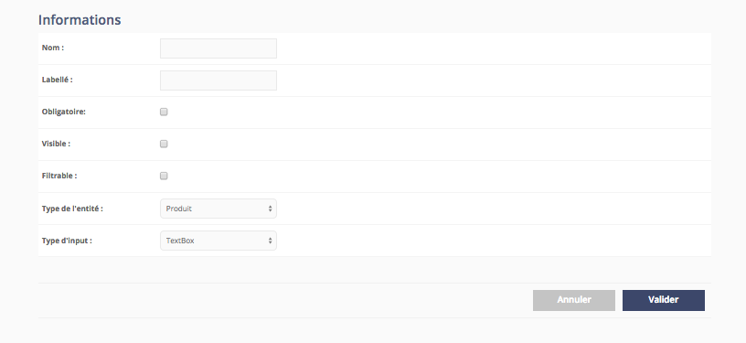

Figure 80 : EAV creation page in ABO

**EAV models**

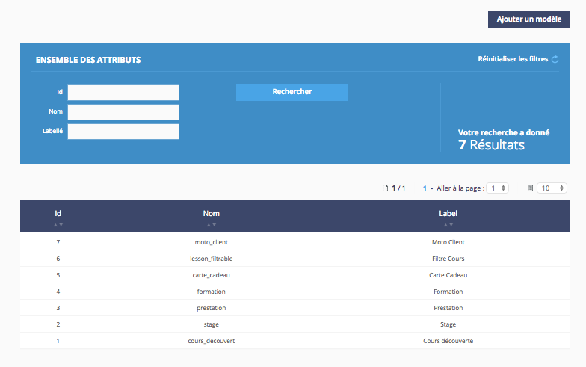

Figure 81 : EAV model list in ABO

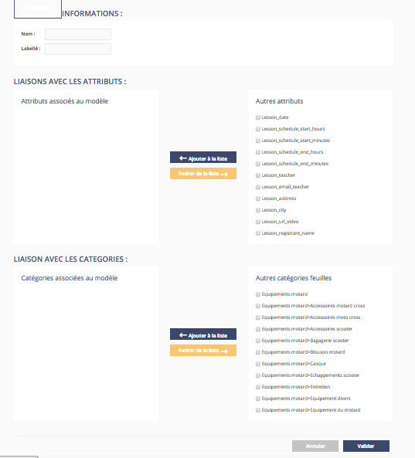

Figure 82

* Patches

Coming soon …

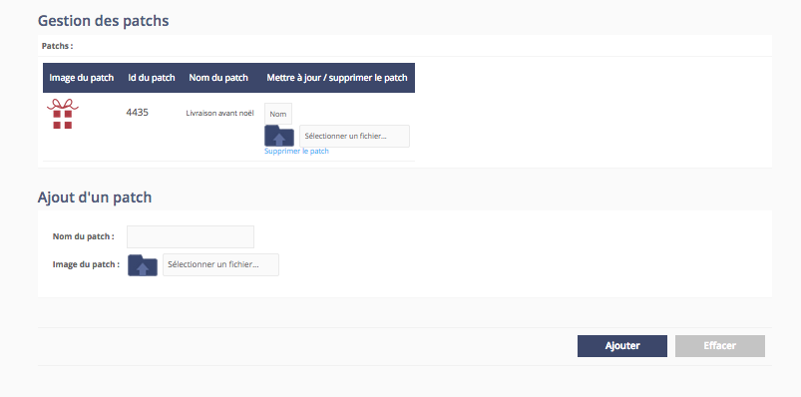

Figure 83 : Patch management section in ABO

## Merchants

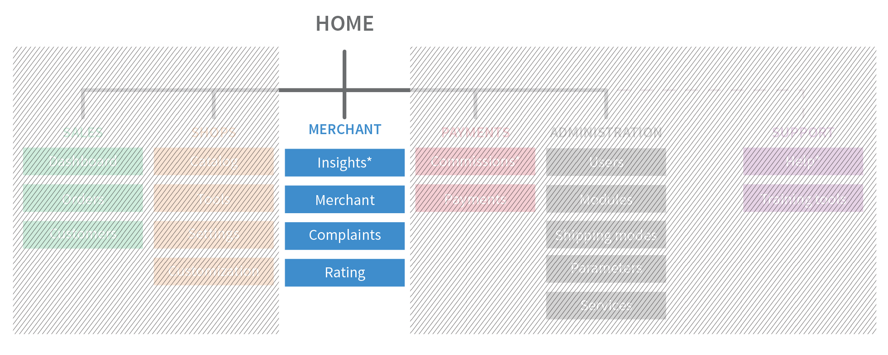

Figure 84 : Merchant section in ABO architecture

### Insights

Comming soon…

Merchant management

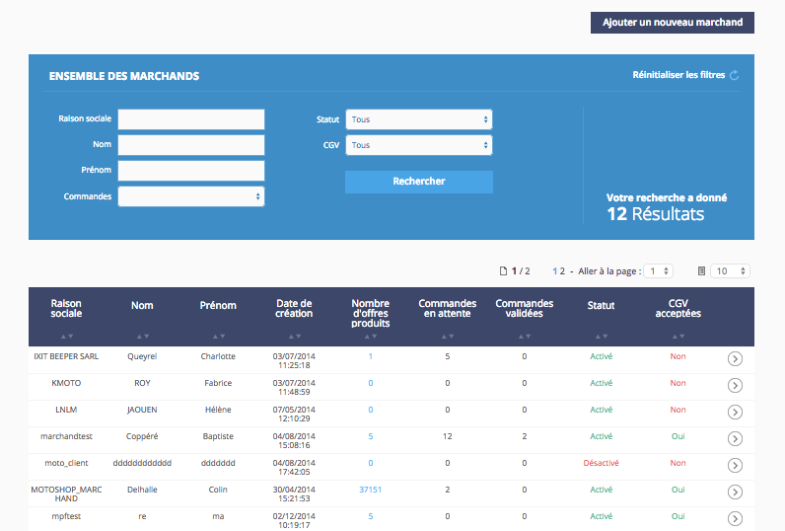

Figure 85 : Merchant dedicated section

Merchant management is an angular stone of our solution.

The merchant area in the ABO (fig. 85) allows sorting and exporting data about merchants and following their activity and sales in the marketplace. The export file contains the following attributes :

* Company name
* First name
* Last name
* Email
* Telephone
* Fax
* Postcode
* City
* Siret
* Status activated
* Account approved

It is possible to edit merchant data there. Each merchant has a merchant detailed page, which sums up the merchant’s data and statistics. If the merchant has a shop in the marketplace, the merchant detailed page will also list data about it.

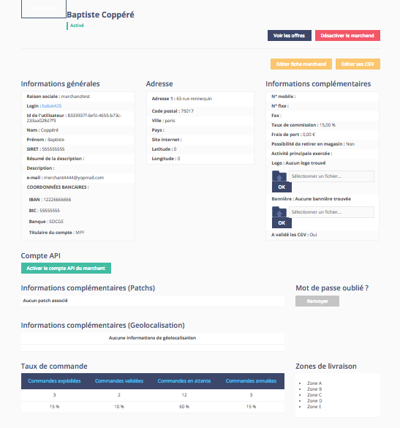

Figure 86: Merchant detail page

The merchant detail page (fig. 86) has a lot of data about merchant activity in the platform. In the general data area, there is data about the merchant and the merchant’s shop:

* Company name (required)
* Login (can’t be removed)
* Merchant ID (automatically attributed and can’t be removed)
* First name (required)
* Last name (required)
* Email
* Company SIRET (14 characters maximum)
* Short description
* Description
* SEPA data
* IBAN (34 characters maximum)
* BIC (12 characters maximum)
* Bank name (50 characters maximum)
* Account holder name (50 characters maximum)
* Mobile phone number
* Phone number
* Commission rates
* Shipping fees
* Select drop to store
* Principal activity
* Used patches
* Available patches
* Geolocation data
* Address
* Postcode
* City
* Country
* Coordinates
* Website URL
* Shipping zones selected
* Logo
* Banner

In this section, an administrator can also activate the merchant API (application programming interface) simply clicking on the corresponding button. This way, the merchant API login and secret key are generated. Finally, a shortcut to the “forgotten password” service is available. The page displays if the account is activated, rules accepted and it is also possible to upload merchant conditions.

### Complaints

People are often dissatisfied about products they have bought. That is the reason why it was important for us to have a good customer relationship management with an improvement of our complaints module (fig. 87). This module aims to answer customer and merchant needs. It has many features, many of which may not be needed, but it is worth noting that they exist.

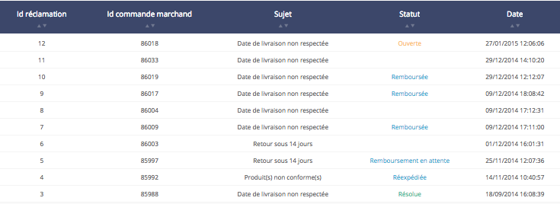

Figure 87: Complaints dashboard

* How does it work?

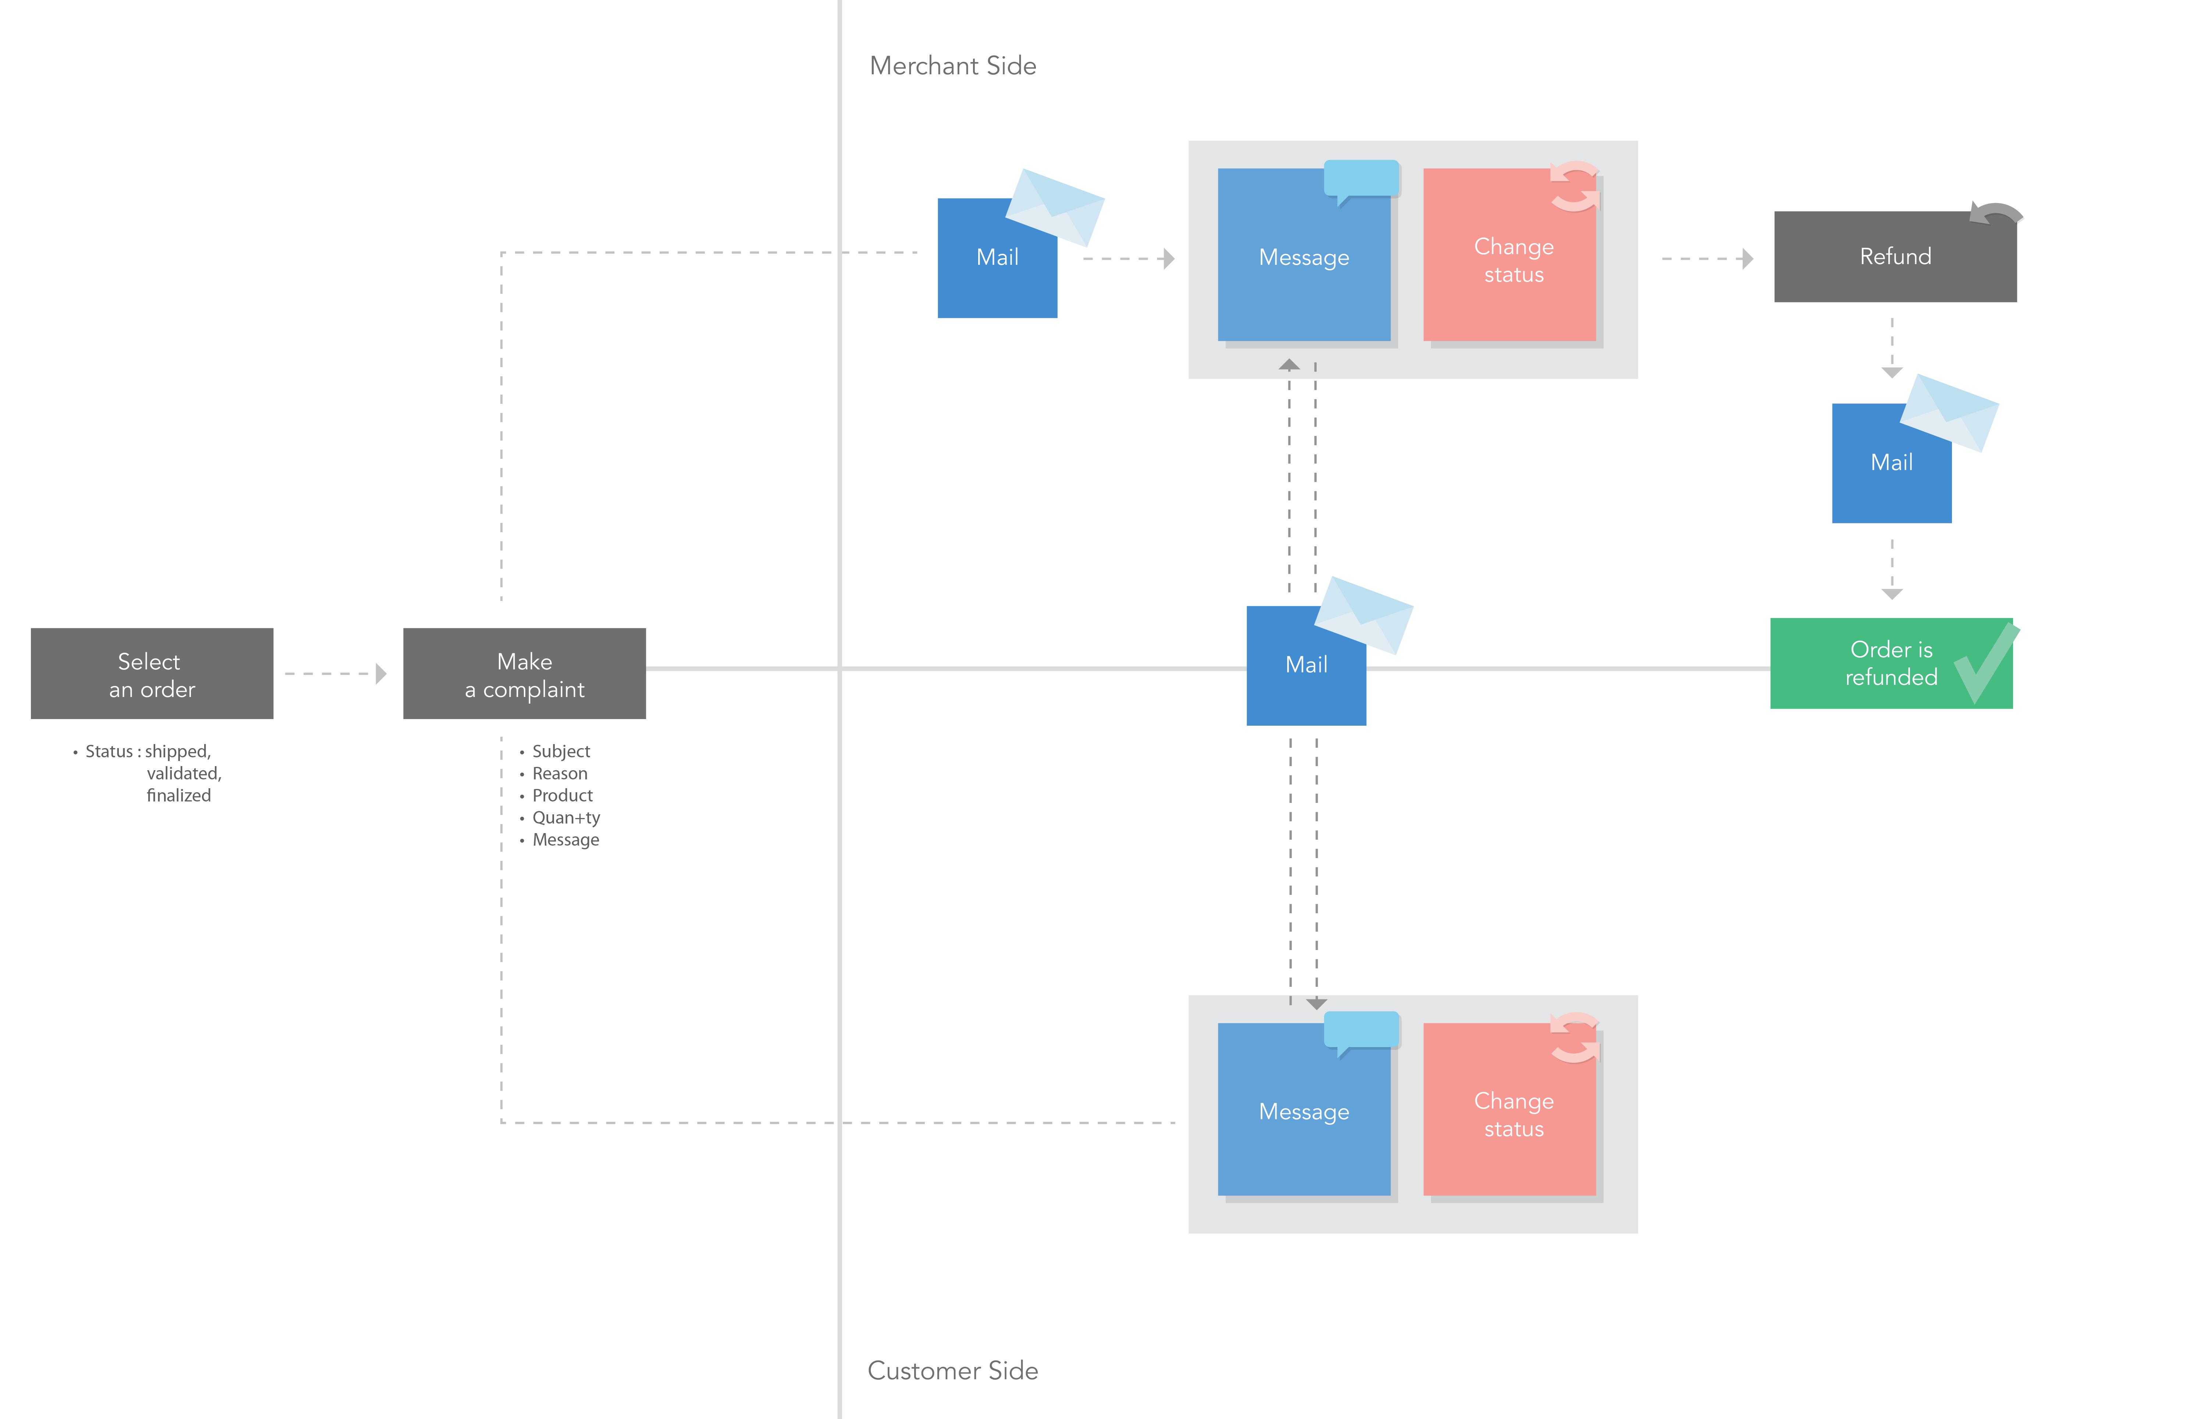

Figure 88: Complaint workflow

In order to make a complaint, ABO or CBO is needed. Selecting a”shipped”, “validated”, or “finalized » merchant order will allows to begin the complaint creation process (fig. 88). The following list contains the data needed in order to finish creating a complaint :

* Subject
* Reason
* Product
* Quantity
* Message

After this, a dialogue box is opened between the merchant and the customer to find an arrangement. Each status change will send a message to inform all the people involved.

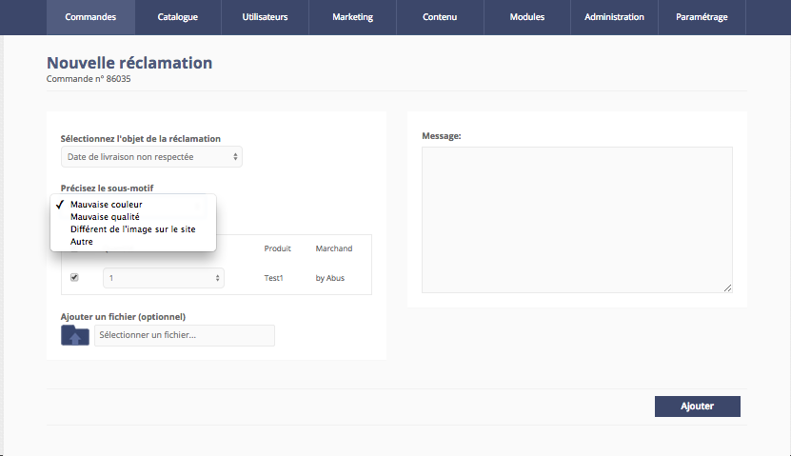

Figure 89: Open a complaint in ABO

It is possible to add details to a complaint. A complaint reason and a clear message are the factor keys to a successful complaint. Sometimes, a photo can help underline the fact that the parcel has arrived damaged. It’s the reason why we offer the opportunity to upload a file. This file can be a picture (jpg, PNG, bmp, gif) or a PDF file, in the case the merchant wants to give the customer a return voucher.

* General rules

**Tracking number**

Each parcel must have a tracking number so that it can be followed by the customer and the merchant. There will be as many tracking numbers as there are parcels for an invoice.

**Statuses and reasons**

The French law is very strict about managing product returns, refunds and complaints. So, we created several complaint reasons and statuses in order to answer all needs. Each status and reason has a precise definition in our solution.

Below is the complete list of statuses :

* “Opened” :as the default status, it informs the customer about the fact that the system has considered the complaint.
* “Resolution in progress” :automatic status when the merchant has read the complaint. This status allows us to notify the customer about the complaint being viewed.
* “Refund in progress”**:** only if the PSP doesn’t manage automatic refunding using an API. The customer knows the refund is in progress.
* “Refunded”**:** if the PSP manages refunding using an API. But the administrator can also use it to update the complaint status.
* “Shipped”: if the customer asked for another parcel to be shipped by the merchant.
* “Cancelled”:this status is about complaint cancellation. A complaint can be cancelled if the reason is not valid or if the customer demands it.
* “Closed”**:** only the customer can close a complaint. But there is also a parameter used to close a complaint after some time passed without message exchanges.

Based on the Hamon Law in France, the reasons list has recently been updated :

* “Failure to comply delivery time”
* “Merchandise return” (14 Days)
* “Lost product” **:** if the customer never receives the parcel(s), a complaint can be open for product loss
* “Defective product” **:** if the product doesn’t work
* “Damaged product” **:** if the product has arrived broken
* “Non-compliant product”

There are many reasons to not really be satisfied about merchandise. In this situation, we try to facilitate the exchanges. During a “Merchandise return”, the customer must upload and fill a merchandise product return form available in French or English. But what is important, as a follow up, is putting the merchandise product return form in the parcel and conserving a copy of it. If the merchant can provide it, a merchandise product return form can be offered to the customer in the dedicated area.

In case of multiple orders, the merchandise return can be effective at the time the customer receives the last parcel.

Refunds

In the case of a complaint, a refund can be about a product or all of the products in an order. The customer can ask for being reimbursed in the complaint section (fig. 90).

First, the merchant or the administrator need to view the complaint detail page. If the complaint is not on « refund in progress », « refunded », « cancelled » or « closed », the reimbursement can be done.

Then, a check must be performed to see if a promotion code has been used. If it has, the price is calculated with the promotion applied equally to each product. Shipping fees are included in the refund if it concerns all the products in the order. In this situation, the order status is also changed to “cancelled”. If the refund concerns only some products, an automatic refund can be made depending to the PSP settings.

The procedure for a PSP allowing automatic refunds is :

* Update merchandise quantity in the complaint
* Update the order price
* Add a negative payment on payment history
* Change complaint status to inform the customer that the refund has been made

The procedure for a PSP that doesn’t allow automatic refunds is :

* Change complaint status to “Refund in progress”
* A button “Manual refund” appears. It can be used to change the complaint status to “Refunded” and notify the customer of the change, if the merchant has reimbursed the customer.

Last but not least, complaints and refunds don’t change merchant order statuses.

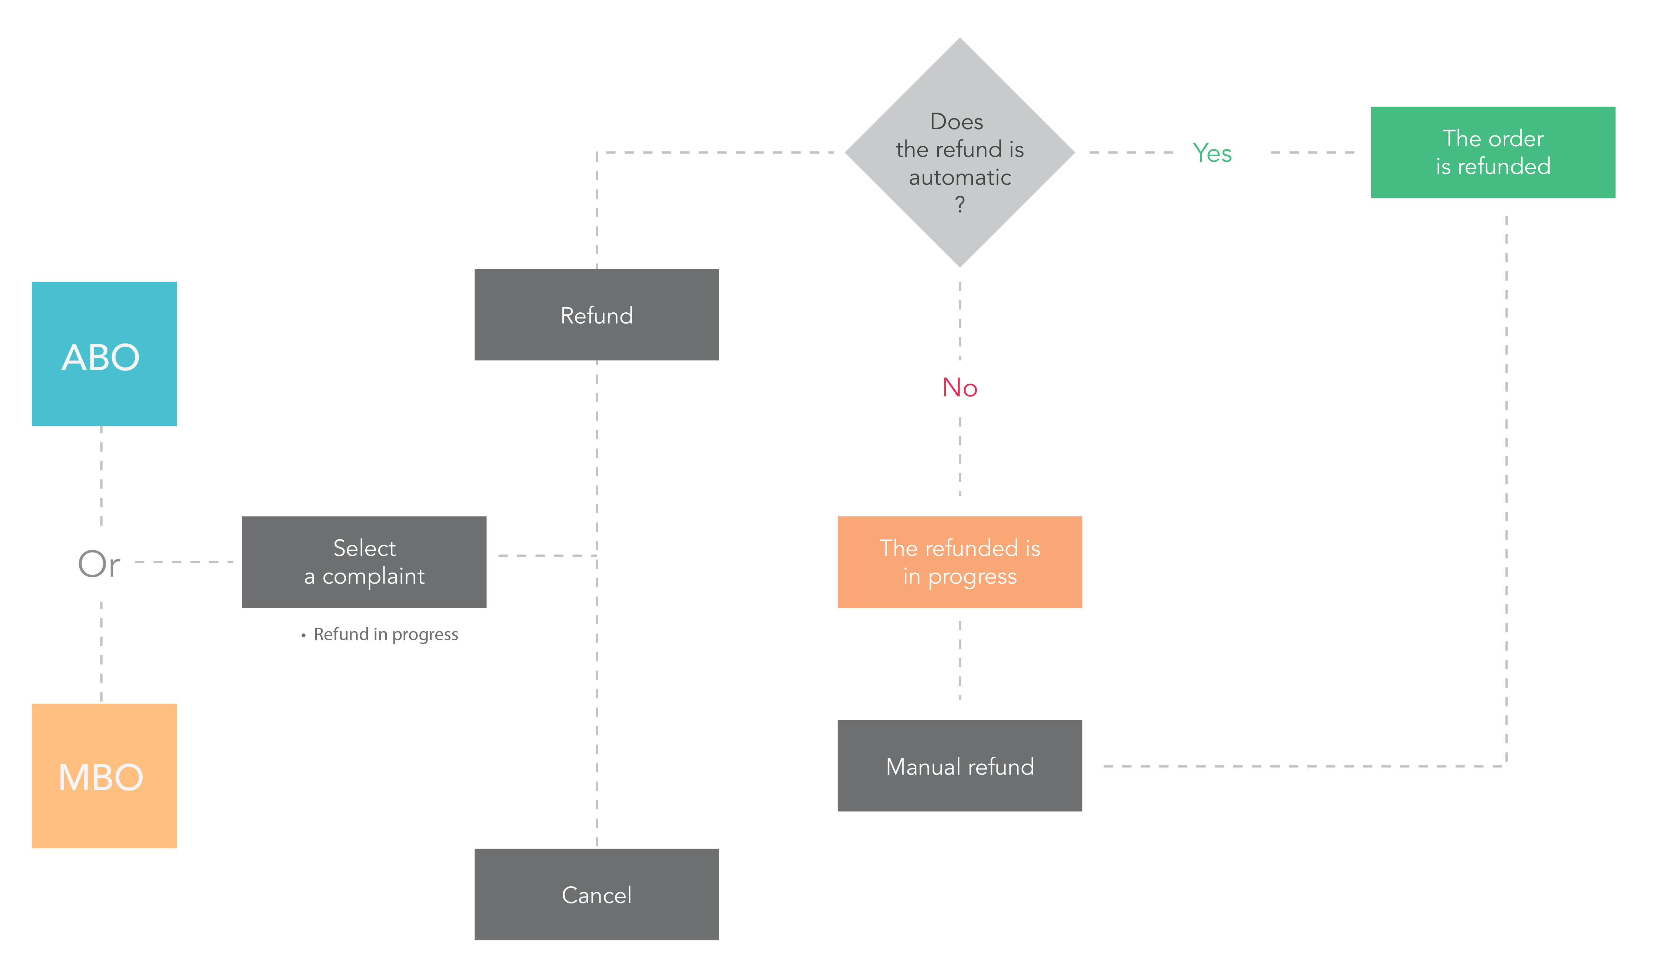

Figure 90: Make a refund workflow

* Billing system (commission e-bill)

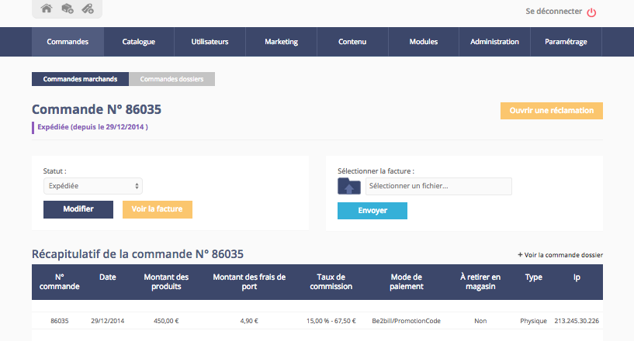

Figure 91: Merchant order detail

The solution generates an invoice for each merchant order. It holds the amount charged by the marketplace for each transaction (fig. 91).

Our solution provides a generic template of merchant order invoice. The file sums up data about the order and the customer. Currently, there is no connection with solutions specialized in billing systems. An administrator can only visualize or upload merchant order invoices.

Furthermore, a table, which sums up all invoices data can be exported. It contains the following attributes :

* Invoice ID
* Order merchant ID
* Order date
* Date
* Customer name
* Merchant name
* Complete address
* VAT RATE
* VAT Price
* VAT Not included
* VAT included

This data can also be changed. For example an administrator can set the marketplace so that the invoice ID and the order merchant ID are the same. If for any reason the merchant decides to refund the customer, the invoice will update with the new data.

### Rating

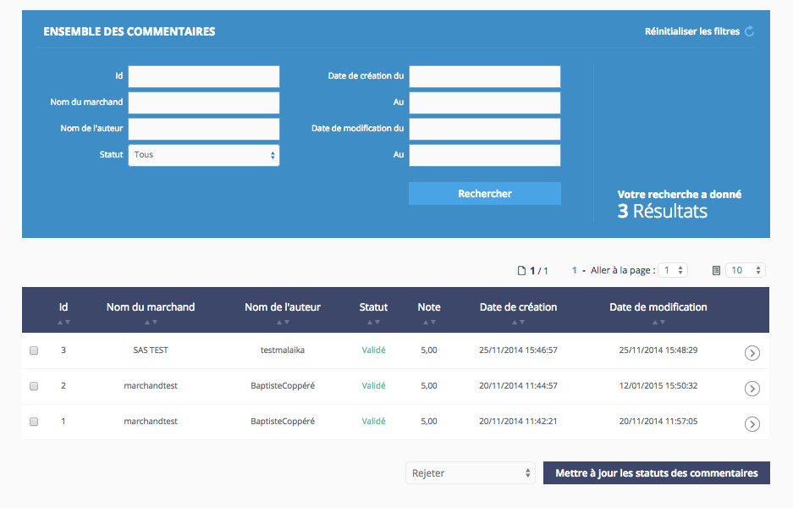

Figure 92: Merchant rating section

Sometimes customers need to express themselves about a merchant and their satisfaction. We provide tools to write reviews and grade merchants. But each such system must be closely moderated.

Before the grades are applied, they must be approved by a marketplace administrator. We keep a history of these reviews in order to be safe about what is published about a merchant and his activity.

If inappropriate reviews have been written, an administrator can remove it before it is published in the merchant area in the platform.

Finally, no need to automatically supress all bad reviews. Allowing them is advised because customers will understand that the truth isn’t being hidden from them. So, they won’t think they are being censored in favor of the merchants.

## PAYMENTS

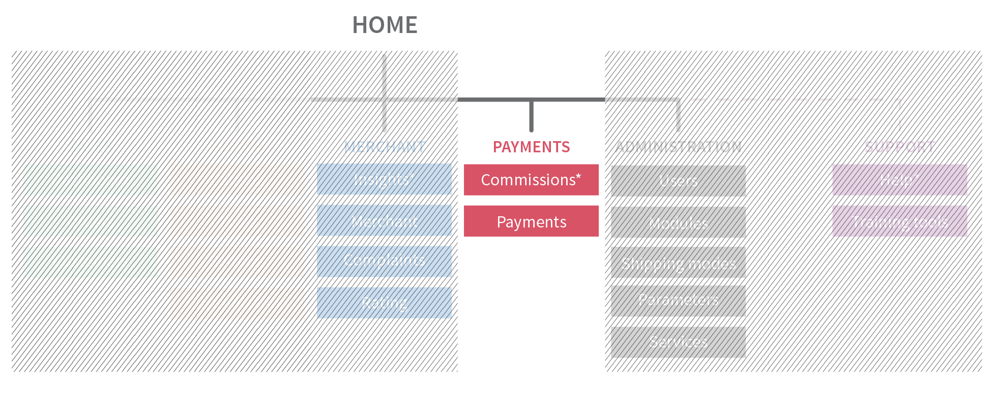

Figure 93: Payments section in ABO architecture

### Commissions

Coming soon …

### Cash transactions management

Comin soon …

## ADMINISTRATION

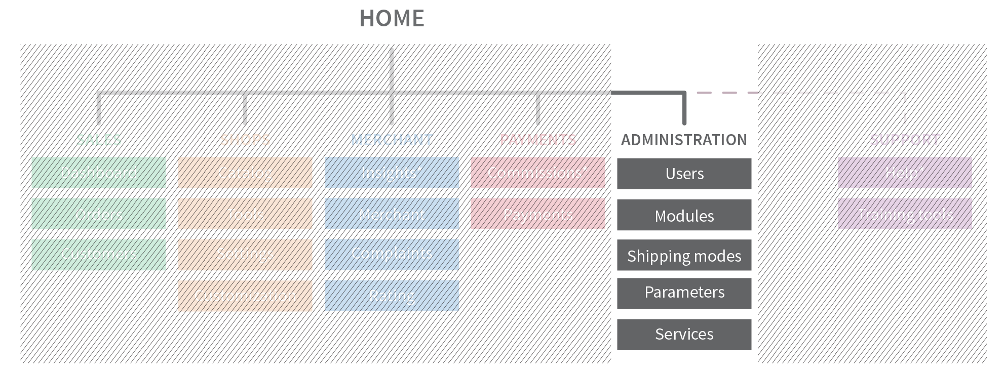

Figure 94 : Administration section in ABO architecture

### Users management

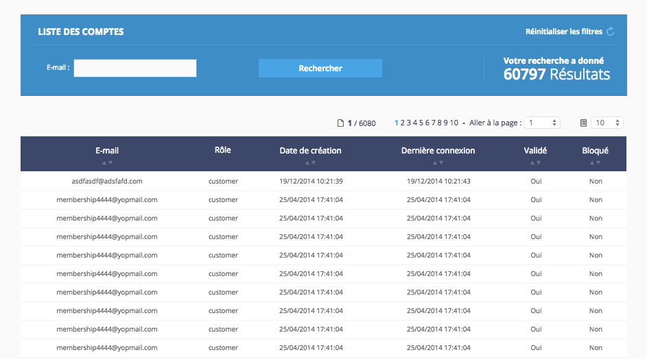

Figure 95: User management section in ABO

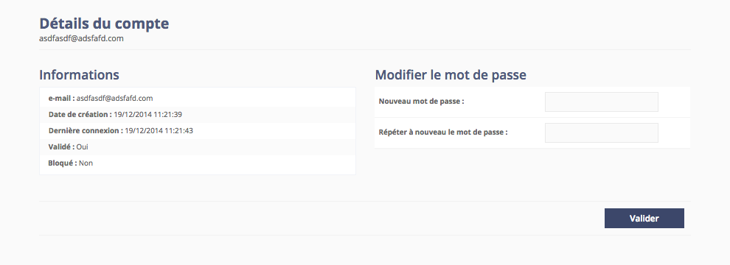

Figure 96: Account details

After some unsuccessful attempts of connection (the number of tries is changeable in the settings), the account will be blocked in order to protect customer data. For this case, we provide a solution for changing the user password. With this feature, admins can manage accounts and check if they are activated or not (fig. 95). The only information needed is the customer or merchant email address to solve the problem (fig. 96).

It is important to note that in this area administrator passwords can be removed.

### Modules

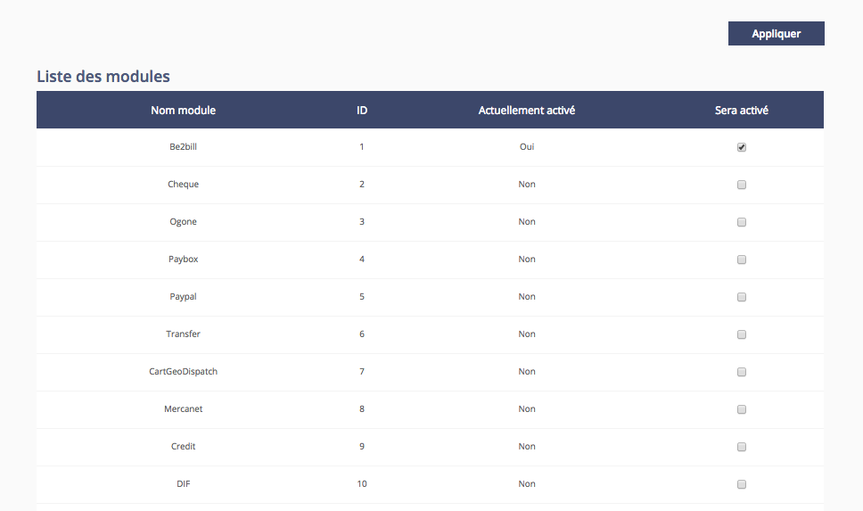

Figure 97: Modules section in ABO

Our solution works with custom modules for PSP or developed for a specific action. A module can be activated in the modules section, which lists all installed modules, by checking the checkbox (fig. 97). Our solution improves with customer needs. This way, an admin can activate modules developed for a specific marketplace, if it exists in our modules section. Based on the need, it is possible to develop, activate, or deactivate a module in the ABO.

### Shipping modes and zones

* Shipping modes

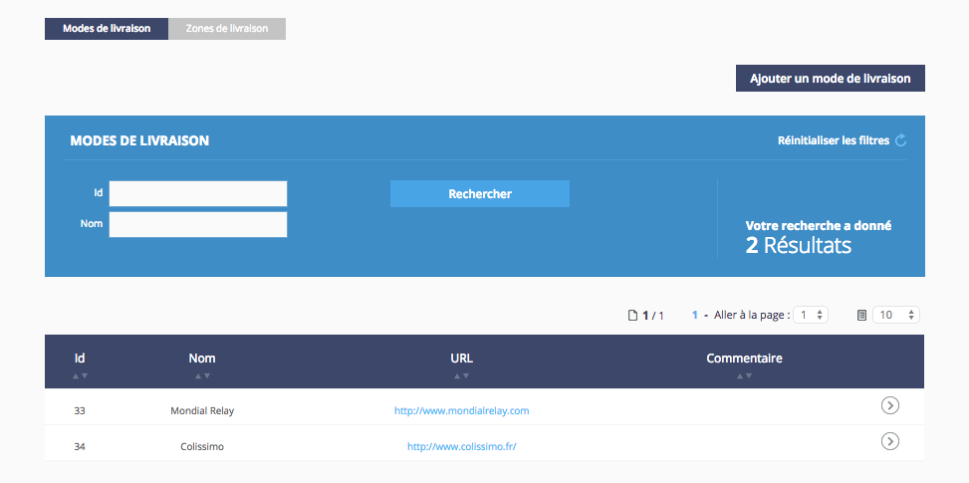

Figure 98: Shipping mode section in ABO

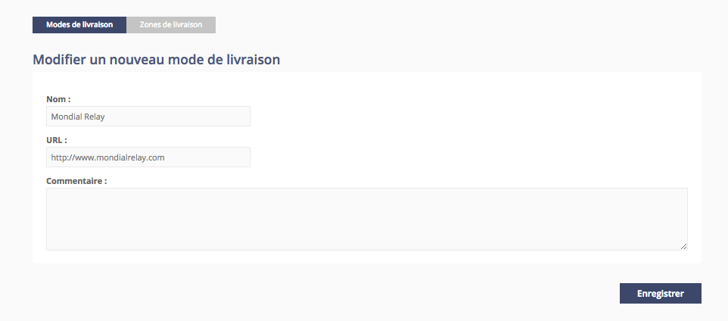

Figure 99: Shipping mode creation page

Our platform supports several merchant shipping modes (fig. 98). Managing shipping modes is easy. It can be done by going to an item and adding a new shipping mode (fig. 99). It is also possible to change the data about shipping logistics.

* Shipping zones

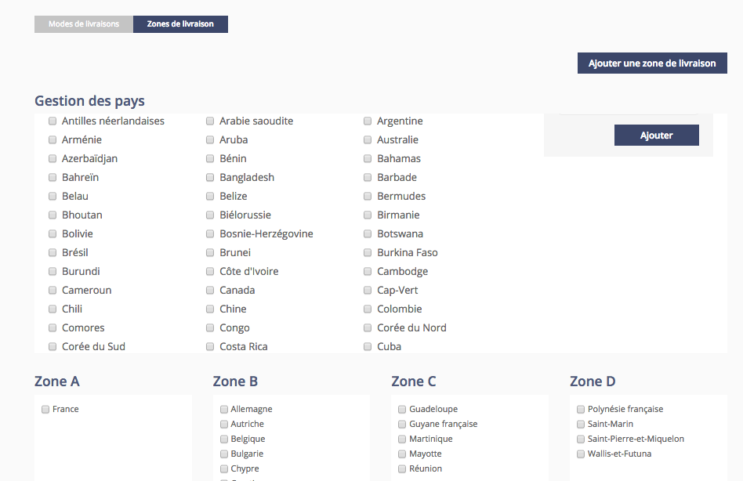

Figure 100: Shipping zones management section in ABO

Managing shipping zones is not yet very customizable, for each merchant. Which is why administrators must define each zone based on each merchant’s needs. Furthermore, countries are grouped by zone (fig. 100). A country can’t be indicated in two shipping zones. It’s also important to choose the most appropriate zone for a country. Lastly, if a country is removed from a zone and left without a zone, clients from that country won’t be able to order products.

Parameters

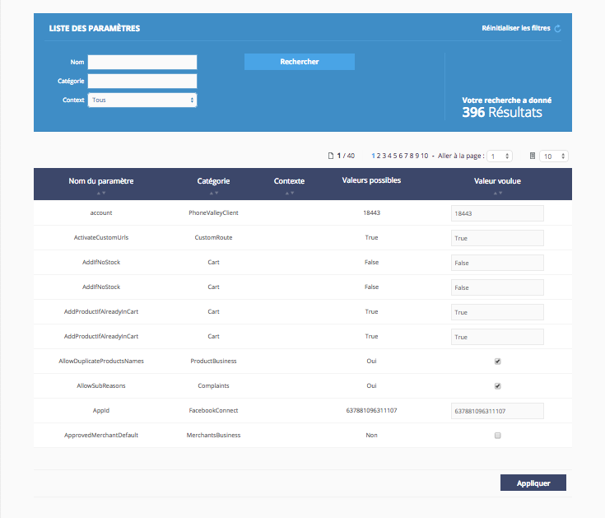

Figure 101: Parameters section in ABO

Services

* API

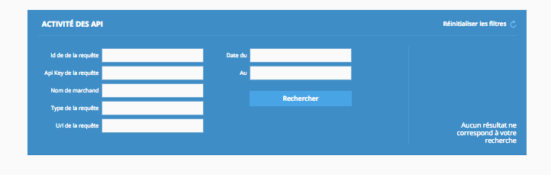

Figure 102: Api management section in ABO

The API are used to send requests to the platform. In this dedicated section (fig. 102), requests can be sorted by:

* Request ID : the ID of the request
* Request API Key : the ID (Guid) of the API
* Merchant Name : the name of the merchant
* Type of request : the file format (ex: application/xml)
* Request URL : the URL to reach the API
* By Date: from DATE to DATE
* CRAWLERS

**Magento**

Coming soon

**Prestashop**

Coming soon

* How to import an existing catalog

In order to import an existing catalog, the following CSV file structure is required :

* *(Product data)*
* PartnerId : not required, product ID in existing e-shop
* Title : product title
* Images : Picture URL in the existing website
* Description : 2048 Maximum length
* DescriptionShort : short description, 265 characters max
* Brand : product brand, alphanumeric canvas
* CategoryId : Category ID in order to correctly organize the product in marketplace
* Category : Category name, tree where you can find the product
* MPID : internal product ID in the marketplace, integer
* EAN : not required but recommended to fill
* ISBN : not required but recommended to fill
* UPC : not required but recommended to fill
* MPN : not required but recommended to fill
* *(Offer data)*
* SKU : merchant id
* Offer ID
* Deliverymodes
* Price : taxes included
* Pricepromo : required if the product is in promotion
* PromoDateStart : date, dd/mm/yyyy
* PromoDateEnd : date, dd/mm/yyyy
* Stock
* ShippingDelay : time before shipping, an integer example: 2 for two days

There must be only one offer per line. The quality of the offer pages depends on the CSV file quality. Moreover, it‘s important that the CSV name doesn’t contain a date, spaces, symbols, or special characters. After choosing a CSV name, it needs to stay, and be the same otherwise it could create troubles or errors in the updates. Depending on the situation, offers can appear between 48 and 72 hours. The catalog export can be edited as needed without having to transfer the file again : each day, our system will update products based on the CSV file. These changes can be applied in the span 24 hours.

* JOBS

**Manage cart reminder**

Coming soon

**Write a review**

Coming soon

**Manage specific jobs**

Coming soon

* JOBS HISTORY

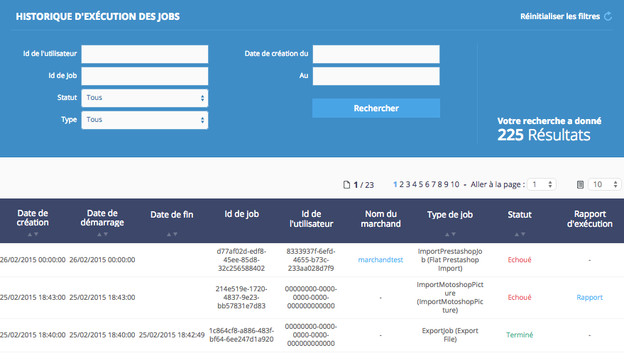

Figure 103: Job history management section in ABO

This tab gives access to the job history detail (fig. 103). To organize data, it can be filtered by :

* User ID : a guide like “b844ca6e-6aa6-412f-89fb-1acb96e6eaa5”
* Job ID : a guide like “b844ca6e-6aa6-412f-89fb-1acb96e6eaa5”
* Status : All, Pending, Processing, Terminated, Failed
* Type
* Date : a range of date

All results will appear in a list, which can be sorted by:

* Creation date : creation date of the job
* Starting date : last date when the job has been launched
* Ending date : last date when the job has been finalized
* Job ID
* User id
* Merchant name
* Type of job
* Status
* Implementation of report

A report is also available to know if the job was executed without failure.

* Jobs planning

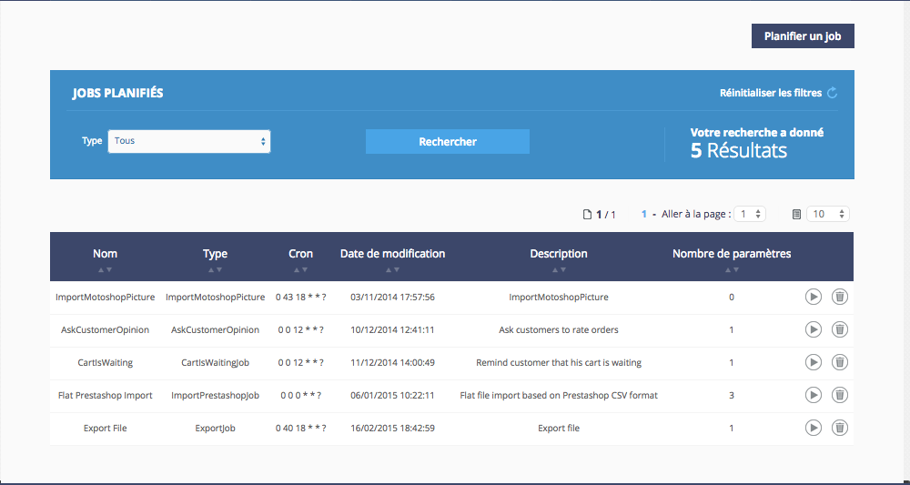

Figure 104: Jobs planning management section in ABO

This area helps manage the jobs batch already scheduled (fig. 104), it can be filtered by type and also sorted by:

* Name
* Type
* Cron – Planning and recurrence syntax
* Modification date
* Description
* Number of parameters : on mouseover the parameters are displayed

There are also some action buttons (play and delete), which ensures the batch management. Planning a job is very simple : selecting the job type and clicking on the validation button is all that needs to be done. After this, some explanation about how to set a valid cron, like “0 0 0 * * ?", is needed in order to plan a job.

Let’s talk about the cron structure :

* The first number is for seconds
* The second for minutes
* The third for hours
* The fourth for days
* The last for months
* The question mark represents no specific value for the year

Then fill all the required parameters.

The types used are the following :

* An “Int” represents an integer
* A “Float”, “Decimal”, and “Double” represent a decimal
* A “String” represents a string of characters
* A “Guid” represents an ID in the form of “b844ca6e-6aa6-412f-89fb-1acb96e6eaa5”.

For the import jobs, some data is required such as :

* Url : the path to take the merchant import (csv file).
* UserId : the merchant id
* DeliveryModeName : the default delivery mode for this merchant (ie. : ups, colissimo…)
* DeliveryModePrice : the default price for this delivery mode

For a better use, optional fields for import jobscan be filled. Among them :

* Brand : the brand name
* Encoding : the text encoding (ex: UTF-8)
* UseShortDescriptionAsDescription : a short description but must not exceed 8 characters
* ForceStocks : an integer, which determines the default stock for the products of this import.
* Culture : the language used for this import (ex: en-EN)

## SUPPORT

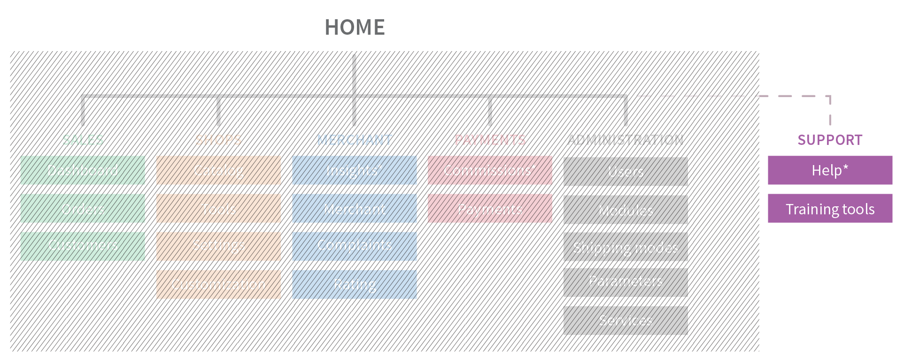

Figure 105: Support section in ABO architecture

### Help

Coming soon

### Training tools

Coming soon

AN OPERATOR AREA

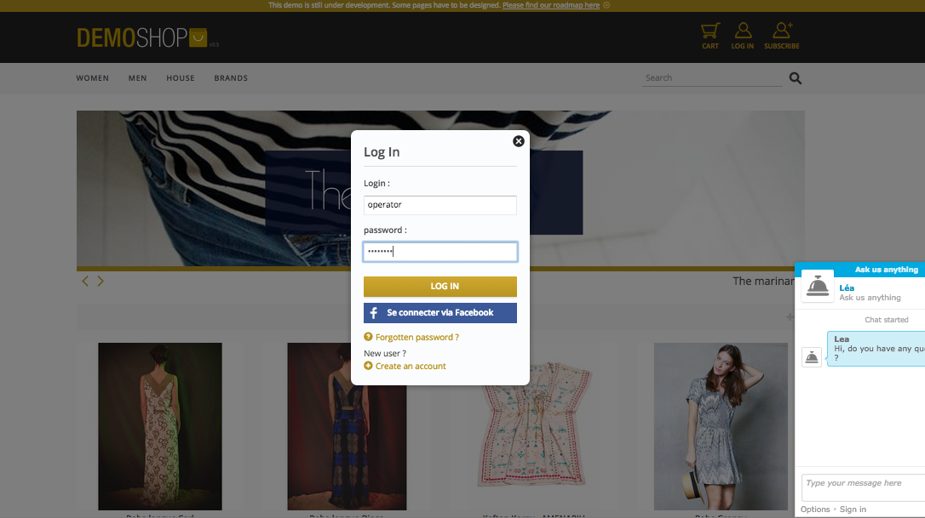

Figure 106: Operator mode connection

As other users, the operator has access to a dedicated area by connecting in the front office (fig. 106). After a successful connection, the operator can create selections and also manage product ordering in the platform.

## MANAGING SELECTIONS

### Creating a selection

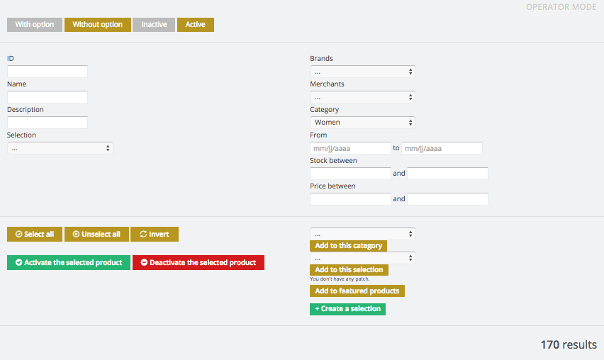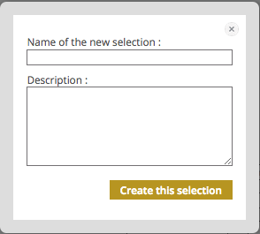

Figure 107: Selection creation area in OBO

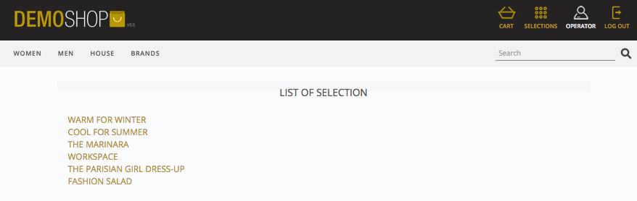

Figure 108: Selection list in OBO

In order to create a product selection in the platform, a click on a product category is necessary. Then, clicking on the « create a selection » button will make appear the associated popup (fig. 107). Creating a selection is simple : all that is needed is a name and short description of it. Finally, a complete list of existing selections can be found in the marketplace by clicking on the icon called selections (fig. 108).

### Editing a selection

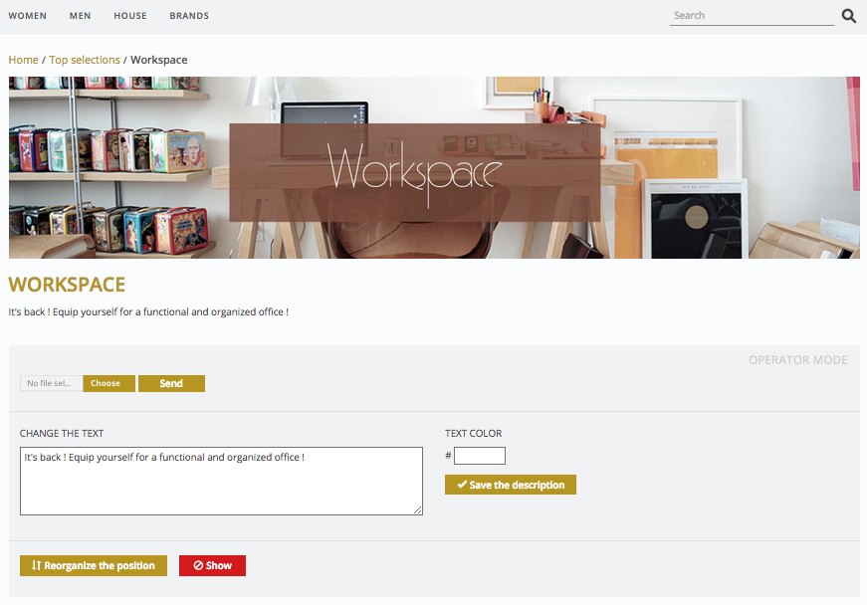

Figure 109: Selection editing page in OBO

Clicking on a selection will give a free access to its editable zone to an operator or an administrator (fig. 109). In this area it is possible to change the selection banner, the description, and reorganize products position. For an optimal use of the selection section, a banner with a size of 1140 x 260 pixels is preferred.

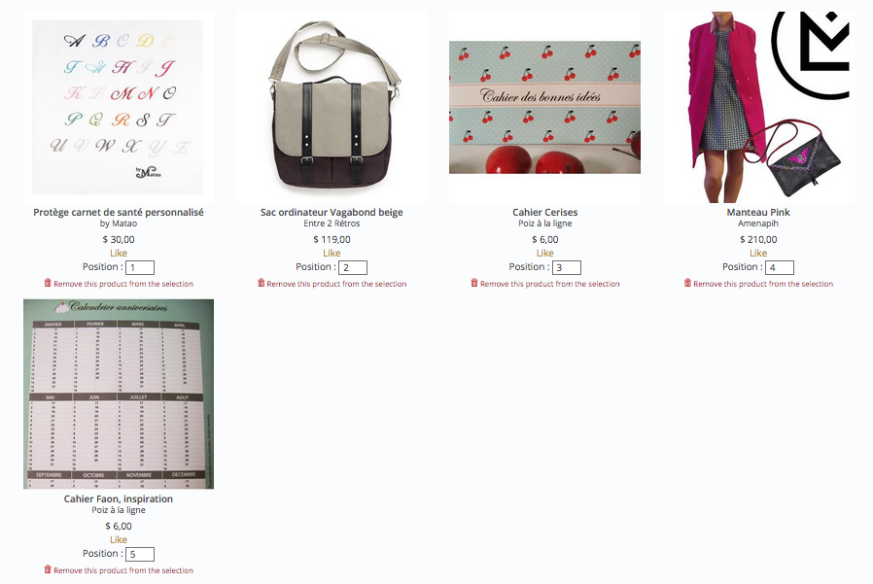

Figure 110: Product position management in OBO

In the OBO (Operator back office) reorganizing products is simple:

* Enter the product position number
* Click on the validation button.

Furthermore, a trash icon is available under each product information which makes it easy to remove a product from the selection (fig. 110).

MANAGING PRODUCTS

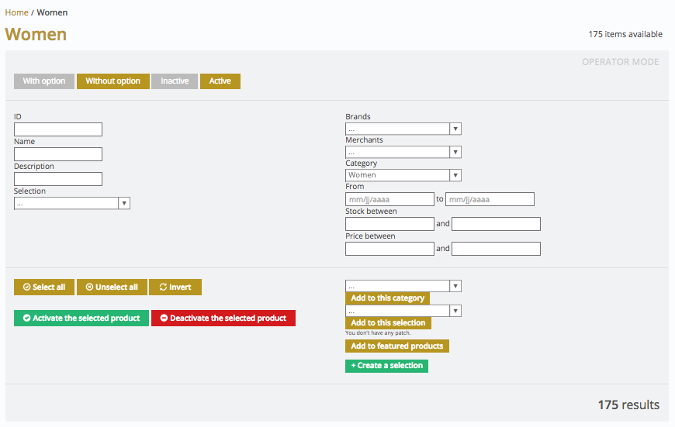

Figure 111: Product management section in OBO

Our front office is entirely customizable. It is not necessary visiting the ABO in order to manage products and categories. By clicking on the existing categories, available and unavailable products on the platform are displayed (fig. 111). This area helps activating huge quantities of products in only one click.

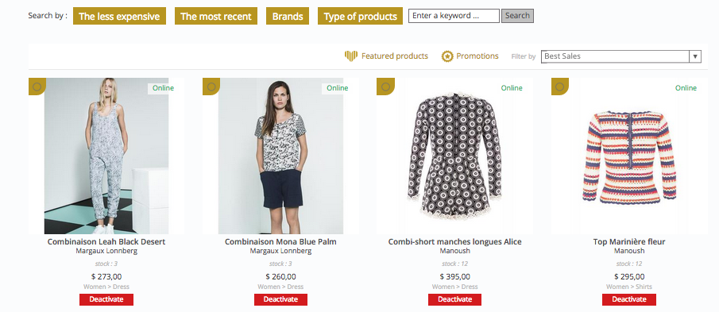

Figure 112: Product activated display

Products can be activated or deactivated just by clicking on the related button. Products can be filtered per date or per type. This area allows easily organizing products. Products can also be search by:

* The price
* The creation date
* Brands
* Type of product
* Sale quantity

# AN EFFICIENT MERCHANT AREA

## MERCHANT ACCOUNT CREATION

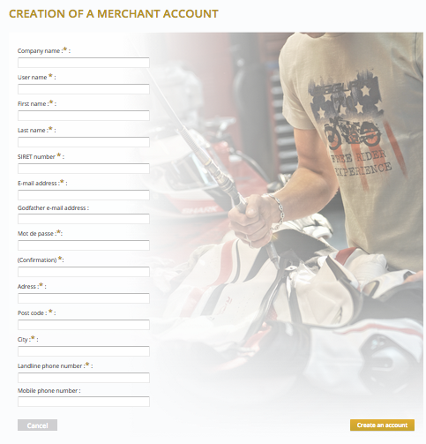

Figure 113: Merchant account creation page

Our solution provides a dedicated area for the merchant. Easily they can communicate and share data with their customers or administrators. Based on the platform strategy, merchant accounts can be created in the front office or manually in the ABO. Both situations need an administrator validation process. Keep in mind that the current version of CCF requires extensive information about merchants in order to satisfy the European legislation (fig. 113).

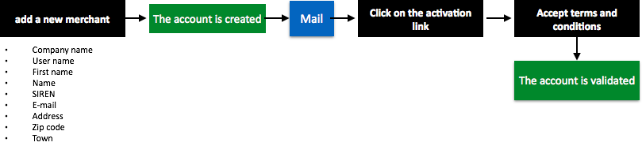

Figure 114 : Merchant account creation workflow

Each merchant must give the same required information in order to be able to sell products on the platform. Confirming account creation doesn’t activate the merchant account (fig. 114). The activation needs two manual steps :

* Accepting the platform terms as a merchant.
* The administrator must validate the account creation.

As we explained earlier, establishing the dialogue between merchants and administrators is important. Currently, our solution requires a SIRET Number per merchant because it’s required in France. But in a long-term strategy, this data will be optional in order to simplify foreign merchants account creation. Our goal is to provide an international solution adaptable to each country.

MANAGING PROFILES

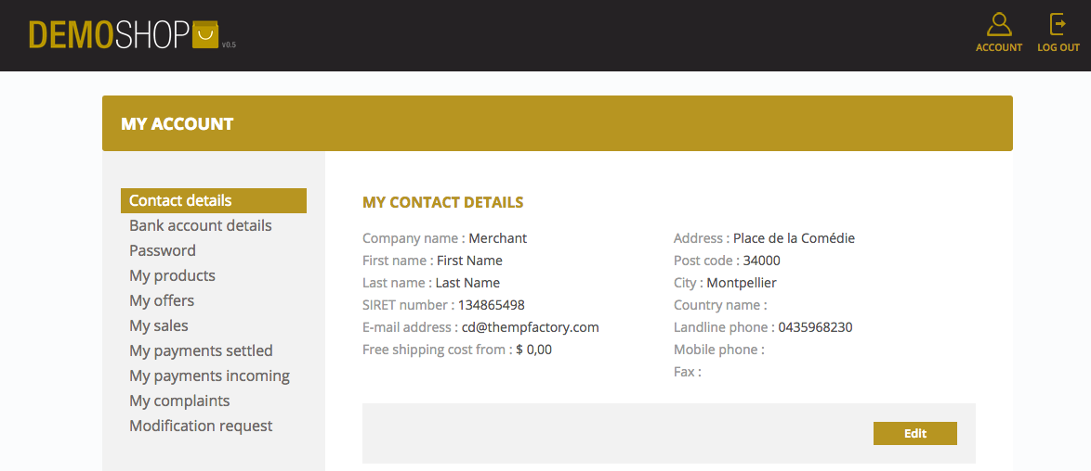

Figure 115: Merchant profile page in MBO

Merchants can edit their own data in our solution. In order to improve the communication between merchants and administrators, the data given by merchants need to be correct (fig. 115). To promote sales, a merchant, together with an administrator, can decide to offer free shipping costs above an order total sum. Since accounts can’t be deleted, if a merchant leaves, the account needs to be deactivated. For security reasons, merchant logins can’t be removed.

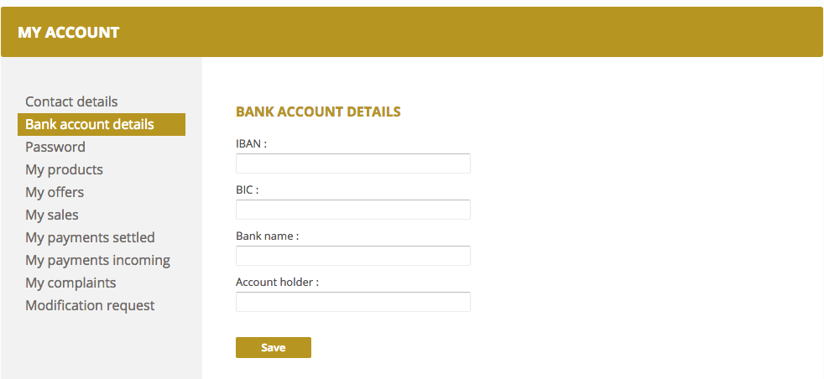

Figure 116: Merchant bank account details page in MBO

To collect money from the sales, the merchant’s IBAN is needed. This section exists in order to help transfer money to merchants. Our solution follows the SEPA norm. The idea is to provide a solution affordable with European payment and foreign payments too. But our solution’s goal is not centralizing all of the transferred money. Based on the available PSP on the platform, the merchant’s bank account details may be needed in the MBO (fig. 116).

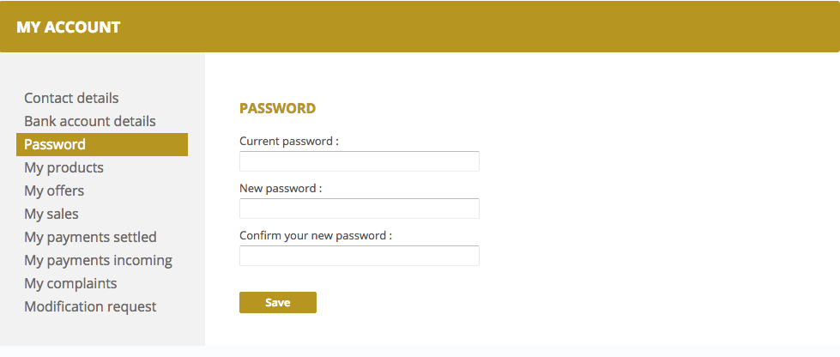

Figure 117: Merchant password management page in MBO

Our security protocol has a powerful password managing system. Based on the process of merchant account creation, the merchant will receive a generated password. After the first connection on the MBO, the password can be changed in the “my password” page (fig. 117).

## CUSTOMIZING THE SHOP

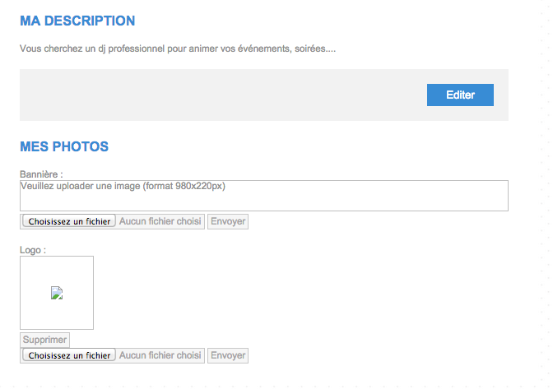

Figure 118: Merchant shop editable page in MBO

In order to let merchants customize their shops, they can upload a banner, a logo, and a description to introduce their business. In order to keep a fluid and pleasant navigation on the platform, they should be given some guidelines and best practices. If it is activated in the marketplace, the shop settings will appear in the MBO.

## MANAGING PRODUCTS

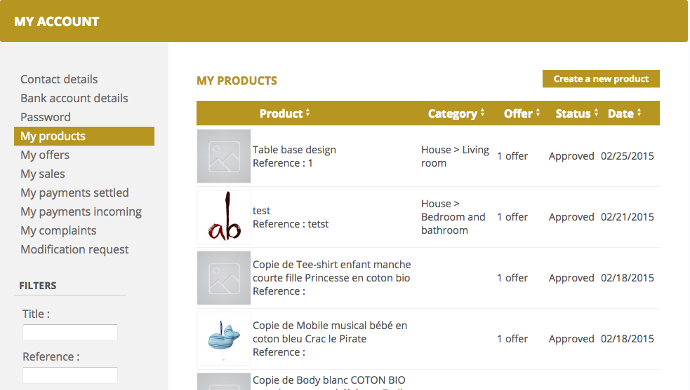

Figure 119: Merchant product management section in MBO

On the “My product” page (fig. 119), all catalog products are displayed. The product list displays products per:

* Product : product name and reference
* Category : product category
* Offer : number of offer on this product
* Status
* Date : creation date

In order to ease merchant navigation on this section, a merchant can browse and filter the products per:

* Title
* Reference
* Associated offers
* Status

Finally, we also give merchants the possibility to manually create products.

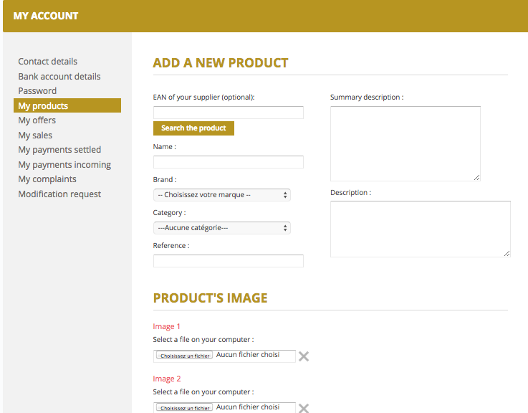

Figure 120: Merchant product creation page in MBO

Manual product creation exists to provide a simple way to create products. If the product has been added in the platform, the merchant can find it by typing its EAN code in the related field (fig. 120). Then, the merchant must fill the required information in order to have a product sheet as complete as possible. Before launching the marketplace, the number of pictures per product must be chosen. The range is from 1 to 6 pictures.

## MANAGING OFFERS

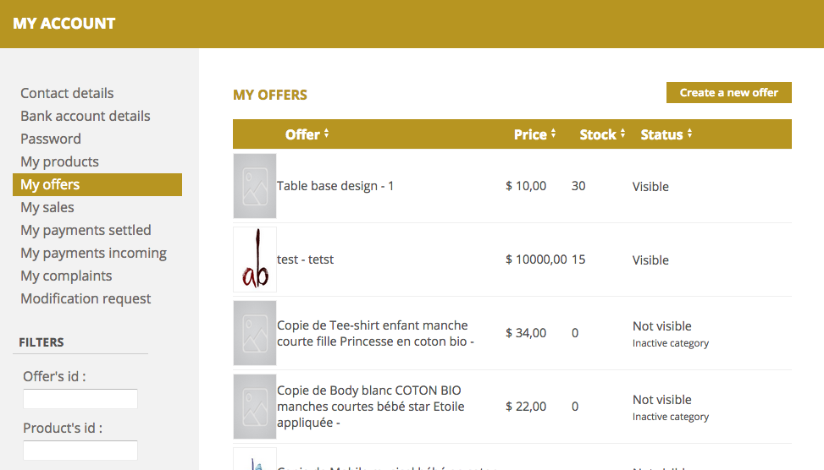

Figure 121: Merchant offer management section in MBO

In the same way as for the product, the merchant can manage the offers on products. In the offer section (121), all relative data about the existing offers is displayed. It can be sorted by:

* Offer ID
* Product ID
* Name
* Reference
* Status
* Promotions
* Stocks

Then, offers can also be created or deactivated using the shortcut in the section.

Finally, remember that in order to create an offer, a product needs to be selected first.

## MANAGING SALES

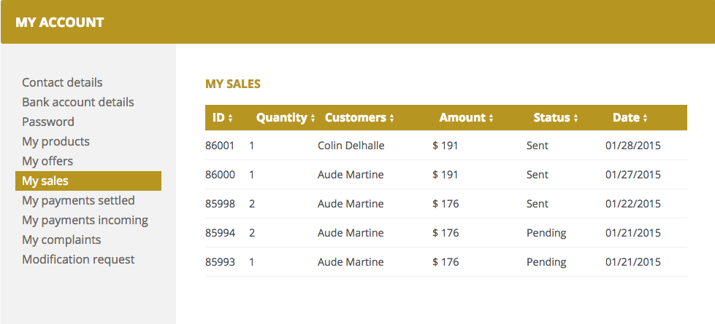

Figure 122: Merchant sales section in MBO

The “sales” section (fig. 122) lists all essential data about orders made in a merchant shop.

All transactions are grouped by date (from the most recent to the oldest).

They can be sorted by :

* Id : order id
* Quantity
* Customers : customer name
* Amount
* Status
* Date

Currently, there is no search box nor export button in the sales section. It will be in the next update of the solution. It is also impossible to delete an order. In European countries, it is forbidden deleting payment data, billings, or orders. It is the reason why there will never be a “delete” button in the MBO. If there is a specific need to delete an order, it can only be done by contacting the marketplace technical team and asking them to delete it in the databases.

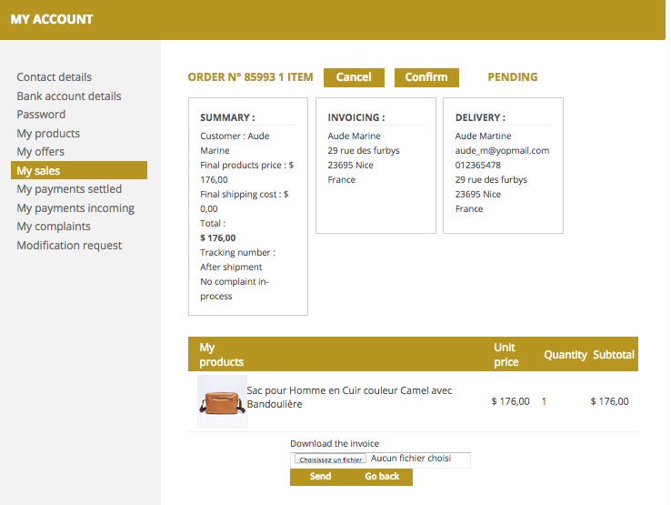

Figure 123: Order details page in MBO

In order to simplify the merchant activities, our solution offers an order details page for each order (fig. 123). Based on the product stocks, a merchant can validate or cancel an order on this page. If needed, an invoice can be joined with the validation or the shipping mail.

Furthermore, an administrator of the marketplace can also decide to not display all customer data before merchant validation. This way, merchant attempts of bypassing the workflow order can be avoided.

Finally, keep in mind that our solution works with a specific order cancelation process. A cancelation reason must be given in order to confirm the cancelation.

## MANAGING COMPLAINTS AND REFUNDS

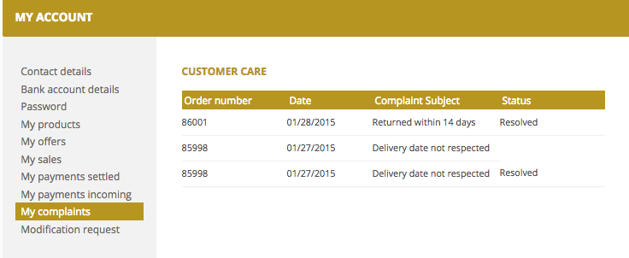

Figure 124: Complaint management in MBO

Merchants can follow and manage complaints in the MBO (fig. 124). All of the complaint history is available in the complaint section listed by:

* Order number : merchant order number
* Date : complaint date
* Complaint reason
* Status

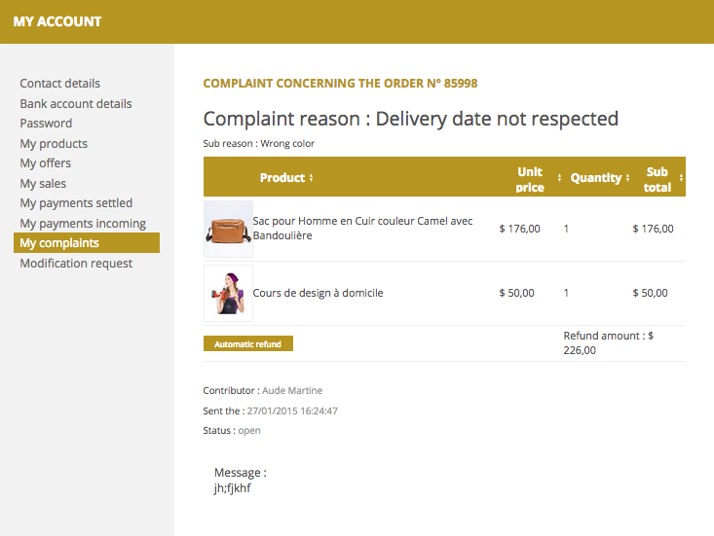

Figure 125: Complaint detailed page in MBO

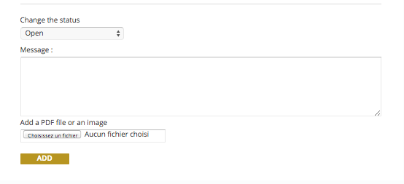

Figure 126: Complaint detailed page footer in MBO

By clicking on the specific line, the merchant can access to the complaint detail page (fig. 125) that summarizes the dialogue between the merchant and the customer. This page sums up all the data about the opened complaint. In the header, the merchant will find:

* The number of the order concerned
* The complaint reason
* The complaint sub reason

For a better complaints management, merchants can be granted the ability to refund automatically an order depending on the PSP used. After changing the settings, the merchant will have a button in the complaint detail page that allows for easy customer reimbursement.

Finally, changing a complaint status expects a message, send to the interlocutor (customer or merchant). This way, the merchant avoids making mistakes in the managing complaints. In order to improve customer relationship management, merchants should be advised to provide return notes. There is a section dedicated to return notes at the bottom of the page (only Pdf files are accepted) (fig. 126).

# A USEFULL CUSTOMER AREA

## CUSTOMER ACCOUNT CREATION

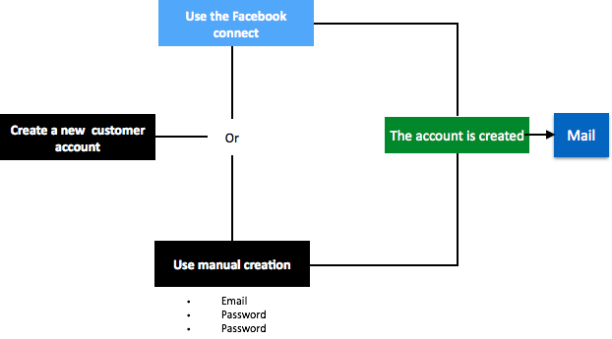

Figure 127: Customer account creation workflow

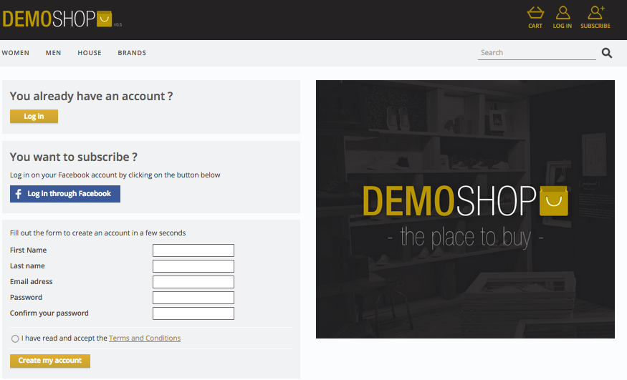

Figure 128: Customer account creation page

Creating a customer account in our solution is simple. There are two ways to create an account (fig. 127). One uses “Facebook Connect process”, and the other one uses a basic manual account creation (fig. 128). To confirm the customer account creation, the customer receives an email that sums up his connection data (id and password).

## MANAGING A PROFILE

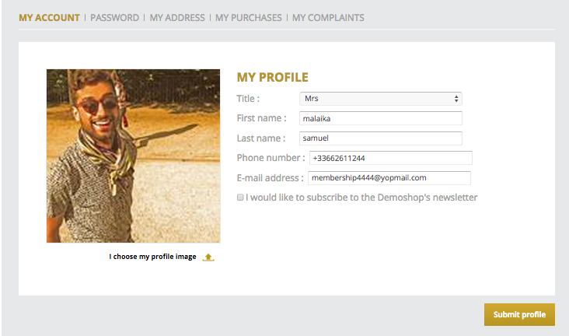

Figure 129: Customer account page

Our solution provides an account management section (fig. 129) for each customer. In this area, they can remove :

* Title
* First name
* Last name
* Phone number
* Newsletter subscription
* Profile picture

The email is often the login. It‘s the reason why the customer can’t delete it. If the customer doesn’t want to use an email anymore, we advise creating another account.

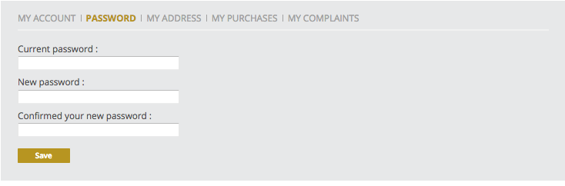

Figure 130: Password management page

Our security protocol has a powerful password managing system. After the first connection on the CBO, the customer can change the password in the “my password” page (fig. 130). Finally, if the customer wants to receive products in parcels, it is required to provide an address in the related section.

**MANAGE YOUR ORDERS**

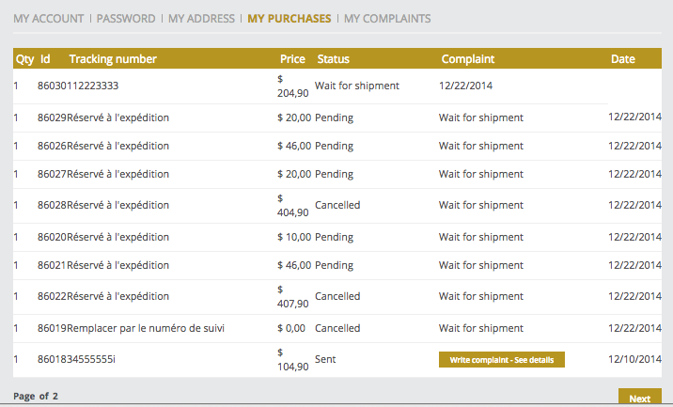

Figure 131: Order management page

In order to improve customer relationship management, our solution provides an order detail page for each order (fig. 131). Based on the need, the customer can follow each order in the marketplace. Finally, if there is any problem with a finalized or shipped order, the customer can open a complaint on it by clicking on the related button.

## MANAGE YOUR COMPLAINTS

For a better complaint management, the customer has access to a dialogue box connected with the merchant that allows for message exchanging about a complaint. The customer can make the follow-up of each complaint organized by status and date. Our solution ensures a simple tool where the customer can give precise details about a complaint or upload return notes or files. Furthermore, after the complaint resolution, the customer will keep a history of complaints.

## MANAGE YOUR WISHLIST